DETECTING AI GENERATED IMAGES WITH CNN AND INTERPRETATION USING EXPLAINABLE AI
VeriVision AI: a local web application that classifies an image as real or AI-generated with four CNN routes and explains the decision with Grad-CAM
A project report submitted in partial fulfilment of the requirements for the award of the degree of
BACHELOR OF TECHNOLOGY
in
COMPUTER SCIENCE AND ENGINEERING
Submitted by
Ponugoti Viduranandan | 23K91A05J5
Naina Baherji | 23K91A05G9
Likki Pranathi | 23K91A05D2
Motasani Sathish | 23K91A05G0
Batch C14 (CSE-C)
Under the esteemed guidance of
M Thanmayee
[DESIGNATION]
DEPARTMENT OF COMPUTER SCIENCE AND ENGINEERING
[COLLEGE NAME]
[COLLEGE ADDRESS]
Academic year [ACADEMIC YEAR]

CERTIFICATE
This is to certify that the project report entitled "Detecting AI Generated Images with CNN and Interpretation Using Explainable AI" is a bonafide record of the work carried out by Ponugoti Viduranandan (23K91A05J5), Naina Baherji (23K91A05G9), Likki Pranathi (23K91A05D2), Motasani Sathish (23K91A05G0), in partial fulfilment of the requirements for the award of the degree of Bachelor of Technology in Computer Science and Engineering, during the academic year [ACADEMIC YEAR], under my supervision.

Project Guide | Head of the Department | Principal
M Thanmayee | [HOD NAME] | [PRINCIPAL NAME]
[DESIGNATION] | Department of Computer Science and Engineering | [COLLEGE NAME]

External Examiner: [NAME AND SIGNATURE]
Place: [PLACE]
Date: [DATE]

DECLARATION
We hereby declare that the project report entitled "Detecting AI Generated Images with CNN and Interpretation Using Explainable AI", submitted to the Department of Computer Science and Engineering, [COLLEGE NAME], in partial fulfilment of the requirements for the award of the degree of Bachelor of Technology in Computer Science and Engineering, is a record of original work carried out by us under the guidance of M Thanmayee, [DESIGNATION]. The results embodied in this report have not been submitted to any other university or institution for the award of any degree or diploma.

Ponugoti Viduranandan 23K91A05J5
Naina Baherji 23K91A05G9
Likki Pranathi 23K91A05D2
Motasani Sathish 23K91A05G0

Place: [PLACE]
Date: [DATE]

ACKNOWLEDGEMENT
We express our sincere gratitude to our project guide, M Thanmayee, [DESIGNATION], for valuable guidance, encouragement and constructive suggestions throughout this project.
We thank [HOD NAME], Head of the Department of Computer Science and Engineering, for providing the facilities and support needed to complete this work, and [PRINCIPAL NAME], Principal, [COLLEGE NAME], for the encouragement given to us.
We thank the project coordinators and all faculty and staff members of the department for their help, and our families and friends for their constant support.
We also acknowledge the authors of the base paper and of the papers that shaped the design, the creators of the CIFAKE dataset, and the maintainers of the open-source software used in this project (PyTorch, torchvision, pytorch-grad-cam, scikit-learn, Flask, React and Vite).

Ponugoti Viduranandan
Naina Baherji
Likki Pranathi
Motasani Sathish

ABSTRACT
Generative models now produce images that people cannot reliably tell from photographs, and detectors trained on one generator often fail on another. This project presents VeriVision AI, a local web application that classifies an uploaded image as real or AI-generated and explains the decision. Four ImageNet-pretrained CNN routes (two EfficientNet-B0 variants, ResNet50 and MobileNetV3-Large) are fused in logit space with configurable weights and two gating rules; Grad-CAM heat maps show where three of the routes looked, and a robustness check re-tests the image under JPEG compression, resizing and blur. The system is served by a Flask API and a React interface and runs on a CPU.
The routes were fine-tuned on a class-balanced subset of CIFAKE (6,000 training, 1,200 validation and 2,000 test images, 32 x 32 pixels, one generator). On the held-out test images the ensemble reaches 92.35% accuracy (95% interval 91.1% to 93.5%), F1 0.927 and ROC-AUC 0.9865; the best single route scores 91.80%, so the ensemble's gain in accuracy is not statistically distinguishable, and the two gates did not improve the result. The model leans toward the AI-generated class (false-positive rate 13.1%). Resizing and blur reduce accuracy to about 58-61%, and on 600 full-resolution images from another source the ensemble is at chance (51.0%, ROC-AUC 0.499), so cross-generator generalisation was measured and not achieved. A verdict takes a median of 0.25 s and a full analysis 1.7 s on a CPU-only PC. Training used 6% of the available training images and a single run per route; the explanations were judged qualitatively and no user study was carried out. The base paper, a one-class face-deepfake detector, uses different data and metrics, so its results are not directly comparable.
Keywords: artificial intelligence, convolutional neural network, AI-generated image detection, explainable AI, Grad-CAM, image forensics, ensemble learning, robustness, Flask, React.

TABLE OF CONTENTS
CERTIFICATE i
DECLARATION ii
ACKNOWLEDGEMENT iii
ABSTRACT iv
TABLE OF CONTENTS v
LIST OF FIGURES viii
LIST OF TABLES x
LIST OF ABBREVIATIONS xi
CHAPTER 1: INTRODUCTION 1
1.1 Domain and Background 1
1.2 Motivation 2
1.3 Problem Statement 2
1.4 Need for the System 2
1.5 Objectives 3
1.6 Scope 3
1.7 Contributions 3
1.8 Summary of Results 4
1.9 Limitations and Assumptions 5
1.10 Organisation of the Report 5
CHAPTER 2: LITERATURE SURVEY 6
2.1 Overview 6
2.2 Base Paper Analysis 6
2.3 Related Work 7
2.3.1 Heterogeneous ensembles and gating 7
2.3.2 Empirical comparison of detectors 8
2.3.3 Detection of GAN and diffusion images 8
2.3.4 Face-forgery detection 8
2.3.5 Explainable detection 9
2.4 Datasets and Algorithms Used in This Area 9
2.5 Strengths and Limitations of the Existing Approaches 10
2.6 Research Gap 10
CHAPTER 3: FEASIBILITY STUDY 12
3.1 Technical Feasibility 12
3.2 Economic Feasibility 12
3.3 Operational Feasibility 13
3.4 Schedule Feasibility 13
3.5 Advantages and Constraints 14
CHAPTER 4: SYSTEM REQUIREMENTS AND ANALYSIS 15
4.1 Existing System and its Limitations 15
4.2 Proposed System and its Advantages 15
4.3 Functional Requirements 16
4.4 Non-Functional Requirements 16
4.5 Hardware Requirements 17
4.6 Software Requirements 17
4.7 User Roles 17
4.8 Constraints 18
CHAPTER 5: SYSTEM DESIGN 19
5.1 Design Goals and Architecture 19
5.2 High-Level Workflow 20
5.3 Data Flow Diagrams 21
5.4 UML Diagrams 24
5.5 Data Model and Storage Design 25
5.6 Module Design 27
5.7 Design of the Core Algorithm 28
5.8 User Interface Design 29
5.9 Design Decisions and Their Reasons 30
CHAPTER 6: METHODOLOGY AND SOFTWARE IMPLEMENTATION 31
6.1 Overall Methodology 31
6.2 Dataset 31
6.3 Preprocessing and Augmentation 33
6.4 Algorithm Choice and Justification 33
6.5 Mathematical Formulation 34
6.6 Model Architecture and Training 35
6.7 Evaluation Protocol 36
6.8 Application Architecture 37
6.9 Explanation and Robustness Modules 38
6.10 API Design 39
6.11 Security and Error Handling 39
6.12 Installation and Execution 40
CHAPTER 7: SYSTEM TESTING 42
7.1 Testing Strategy 42
7.2 Unit Testing 42
7.3 Integration Testing 43
7.4 Functional Testing 44
7.5 Security Testing 44
7.6 Validation and Edge Cases 44
7.7 Performance Testing 45
7.8 User Acceptance Testing 46
7.9 Summary of Results and Findings 46
7.10 Limits of the Testing Done 47
CHAPTER 8: RESULTS AND OUTPUT SCREENS 48
8.1 Experimental Set-up 48
8.2 Output Screens 49
8.3 Model Performance on the Held-out Test Set 51
8.4 Fusion Rules and Decision Threshold 54
8.5 Robustness to Compression, Resizing, Blur and Noise 55
8.6 Cross-domain Probe 56
8.7 Grad-CAM Explanations 57
8.8 Comparison with the Base Paper and the Design Reference 58
8.9 Sample Inputs and Outputs, Speed and Testing 59
8.10 Success and Failure Analysis 60
8.11 Limitations of the Results 61
8.12 Objectives versus Outcomes 62
CHAPTER 9: CONCLUSION 63
9.1 Summary of the work 63
9.2 Objectives achieved 63
9.3 Key findings 63
9.4 Practical applications 64
9.5 Known limitations 64
CHAPTER 10: FUTURE SCOPE 65
10.1 Improvements to the existing system 65
10.2 Additional features 65
10.3 Scalability and deployment 66
10.4 Further research 66
REFERENCES 67
APPENDIX A: IMPORTANT CODE 69
A.1 Upload validation and decoding (`app/preprocessing.py`) 69
A.2 Running the four routes (`app/inference.py`) 69
A.3 Weighted logit fusion and the two gates (`app/ensemble.py`) 69
A.4 Grad-CAM (`app/explainability.py`) 71
A.5 Robustness variants (`app/robustness.py`) 71
A.6 The analyze endpoint (`app/api.py`) 71
A.7 The training loop (`scripts/common.py`) 72
APPENDIX B: INSTALLATION AND USER GUIDE 73
B.1 Requirements 73
B.2 One-click start 73
B.3 Manual commands 73
B.4 Using the application 74
B.5 Interface summary 74
B.6 Troubleshooting 75
APPENDIX C: ADDITIONAL SCREENS 76

LIST OF FIGURES
Figure 1: Class-balanced CIFAKE subset used here: 6,000 training, 1,200 validation and 2,000 test images. 4
Figure 2: Accuracy, F1 and ROC-AUC of the four routes and the ensemble on the 2,000 held-out images (single run). 18
Figure 3: Four-tier architecture of VeriVision AI: React web app, Flask application, PyTorch inference and local file storage. 20
Figure 4: High-level workflow of VeriVision AI for one POST /api/analyze request. 21
Figure 5: Context diagram (DFD level 0) of VeriVision AI with its two actors and two external stores. 22
Figure 6: DFD level 1 of VeriVision AI: seven processes and three data stores. 23
Figure 7: DFD level 2 of VeriVision AI: processes 2.0 and 3.0 expanded into eleven sub-processes. 23
Figure 8: UML class diagram of VeriVision AI showing the application factory, the two blueprints and the service modules. 24
Figure 9: Sequence diagram of one image analysis, from the browser upload to the JSON response. 25
Figure 10: Use-case diagram of VeriVision AI with the user and the developer. 25
Figure 11: Persisted data model of VeriVision AI: model checkpoints, model metadata and metric artifacts, plus the runtime-only session token and upload buffer. 26
Figure 12: Flowchart of the logit fusion with the two gating rules implemented in app/ensemble.py. 28
Figure 13: Analyze page with an image chosen and the four steps explained on the right. 29
Figure 14: Grad-CAM tab: original image beside the EfficientNet heat map. 29
Figure 15: Class counts of the train, validation, test, robustness and cross-domain sets. 33
Figure 16: Training and validation curves of the four routes. 36
Figure 17: Landing page (light theme): the four routes with their input sizes and fusion weights, read live from the API. 49
Figure 18: Sign-in page: the demo account is shown beside the form; images are analysed locally. 49
Figure 19: Result for fake_00000.png: "Likely AI-generated", 99.25% (High confidence), 4/4 branches agree; the bar splits the fused probability into Real 0.8% and AI-generated 99.2%. 49
Figure 20: Result for real_00000.png: "Likely a real image", 97.17% (High confidence), Real 97.2% / AI-generated 2.8%, 4/4 branches agree, robustness consistency 4/4 (green). 49
Figure 21: Branch votes and robustness check for the same image. All four routes vote AI-generated (99.3%, 100.0%, 99.4%, 89.9%) with fusion weights 35, 15, 25 and 25%. The re-test agrees on the original, JPEG and blur variants but reads the 2x resized copy as Real, giving consistency 3/4 and an amber warning. 50
Figure 22: Grad-CAM tab for route A1 (EfficientNet): the activation concentrates on the right edge of the subject. 50
Figure 23: Grad-CAM tab for route B (ResNet50) on the same image: activation spreads over most of the subject. 50
Figure 24: Cross-domain AI-generated image (fake_0000.jpg, 1024 px): correctly called AI-generated with 100.00% confidence, but the robustness check agrees on only 3/4 variants. 50
Figure 25: Cross-domain real photograph (real_0000.jpg): called AI-generated with 100.00% confidence and 4/4 consistency. This is a confident wrong answer. 50
Figure 26: Model insights page: held-out ensemble metrics (accuracy 92.35%, precision 88.19%, recall 97.80%, F1 92.75%, ROC-AUC 98.65%, balanced accuracy 92.35%), the confusion matrix (869 / 131 / 22 / 978) and the clean-versus-degraded chart, all read from the evaluation files. 51
Figure 27: How-it-works page with one card per route: backbone, input size, loss, fusion weight and F1. 51
Figure 28: System status page: the /health answer (models loaded, device cpu) and the upload rules. 51
Figure 29: Confusion matrix of the deployed ensemble: counts (left) and row-normalised (right). 52
Figure 30: ROC curves of the four routes and the ensemble on the held-out test set. 52
Figure 31: Training and validation curves of the four routes (route B stopped after three epochs; C uses focal loss, so its loss scale differs). 53
Figure 32: Reliability diagram of the ensemble (expected calibration error 0.022); bin sizes are printed under the points. 53
Figure 33: Fused logit margin of correct (green) and wrong (red) predictions on the test set. 53
Figure 34: Accuracy and F1 of the fusion variants; the vertical axis starts at 0.905, which magnifies differences of a few images. 54
Figure 35: Precision, recall, F1 and accuracy of the ensemble as the decision threshold on the fused fake probability moves from 0.1 to 0.9. 54
Figure 36: Accuracy of each route and the ensemble on the clean subset and four degradations (dashed line: chance). 55
Figure 37: Cross-domain accuracy (left) and per-class recall (right) of each route and the ensemble; the dashed line is chance. 56
Figure 38: Grad-CAM overlays of routes A1, B and C on the first three real (top) and first three AI-generated (bottom) correctly classified test images. 57
Figure 39: Grad-CAM overlays on the cross-domain probe: two real photographs (both called AI-generated, 100%) and two AI images (the second called REAL, 100%). 58
Figure 40: Agreement of each route with the final label (the vertical axis starts at 0.87). 60
Figure 41: First six false positives (real images called AI-generated, top) and first six false negatives (AI images called real, bottom) with the ensemble's fake probability. 61
Figure 42: Landing page in the dark theme: the same ensemble card and feature strip; the theme is switched with the button at the top right. 76
Figure 43: Model insights page in the dark theme: the same measured values as the light page of Chapter 8. 76
Figure 44: Analyze page after sign-in, before an image is chosen; the toast confirms "Signed in, Welcome, Demo User". 76
Figure 45: fake_00000.png (2.6 KB) selected: file name, size, remove button and a preview appear, and the Analyze button is enabled. 76
Figure 46: Result page captured while the headline confidence was still counting up: it reads 88.33% beside a bar already at Real 0.8% / AI-generated 99.2%; the settled value is 99.25% (Chapter 8). The file keeps the name 06_analyze_running.png from the capture script. 77
Figure 47: Landing page, features: four-model ensemble, Grad-CAM, robustness check, runs locally, CPU or GPU, and honest about limits. 77
Figure 48: Landing page, numbers: accuracy 92.3%, F1 92.7%, ROC-AUC 98.7%, 2,000 test images and 61.0% after a 2x resample, with the "what it cannot do" box. 77

LIST OF TABLES
Table 1: Abbreviations used in this report xi
Table 2: Objectives and their status 3
Table 3: Organisation of the report 5
Table 4: Comparison of the surveyed work 9
Table 5: Strengths and limitations by approach 10
Table 6: Project phases and outputs 13
Table 7: Functional requirements and where they are met 16
Table 8: Non-functional requirements, targets and measured status 16
Table 9: Hardware used and recommended 17
Table 10: Software stack 17
Table 11: User roles 17
Table 12: Tiers, technologies and responsibilities 20
Table 13: Level 1 processes and their data 22
Table 14: Persisted and runtime data 26
Table 15: Back-end modules (app/) 27
Table 16: Pages of the web application 29
Table 17: Principal design decisions 30
Table 18: Data splits used in this project 32
Table 19: Training augmentation per route (scripts/common.py) 33
Table 20: Routes and training configuration 36
Table 21: Experiments run on the cached logits 37
Table 22: Configuration variables (app/config.py) 38
Table 23: Endpoints of the VeriVision AI API 39
Table 24: Error handling 40
Table 25: Testing environment 42
Table 26: Unit tests of the application logic 42
Table 27: Integration tests of the JSON API 43
Table 28: Groups of the smoke test (scripts/smoke_test.py) 44
Table 29: Edge-case uploads to /api/analyze 44
Table 30: Response times of the API (median of 8 runs; minimum to maximum) 45
Table 31: Summary of the test runs 46
Table 32: Objectives and the tests that cover them 47
Table 33: Evaluation set-up used for every result in this chapter 48
Table 34: Held-out performance of the four routes and the ensemble (n = 2,000) 52
Table 35: Confusion-matrix counts and error rates (positive class: AI_GENERATED) 52
Table 36: Fusion-rule ablation on the held-out test set (same logits) 54
Table 37: Accuracy under degradation (1,000 images, same images in every condition) 55
Table 38: Cross-domain probe, 600 images (models trained on CIFAKE only) 56
Table 39: Comparison with the base paper and the design reference 58
Table 40: Sample analyses captured from the application 59
Table 41: Response time of the running API (median of 8 runs, 127.0.0.1, idle machine) 59
Table 42: Objectives of the project against what was measured 62
Table 43: Objectives of the project against the measured outcome 63
Table 44: HTTP interface of the application (API on port 8414) 74
Table 45: Settings in .env (defaults shown) 75

LIST OF ABBREVIATIONS
Table 1: Abbreviations used in this report
Abbreviation | Expansion
AI | Artificial Intelligence
API | Application Programming Interface
AUC | Area Under the Curve
CE | Cross-Entropy
CI | Confidence Interval
CNN | Convolutional Neural Network
CPU | Central Processing Unit
DCT | Discrete Cosine Transform
DFD | Data Flow Diagram
ECE | Expected Calibration Error
ER | Entity-Relationship
FNR | False-Negative Rate
FPR | False-Positive Rate
GAN | Generative Adversarial Network
GPU | Graphics Processing Unit
Grad-CAM | Gradient-weighted Class Activation Mapping
HTTP | Hypertext Transfer Protocol
JPEG | Joint Photographic Experts Group
JSON | JavaScript Object Notation
ML | Machine Learning
REST | Representational State Transfer
ROC | Receiver Operating Characteristic
TTA | Test-Time Augmentation
UI | User Interface
UML | Unified Modeling Language
XAI | Explainable Artificial Intelligence

CHAPTER 1: INTRODUCTION
This chapter introduces the domain of the project, the motivation for building VeriVision AI, the problem it addresses, the objectives set for it, the scope that was actually delivered, the contributions, and the limitations and assumptions that govern every result reported later. It closes with a map of the rest of the report.

1.1 Domain and Background
The project belongs to computer vision, deep learning and explainable artificial intelligence, with a link to digital image forensics. Image forensics asks whether a picture is what it claims to be. For most of the history of the field the question concerned manipulation of a real photograph: splicing, cloning or retouching. Since generative adversarial networks [11] and, more recently, latent diffusion models [10], the question has widened to whether the image was ever photographed at all. A generator can now produce a picture from a short text prompt, and the result is realistic enough that casual inspection no longer separates it from a camera image.
A convolutional neural network (CNN) is a natural tool for this task. It learns filters directly from pixel data, so it can pick up the faint statistical regularities that generation leaves behind, which are invisible to the eye. Pretrained backbones such as EfficientNet [19], ResNet [20] and MobileNetV3 [21] already encode general visual features learned on ImageNet [24], so a detector can be built by fine-tuning rather than by training from scratch. Explainable AI (XAI) adds a second layer: instead of a bare label, the system shows which regions of the image drove the decision. Gradient-weighted class activation mapping (Grad-CAM) [26] produces such a heat map from the gradients that flow into the last convolutional layer, without changing the network.
The base paper chosen for this batch, Larue et al. [1], studies a related but different problem: generalisable deepfake detection on face images, with a one-class model that sees only authentic faces and synthesised pseudo-fakes. It is discussed in detail in Chapter 2. The heterogeneous ensemble and gating design of HEDGE [2], which combines several detectors through weighted logit fusion and two gating rules, supplied the architecture pattern used here, and the empirical study of Tasnim et al. [3] supplied a comparison of detector families and a Grad-CAM analysis.

1.2 Motivation
• Realism. Generated images are used for misinformation, fraud, fabricated evidence and reputational harm, and people cannot reliably tell them from photographs.
• Fragile detectors. A detector trained on one generator often fails on images from another, and the cues it relies on are weakened by the resizing and compression that social platforms apply to every upload.
• Unexplained verdicts. A score without a reason is hard to defend in a dispute. An analyst needs to see where the model looked and whether several independent models agree.
• Access. The strongest published detectors rely on large foundation-model backbones and GPU clusters. A student-built tool that runs on a laptop CPU and keeps the uploaded image on the machine is a useful complement for education and for preliminary screening.

1.3 Problem Statement
Synthetic images are realistic enough to deceive human observers. Detectors trained on one generator degrade sharply on images from another. Compression and resizing remove many detectable artefacts, and a verdict without visual justification is not credible in a dispute. The problem addressed by this project is to build a CNN-based detector that classifies an uploaded image as real or AI-generated, reports a confidence and the agreement between its component models, explains the decision with Grad-CAM heat maps, checks how stable the answer is under common degradations, and measures honestly how well all of this works.

1.4 Need for the System
• A single model gives a single opinion; four heterogeneous routes expose disagreement, and the fusion rule makes the combination explicit and inspectable.
• Explanations must travel with the verdict, so the interface shows the votes, the heat map and the robustness check on one screen.
• A local application keeps sensitive images off third-party servers and needs no GPU.
• Claims of generalisation must be tested rather than assumed, so the project includes held-out, degraded and cross-domain evaluations and reports the failures.

1.5 Objectives
The six objectives of the batch, taken from the objectives document, and what became of each, are listed below.
Table 2: Objectives and their status
No. | Objective | Status
1 | Assemble a dataset of real photographs and AI-generated images | Partly met. Real images from CIFAR-10 and images from one generator (Stable Diffusion v1.4) in CIFAKE [8]; a 600-image second-source set was used for a probe only.
2 | Preprocess and augment the images to improve robustness across sources | Met. Per-route augmentation (crop, flip, colour jitter, blur, noise, JPEG, resize) and ImageNet normalisation.
3 | Train CNN classifiers that separate real images from generated ones | Met. Four CNN routes trained; ensemble accuracy 92.3% on 2,000 held-out images.
4 | Evaluate cross-generator performance to test generalisation | Measured, not achieved. Ensemble accuracy 51.0% (ROC-AUC 0.499) on a different-source probe, i.e. chance.
5 | Apply Grad-CAM to highlight the regions driving each classification | Met. Grad-CAM overlays for three routes, judged qualitatively; no quantitative faithfulness test.
6 | Deploy the models behind an interface returning verdict, confidence and explanation | Met. Flask API on port 8414, React interface on port 5414, verdict, confidence, votes, heat maps and robustness check.

1.6 Scope
The delivered system is a working web application and the experiments behind it. In scope are: image upload and validation (PNG, JPEG, WebP, up to 10 MB); four fine-tuned CNN routes; logit-space fusion with two gating rules; confidence wording; Grad-CAM overlays; a robustness re-check under JPEG compression, down-and-up resizing and Gaussian blur; a demo sign-in; an insights page that reads the stored evaluation; training and evaluation scripts; and the automated tests. Out of scope are: video and audio; face-specific deepfake detection as in the base paper; attribution of an image to a particular generator; detection of partial edits and inpainting; a multi-user account system and database; and deployment as a hosted service. Chapter 10 of the report lists directions beyond this scope.

1.7 Contributions
1. A working end-to-end detector that serves four CNN routes through one Flask API and one React interface on a CPU-only machine, with a median response of 0.25 s for a verdict and 1.7 s for a full analysis.
2. A transparent fusion design: weighted logit combination with two deterministic gates, every parameter in one configuration file, and per-route votes shown with the verdict.
3. A combined explanation panel: Grad-CAM heat maps for three routes plus a robustness consistency score (k of n variants agreeing).
4. A measured evaluation on 2,000 held-out images with bootstrap confidence intervals, a fusion ablation, a threshold sweep, calibration, robustness tests and a cross-domain probe.
5. An honest set of negative findings: the gates did not help, the ensemble gain over the best single route is not statistically distinguishable, and generalisation to other sources failed.

1.8 Summary of Results
On the held-out CIFAKE subset the deployed ensemble reaches an accuracy of 92.3% (95% bootstrap interval 91.1% to 93.5%), an F1 score of 0.927 and a ROC-AUC of 0.9865. The best single route, A1, scores 91.8%; the two intervals overlap, so the ensemble's advantage in accuracy is not statistically distinguishable on this sample, although its ROC-AUC is higher (0.9865 against 0.9749). The ensemble leans toward the AI-generated class (false-positive rate 13.1%, false-negative rate 2.2%). Resizing and blur reduce the 32-pixel images to about 58 to 61% accuracy, and on full-resolution images from other sources the ensemble is at chance (51.0%). These numbers are reported in Chapter 8 together with their limits.
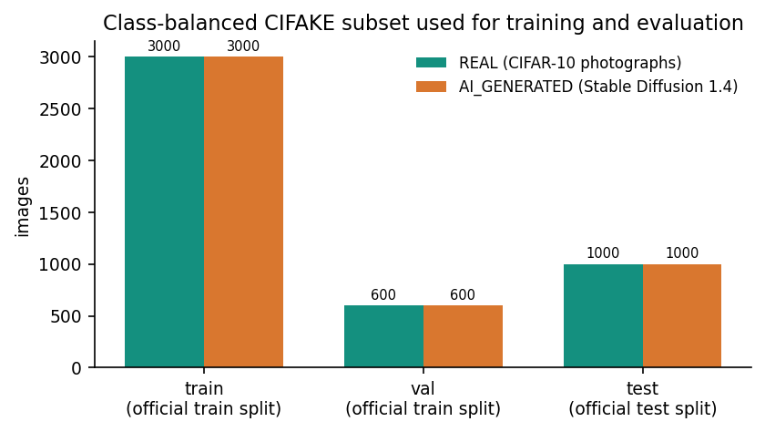
Figure 1: Class-balanced CIFAKE subset used here: 6,000 training, 1,200 validation and 2,000 test images.

1.9 Limitations and Assumptions
• Data. Training used 6,000 of the 100,000 CIFAKE training images and 3 to 5 epochs because the machine has no GPU. The images are 32 x 32 pixels from a single generator.
• Single run. Each route was trained once (seeds 42 to 45); the ranking of routes carries run-to-run uncertainty beyond the bootstrap interval.
• Test-set choices. The threshold sweep and the fusion ablation were evaluated on the test subset, so any operating point picked from them is optimistic.
• Explanations. Grad-CAM maps were inspected by eye; there is no deletion or insertion test of their faithfulness.
• Not measured. User study, GPU timing, load testing and adversarial attacks.
• Assumptions. The user uploads a single still image; the machine has about 16 GB of RAM; the demo account is for local use only; the verdict is decision support, not proof of origin.

1.10 Organisation of the Report
Table 3: Organisation of the report
Chapter | Content
1 | Introduction: domain, motivation, problem, objectives, scope, contributions, limitations.
2 | Literature survey: the base paper, related work by theme, datasets and algorithms, research gap.
3 | Feasibility study: technical, economic, operational and schedule feasibility.
4 | System requirements and analysis: existing and proposed system, requirements, hardware, software, users.
5 | System design: architecture, workflow, data flow diagrams, UML, data model, modules, user interface.
6 | Methodology and implementation: data, preprocessing, models, training, fusion, explanation, API, security, installation.
7 | System testing: strategy, unit, integration, functional, security, performance and the limits of the testing.
8 | Results and output screens: model performance, ablation, robustness, cross-domain probe, screens, objectives versus outcomes.
9 | Conclusion: summary, objectives achieved, key findings, applications, limitations.
10 | Future scope: improvements, features, scalability and further research.

The report ends with the reference list and three appendices: important code, the installation and user guide, and additional screens.

CHAPTER 2: LITERATURE SURVEY
This chapter reviews the literature that frames the project: the base paper assigned to the batch, the heterogeneous-ensemble paper whose design the system follows, an empirical comparison of detectors, the work on detecting images from generative adversarial networks and diffusion models, the datasets used in this area, and the explainability method. It ends with the research gap that the project tries to address. Every figure quoted from a paper was read from the paper itself; where a table in a paper could not be read as text, no number is quoted.

2.1 Overview
Early work on detecting generated images studied images from generative adversarial networks [11]. Wang et al. [12] trained a ResNet-50 classifier on images from one GAN and found that, with suitable augmentation, it recognised many other GANs; Frank et al. [14] showed that GAN images carry visible traces in the frequency domain, and Gragnaniello et al. [16] analysed how well the state of the art really works under realistic conditions. Diffusion models changed the picture: Corvi et al. [15] studied the detection of diffusion-generated images, and Ojha et al. [13] proposed using the features of a large pre-trained vision-language model with a simple classifier on top so that the detector transfers to generators it has not seen. In parallel, face manipulation datasets such as FaceForensics++ [17] and Celeb-DF [18] drove a separate line of deepfake detection research, to which the base paper belongs.
Across these studies two difficulties recur. The first is generalisation: a classifier that is accurate on the generator it was trained on is often much weaker on another. The second is fragility: post-processing such as JPEG compression and resizing alters or removes the cues the classifier uses. A third concern, important for practical use, is that a score alone does not justify a decision, which is why explainable AI is increasingly paired with detection.

2.2 Base Paper Analysis
The base paper given to the batch is N. Larue, V. Struc, P. Peer and N.-S. Vu, "Learning the manifold of authenticity: hybrid-curvature representation learning for generalizable deepfake detection," IEEE Access, vol. 14, 2026 [1]. Its setting and contribution, as read from the paper, are summarised below.
• Problem. Generalisable deepfake detection on face images and video frames: a detector must work on manipulations it was not trained on.
• One-class training. Only authentic faces are used for training, together with synthesised pseudo-fakes, so that the model learns what authentic data looks like rather than the signature of particular manipulations (the title's manifold of authenticity).
• Representation. A hybrid-curvature representation on an EfficientNet-B4 backbone (19.3 million parameters, 4.4 GFLOPs).
• Data and compute. 720 pristine FaceForensics++ videos; 200 epochs on two V100 GPUs, about 16 hours; 74 frames per second at inference on an RTX 3060.
• Reported results. An AUC of 98.9% on FaceForensics++ and 77.0% on DFDC in the lambda = 1 ablation. The paper's cross-dataset comparison table is an image in the PDF and its values are not quoted here.
The paper is relevant to this project because it makes generalisation to unseen manipulations the central question, which is also Objective 4 of the batch. It differs from the project in four ways that matter for any comparison. Its domain is human faces in video frames, whereas this project classifies general still images. It is trained one-class without any real fake examples, whereas this project trains supervised classifiers on labelled real and generated images. Its backbone and compute budget (EfficientNet-B4, two V100 GPUs, 200 epochs) are much larger than the CPU-only fine-tuning of four small networks used here. Finally, it reports AUC on face benchmarks, whereas this project reports accuracy, F1 and AUC on a different dataset. The project therefore adopts the paper's question (does the detector generalise beyond its training data?) and tests it, but it does not implement the paper's method; Chapter 8 compares the two only where a like-for-like quantity (AUC) exists and says plainly that the datasets differ.

2.3 Related Work

2.3.1 Heterogeneous ensembles and gating
HEDGE, by Wu et al. [2], was a fourth-place entry in the NTIRE 2026 robust AI-generated image detection challenge. It combines three routes: a DINOv3-based route trained progressively, a route working at higher resolution, and a MetaCLIP2-based route. The route outputs are fused in logit space with weights of 7:3 in two steps, and two gating rules correct the fusion when a route is an outlier or when two routes agree strongly against the fused direction (the second gate uses thresholds tau1 = 8 and tau2 = 3 and a correction delta = 2.5). The paper reports an average balanced accuracy of 98.3% on five standard benchmarks (97.8% under JPEG compression and 98.4% under resizing). Its ablation on the competition set reports a robust F1 of 80.52 for the full fusion and 80.89 when the gates are added, a gain of 0.37 points. The models were trained on 8 H800 GPUs. VeriVision AI keeps the idea of heterogeneous routes, logit-space weighted fusion and two gates, but replaces the large backbones with four small CNNs that run on a CPU; the gate thresholds are the product's own engineering defaults and were not tuned.

2.3.2 Empirical comparison of detectors
Tasnim et al. [3] evaluated ten forensic methods on seven GAN and diffusion datasets with accuracy, average precision and AUC, and added a Grad-CAM and confidence-curve analysis. Their finding is that methods are strong on the distribution they were trained on and weaker across generators. This is the benchmark framing adopted for the project's own evaluation: a held-out test, degraded variants and a probe from a different source.

2.3.3 Detection of GAN and diffusion images
Wang et al. [12] showed that a standard CNN classifier trained on one generator can generalise to others when the training uses blur and JPEG augmentation, which is the motivation for the distortion-hardened route A2 in this project. Frank et al. [14] used a discrete cosine transform to expose spectral artefacts, a cue that is easily damaged by resizing. Corvi et al. [15] examined the detection of diffusion-generated images, a different generator family from the GANs most earlier detectors were built for. Gragnaniello et al. [16] gave a critical analysis of detectors under realistic post-processing. Ojha et al. [13] avoided training a dedicated real-versus-fake feature extractor and used a frozen CLIP feature space with a linear classifier, which transfers better to unseen generators but depends on a large pre-trained model.

2.3.4 Face-forgery detection
FaceForensics++ [17] provides over a thousand original videos manipulated by several face-forgery methods, and Celeb-DF [18] provides higher-quality forged celebrity videos. Detectors for these datasets, including the base paper, exploit face-specific structure. They are not directly usable for general photographs, which is the case this project addresses.

2.3.5 Explainable detection
Grad-CAM [26] weights the feature maps of a chosen convolutional layer by the gradient of the class score and overlays the result on the image. It works with any CNN without retraining. The open-source library pytorch-grad-cam [27] implements it, and it is the implementation used here. Bird and Lotfi [8] paired a CNN detector with Grad-CAM on the CIFAKE data, which makes their setting the closest match to this project's data and to its explanation method. Heat maps show where the network looked, not why that region matters, so they are read here as supporting evidence and not as proof.
The survey list recorded for the batch also names four 2025 items (a deepfake and AI-generated image detection system, a deepfake tweet detection study, a multimodal deepfake detection paper and a deep-learning deepfake detection approach). Their bibliographic details could not be confirmed online during this work, so they appear in the reference list marked as unverified and no claim or number in this report depends on them.
Table 4: Comparison of the surveyed work
Work | Year | Approach | Finding / limitation
Larue et al. CTrue [1] (base paper) | 2026 | One-class face-deepfake detector, EfficientNet-B4, pseudo-fakes, hybrid curvature | AUC 98.9% FF++, 77.0% DFDC (lambda=1); faces only, 2 V100 GPUs, 200 epochs
Wu et al. HEDGE [2] | 2026 | Three heterogeneous routes, logit fusion and dual gating, DINOv3 / MetaCLIP2 | Balanced acc. 98.3% on five benchmarks; gates add 0.37 F1; 8 H800 GPUs
Tasnim et al. [3] | 2025 | Ten forensic detectors on seven GAN/diffusion sets, Grad-CAM analysis | Strong in-distribution, weaker transfer across generators
Bird & Lotfi CIFAKE [8] | 2024 | CNN on 60,000 real vs 60,000 Stable Diffusion images (32 px), Grad-CAM | Small-image benchmark; one generator; used as this project's data
Wang et al. [12] | 2020 | ResNet-50 trained on one GAN, tested on many | Generalises with augmentation; GAN-era generators only
Ojha et al. [13] | 2023 | Frozen CLIP features with a linear probe for universal detection | Better transfer to unseen generators; needs a large pre-trained backbone
Frank et al. [14] | 2020 | Frequency-domain (DCT) analysis of GAN images | Spectral artefacts are visible; fragile after resizing or compression
Corvi et al. [15] | 2023 | Detectors for diffusion-generated images | Diffusion images are harder; detectors lose accuracy on new generators
Selvaraju et al. Grad-CAM [26] | 2017 | Gradient-weighted class activation maps for any CNN | Qualitative heat maps; no guarantee of faithfulness

2.4 Datasets and Algorithms Used in This Area
Datasets. FaceForensics++ [17] and Celeb-DF [18] cover face forgeries. CIFAKE [8] contains 60,000 real images from CIFAR-10 [9] and 60,000 images generated with Stable Diffusion v1.4 [10] at 32 x 32 pixels, split into 100,000 training and 20,000 test images; it is small enough to train on a CPU and is the data used here. The benchmarks in HEDGE and in the empirical study cover many more generators and larger images.
Algorithms. The detectors in the literature are CNN classifiers fine-tuned from ImageNet weights [20], [19], frozen foundation-model features with a linear probe [13], frequency-domain classifiers [14], one-class models [1] and ensembles [2]. Training uses cross-entropy or focal loss [22] with AdamW [23]; probability quality is measured by calibration error [25]. Grad-CAM [26] provides the explanation. The project uses the CNN fine-tuning, ensemble and gating and Grad-CAM elements.

2.5 Strengths and Limitations of the Existing Approaches
Table 5: Strengths and limitations by approach
Approach | Strength | Limitation
Single CNN classifier [12], [8] | Simple, fast, strong in-distribution | One opinion, weak on other generators, no reason given
Frequency-domain cues [14] | Exposes GAN spectral artefacts | Damaged by resizing and compression
Frozen foundation features [13] | Better transfer to unseen generators | Needs a large pre-trained model
One-class face detector [1] | No fake examples needed; generalisation as the aim | Faces and video only; heavy training
Heterogeneous ensemble with gates [2] | Complementary routes, robust fusion | Large backbones and GPU clusters
Grad-CAM explanation [26] | Model-agnostic, visual, no retraining | Qualitative; faithfulness not guaranteed

2.6 Research Gap
The survey shows that detection of generated images is well studied but that deployable, explained and honestly evaluated tools are scarce. The gaps this project addresses are:
• The base paper targets face deepfakes with a one-class model, not general images
• Most detectors report a verdict only; Grad-CAM pairing is rare in deployable tools
• Cross-generator generalisation is claimed often but rarely re-measured on other sources
• Heterogeneous ensembles with gating exist (HEDGE) but need large GPU-trained backbones
• Robustness to JPEG, resizing and blur is seldom reported next to the verdict
• No student-deployable CPU tool joins four CNN routes, Grad-CAM and a robustness check
The project does not close the generalisation gap. Its contribution is to build the missing tool, to make its disagreement and instability visible, and to measure them: in-domain accuracy of 92.3%, a drop to 58-61% under resizing and blur, and a result at chance (51.0%) on images from another source.

CHAPTER 3: FEASIBILITY STUDY
A feasibility study asks whether the proposed system can be built and used with the resources at hand. This chapter answers that question for four aspects and sums up the advantages and constraints. Every statement about speed or resources is backed by a measurement taken on the development machine described in Section 4.5.

3.1 Technical Feasibility
The technical question is whether four CNN routes, a fusion rule, Grad-CAM and a robustness check can be trained and served on a computer without a GPU. The development machine has an Intel Core i5-12500 (6 cores, 12 threads), 15.7 GB of RAM and no GPU. All four routes were fine-tuned on it: about 24 minutes for A1, 22 for A2, 13 for C and 53 for B (wall-clock times from file timestamps; the machine was shared with other jobs, so these are upper bounds). Serving was equally feasible. With the models loaded once at start-up, a verdict from all four routes plus fusion takes a median of 0.25 s, and a full analysis including three Grad-CAM overlays and three robustness variants takes 1.70 s (median of 8 runs on a 32-pixel image; 1.98 s for a 1,024-pixel photograph). The earlier estimate of 10 to 60 seconds in the project README turned out to be pessimistic.
The software stack is mature and open: PyTorch [28] and torchvision for the models, pytorch-grad-cam [27] for the explanations, scikit-learn [29] for the metrics, Flask [30] for the server and React with Vite for the interface. The pinned versions are listed in requirements.txt and were installed and exercised together (Python 3.11.9, torch 2.14.1 CPU build). The technical risks were the CPU training time, which limited the training subset to 6,000 images, and the small image size of the data, which limits what the models can learn; both are reported as limitations.

3.2 Economic Feasibility
The system needs no paid component. Every library is open source, the pretrained weights are the freely distributed ImageNet weights shipped with torchvision, the datasets are public (CIFAKE through a Hugging Face copy; a second public image set for the cross-domain probe), and the whole project ran on an existing personal computer. There is no hosted service, no per-request fee and no GPU rental. The principal cost is therefore team time. No cost figures are given because none were recorded.
One licensing note matters for any wider use. The CIFAKE copy used here carries no licence field on its Hugging Face card, while the Kaggle original and other copies are tagged MIT; the second dataset used for the probe is tagged MIT.

3.3 Operational Feasibility
The operational question is whether a person who is not a developer can use the result. The interface has six pages (landing, sign-in, analysis, model insights, how it works and system status). A user signs in with the demo account, drops in an image and, within a couple of seconds, sees the verdict with a confidence word, the votes of the four routes, the heat maps and the robustness check. Upload limits are enforced (PNG, JPEG or WebP, up to 10 MB), errors are returned as plain messages, and a status page names any missing model file. The application runs locally with two commands, the uploaded image is held in memory and discarded after the reply, and nothing leaves the machine. Automated checks give confidence that this works: 19 of 19 unit and API tests and 29 of 29 smoke checks pass. What operational feasibility does not cover is use by a real organisation: there is no user study, no multi-user account system and no hosted deployment.

3.4 Schedule Feasibility
The work followed the order of the pipeline. The table lists the phases, the output of each and the one duration that was measured; calendar dates are not given because they were not recorded.
Table 6: Project phases and outputs
Phase | Work | Output | Measured duration
1 | Study of the base paper, HEDGE and the empirical study; choice of the four-route design | Design and parameters in app/config.py | -
2 | Application: Flask API, inference, fusion, Grad-CAM, robustness, React interface | Running application on ports 8414 and 5414 | -
3 | Real data preparation: class-balanced CIFAKE subset and cross-domain probe set | 6,000 / 1,200 / 2,000 images and 600 probe images | -
4 | Fine-tuning of the four routes on the CPU | Four checkpoints and training histories | A1 24 min, A2 22 min, B 53 min, C 13 min
5 | Evaluation: held-out test, ablation, threshold sweep, calibration, robustness, probe | experiments/cifake/metrics.json | 283 ms per image, all routes, batched
6 | Testing and timing | 19 unit tests, 29 smoke checks, latency file | Unit tests 35 s
7 | Screens, diagrams and documentation | 19 screenshots, 11 diagrams, 15 charts, this report | -

The schedule was feasible because the models are small. A larger backbone or the full 100,000-image training set would not have been, which is the main reason the training subset is only 6% of the available training images.

3.5 Advantages and Constraints
• Advantages. No GPU or paid service; a response in about two seconds for a full analysis; four independent opinions with visible weights; explanation and stability check next to the verdict; images stay on the machine; every parameter in one configuration file; reproducible training and evaluation scripts.
• Constraints. CPU-only training limited the data to a 6,000-image subset and 3 to 5 epochs; the data are 32-pixel images from one generator; each route was trained once; the machine had to be shared; the base paper's face-specific method could not be reproduced within these resources and is not implemented.

CHAPTER 4: SYSTEM REQUIREMENTS AND ANALYSIS
This chapter describes the situation the system is meant to improve, the system that was built, and the requirements it was built to meet, with the hardware, software and user roles involved.

4.1 Existing System and its Limitations
Today an image of doubtful origin is checked in one of four ways.
• Manual inspection of artefacts such as hands, text and lighting
• Single-model detectors that return only a real/fake score
• Large foundation-model detectors that need GPUs and cloud services
• Metadata and watermark checks that fail once the image is re-saved
These approaches have the following limitations.
• Human eyes can no longer separate modern generated images reliably
• A single score hides disagreement between models and gives no reasons
• Detectors trained on one generator fail on another (cross-domain drop)
• Resize, blur and compression remove the cues many detectors rely on
• Uploading images to a remote service conflicts with privacy for sensitive content
The research detectors discussed in Chapter 2 [2], [3] improve on manual inspection but typically return a score or a label, depend on large models and GPU hardware, and are seldom packaged so that an analyst can see the disagreement between models, the explanation and the stability of the answer together.

4.2 Proposed System and its Advantages
VeriVision AI is a local web application. The user uploads an image; the server validates it, runs four fine-tuned CNN routes, fuses their logits with two deterministic gating rules, and returns the verdict, the confidence word, the per-route votes, Grad-CAM overlays for three routes and a robustness consistency score. An insights page shows the stored evaluation of the models.
• Four ImageNet-pretrained CNN routes: EfficientNet-B0 x2, ResNet50, MobileNetV3-Large
• Fuse the route logits with weights 0.35 / 0.15 / 0.25 / 0.25 and two gating rules
• Explain each verdict with Grad-CAM heat maps on three routes
• Re-test every image under JPEG, resize and blur and report a consistency score
• Serve it locally: Flask API on 8414 and React web app on 5414, CPU only
Its advantages over the existing practice are: the combined output is available on one screen; the fusion is transparent and configurable; the explanation is generated for the class that was predicted; the stability check shows when a verdict depends on fragile cues; the tool runs offline on a CPU; and the evaluation is published inside the application, including the numbers that are unflattering.

4.3 Functional Requirements
Table 7: Functional requirements and where they are met
ID | Requirement | Realised by
FR1 | The user shall sign in with a demo account and receive a time-limited token. | POST /api/auth/login (signed token, 12 h)
FR2 | The user shall upload a PNG, JPEG or WebP image of at most 10 MB; invalid files shall be rejected with a clear error. | app/preprocessing.py, 400 / 413 responses
FR3 | The system shall classify the image as REAL or AI_GENERATED with a probability and a confidence word. | app/ensemble.py, High / Moderate / Low
FR4 | The system shall show the vote, confidence and weight of each of the four routes. | POST /api/analyze branches
FR5 | The system shall produce Grad-CAM overlays for the predicted class. | app/explainability.py (routes A1, B, C)
FR6 | The system shall re-test the image under JPEG, resize and blur and report a consistency k/n. | app/robustness.py
FR7 | The system shall show the stored evaluation of the models (metrics, confusion matrix). | GET /api/insights, Insights page
FR8 | The system shall report its health and the presence of each model file. | GET /health, Status page
FR9 | The system shall offer a JSON verdict endpoint that needs no token. | POST /api/predict
FR10 | The developer shall be able to prepare data, train, and evaluate the routes by script. | scripts/prepare_*.py, train_*.py, run_cifake_experiments.py

4.4 Non-Functional Requirements
Table 8: Non-functional requirements, targets and measured status
Quality | Requirement | Status
Performance | A verdict within a few seconds on a CPU | Median 0.25 s (verdict) and 1.70 s (full analysis), 8 runs each
Reliability | Clear errors for bad input or missing models | JSON errors 400, 401, 413, 500, 503; Status page; error paths tested
Security and privacy | Authenticated analysis, upload checks, no external calls | Signed bearer token; image decoded in memory; nothing stored or sent out
Usability | One screen for verdict, votes, heat map and robustness | React interface, light and dark themes; 19 screens captured
Maintainability | All tunables in one place; automated tests | app/config.py; 19 unit tests, 29 smoke checks
Portability | Run on a plain Windows or Linux PC | CPU build of PyTorch; Dockerfile and compose file supplied
Accuracy | Useful in-domain accuracy with measured limits | 92.3% on the held-out subset; chance on another source (Chapter 8)

4.5 Hardware Requirements
Table 9: Hardware used and recommended
Item | Used for development and all measurements | Recommended minimum
Processor | Intel Core i5-12500, 6 cores / 12 threads | Any modern 4-core CPU
Memory | 15.7 GB RAM | 8 GB for serving; 16 GB for training
Graphics | None (CPU inference and training) | Not required
Storage | Four checkpoints 138 MB; data folder 720 MB | 2 GB free
Network | Not needed after installation | Needed once to download weights and packages

4.6 Software Requirements
Table 10: Software stack
Component | Version used | Purpose
Operating system | Windows 11 | Host
Python | 3.11.9 | Backend, training, evaluation
PyTorch / torchvision | 2.14.1 (CPU) / 0.29.1 | Models, training, inference
pytorch-grad-cam | 1.5.7 | Grad-CAM overlays
Flask | 3.1.3 | API and classic pages
scikit-learn, NumPy, pandas, Pillow, OpenCV (headless) | 1.9.1, 2.4.6, 3.0.6, 13.0.0, 5.0.0.93 | Metrics, arrays, tables, image I/O, degradations
Matplotlib, ReportLab | 3.11.2, 5.1.0 | Charts and the generated PDF report
pytest | 9.1.1 | Automated tests
Node.js, Vite, React | Node 24; Vite 8, React 19 | Web interface
Browser | Chrome (tested) | Interface

4.7 User Roles
Table 11: User roles
Role | Description | Permissions
Analyst (demo user) | Anyone checking an image | Sign in, upload, read verdict, votes, heat maps and robustness; read insights and status
Developer | Maintains the models and data | Run the preparation, training and evaluation scripts; edit app/config.py
API client | Another program | POST /api/predict for a JSON verdict (no token)

There is a single demo account for local use; the product has no registration or database of users, so role separation is conceptual rather than enforced.

4.8 Constraints
• The detector is only as good as its training data: 32-pixel images from one generator.
• The verdict is a probability from a statistical model and not proof of origin; it should be combined with other evidence.
• The Grad-CAM heat map is produced for the predicted class and is an aid to reading, not a faithful account of the decision.
• Images smaller than 8 x 8 pixels, files that do not decode as RGB and files larger than the limit are refused.
• The application assumes a trusted local network and a single user session at a time.
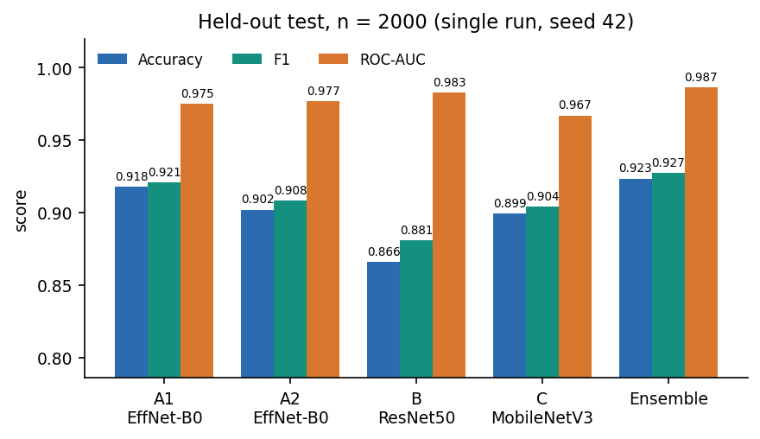
Figure 2: Accuracy, F1 and ROC-AUC of the four routes and the ensemble on the 2,000 held-out images (single run).

CHAPTER 5: SYSTEM DESIGN
This chapter turns the requirements of Chapter 4 into a design. It gives the architecture, the workflow of one analysis, the data flow diagrams, the UML models, the data model, the module design, the design of the core algorithm, the interface design and the reasons for the main decisions. Every diagram was drawn from the code in the repository (app/, scripts/ and frontend/) and not from a plan; all eleven are listed again, with explanations, in the block-diagram document.

5.1 Design Goals and Architecture
Five goals shaped the design. The first is an explanation with every verdict: a bare label is not credible in a dispute, so each answer carries per-route votes, Grad-CAM heat maps and a robustness check. The second is heterogeneity: four routes that differ in backbone, input size, loss and augmentation are combined, in the spirit of the heterogeneous ensemble and gating of HEDGE [2], so that one route's blind spot can be outvoted. The third is local operation: an uploaded image is decoded in memory, analysed on the machine and discarded, and no external service is called. The fourth is CPU-only operation: the models are small enough to answer in about two seconds on a desktop processor. The fifth is honest degradation: when a checkpoint is missing the API answers 503 and the Status page names the problem instead of guessing.
The architecture has four tiers. The presentation tier is a React single-page application served by Vite on port 5414; it has a landing page, a sign-in page and four workspace pages, and a client module, lib/api.js, that calls the API with fetch and keeps the bearer token. The application tier is a Flask service on port 8414; its routes are split between app/routes.py (classic HTML pages, health and the original JSON predict) and app/api.py (demo sign-in, configuration, insights and analyze). The inference tier is PyTorch: app/inference.py loads the four models once and runs them, app/ensemble.py fuses the logits, and app/explainability.py and app/robustness.py produce the Grad-CAM overlays and the degraded variants. The data tier is a set of local files: four checkpoints, one metadata file, the evaluation artifacts and the dataset folders.
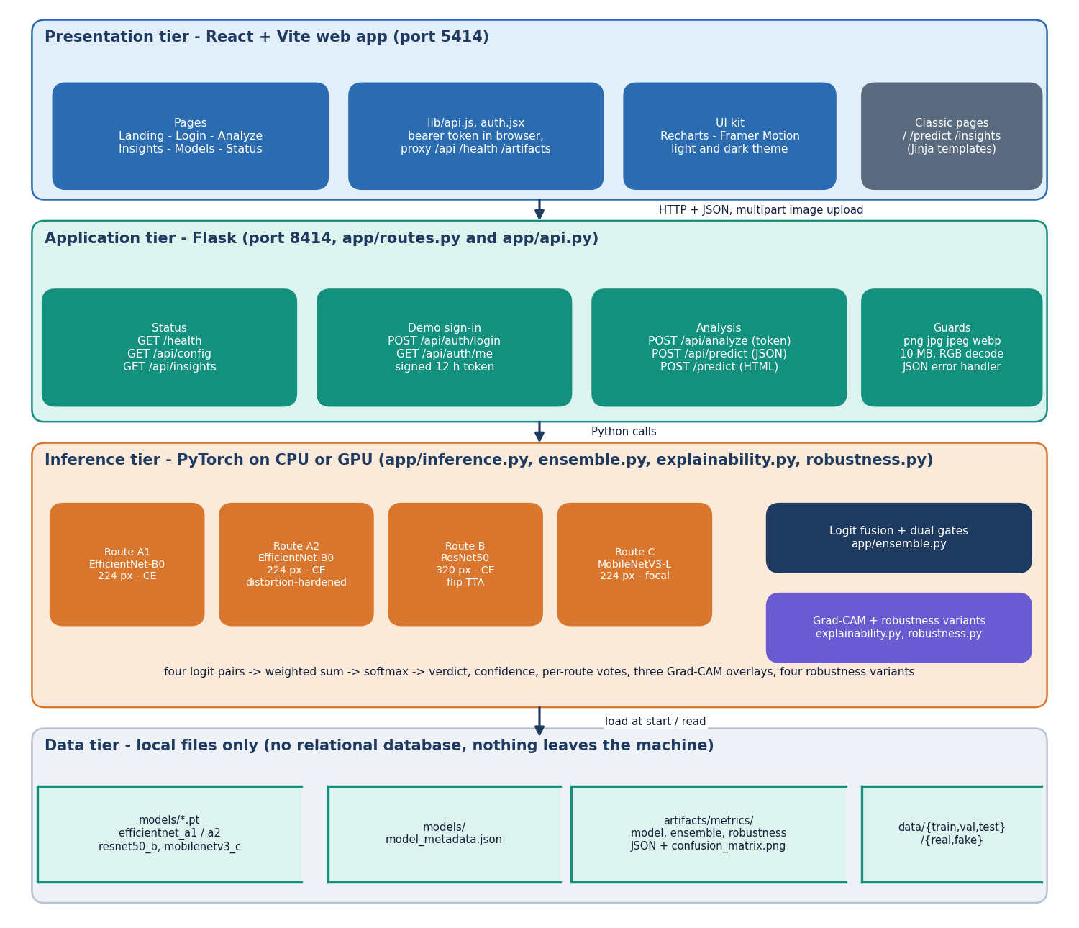
Figure 3: Four-tier architecture of VeriVision AI: React web app, Flask application, PyTorch inference and local file storage.
Table 12: Tiers, technologies and responsibilities
Tier | Technology | Responsibility
Presentation | React, React Router, Vite, Recharts, Framer Motion | Pages, upload form, verdict card, heat-map selector, charts, light and dark theme
Application | Flask 3.1 blueprints, itsdangerous signed tokens | Routes, upload guards, demo sign-in, JSON error handler (400, 401, 413, 500, 503)
Inference | PyTorch 2.14, torchvision, pytorch-grad-cam, OpenCV, Pillow | Preprocessing, four route models, logit fusion with gates, Grad-CAM, robustness variants
Data | Checkpoint .pt files, JSON, PNG, image folders | Model weights, model metadata, evaluation artifacts, train / validation / test images

The inference modules are plain Python files of functions, not a class hierarchy. Each stage takes data and returns a dictionary, so it can be tested on its own, replaced without touching the others, and the whole analysis can be returned as one JSON object. The UML diagram in Section 5.4 draws these modules as classes only to show their responsibilities. The classic server-rendered pages of the first version remain available on the API port as a fallback.

5.2 High-Level Workflow
The workflow of the system is the workflow of one POST /api/analyze request, and it has ten stages. The image is validated (extension, size, non-empty, decodable) and converted to RGB. It is resized for each route and normalised with ImageNet statistics. The four routes return a pair of logits each, Route B averaging the original and a horizontally flipped copy. The pairs are fused with the configured weights and two gates into a verdict, a probability pair and a confidence word. Grad-CAM overlays are produced for three routes on the predicted class. The image is then re-tested under JPEG compression, a half-size resample and a Gaussian blur, and the number of variants that keep the original verdict is reported. The result is returned as one JSON object and displayed as a verdict card with tabs.
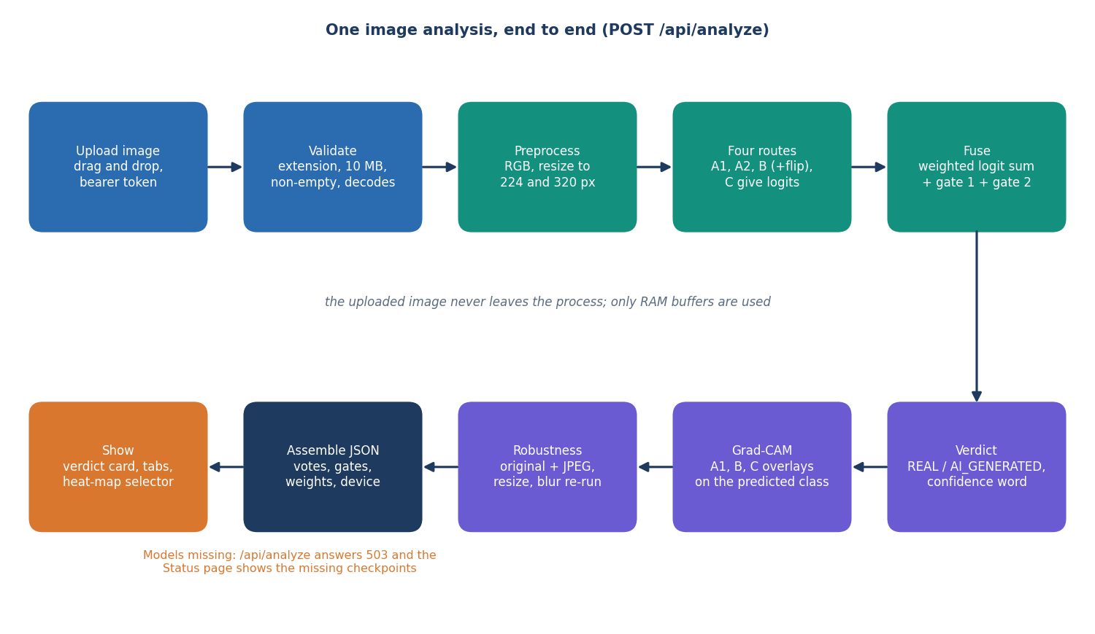
Figure 4: High-level workflow of VeriVision AI for one POST /api/analyze request.
There is one failure path that matters. If a checkpoint file is missing, ensure_models_loaded raises an error that lists the missing files, the analyze and predict endpoints answer 503, and /health reports status 'degraded' with the same message, which the Status page shows. If Grad-CAM fails for one route, that overlay is returned as null and the others are unaffected; if the robustness check fails, the consistency is reported as 'n/a'.
A second workflow runs offline and prepares the models. A dataset script builds class-balanced train, validation and test folders; each route is fine-tuned from ImageNet weights with its own augmentation, AdamW with cosine decay and early stopping on the validation F1; and an evaluation script measures every route and the ensemble and writes the JSON artifacts that the Insights page reads (diagram 11 of the block-diagram document).

5.3 Data Flow Diagrams

5.3.1 Level 0: context
At the context level VeriVision AI is one process with two actors and no external service. The user sends an image and the demo login and receives the verdict, the confidence, the per-route votes, the Grad-CAM overlays and the robustness result. The developer sends training and evaluation commands and receives checkpoints and metrics. The process reads and writes the model files and metric artifacts and, in training, reads the image folders.
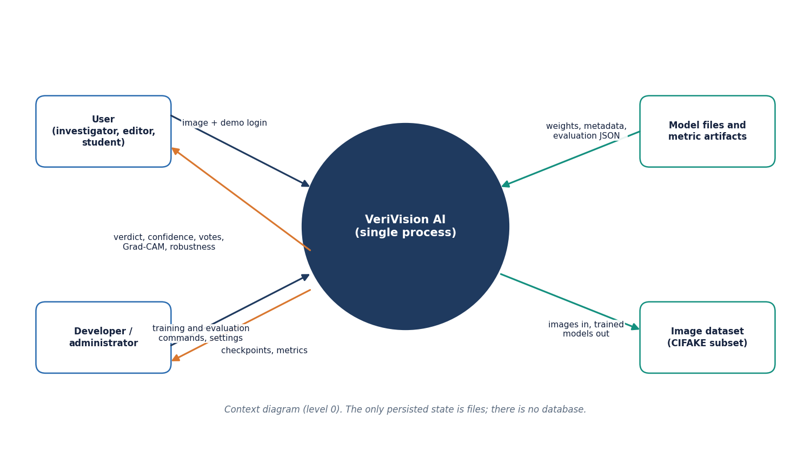
Figure 5: Context diagram (DFD level 0) of VeriVision AI with its two actors and two external stores.

5.3.2 Level 1: main processes
Level 1 divides the system into seven processes over three stores: D1, the model checkpoints; D2, the model metadata; and D3, the metric artifacts. Process 2.0 loads D1 and D2 once, on the first request.
Table 13: Level 1 processes and their data
No. | Process | Inputs | Outputs | Stores
1.0 | Validate and authenticate | Image, demo login, token | RGB image, 400 / 401 / 413 errors | -
2.0 | Preprocess and route logits | RGB image | Four logit pairs | D1, D2 (read)
3.0 | Fuse and gate | Logit pairs, weights, gate settings | Verdict, probabilities, confidence | -
4.0 | Explain (Grad-CAM) | Image, predicted class | Three heat-map overlays | D1 (read)
5.0 | Robustness re-check | Image | Verdicts on JPEG, resize, blur variants | D1 (read)
6.0 | Report insights | Stored metrics | Insights JSON, confusion matrix image | D3 (read)
7.0 | Train and evaluate | Developer commands, image folders | Checkpoints, metadata, metrics | D1, D2, D3 (write)

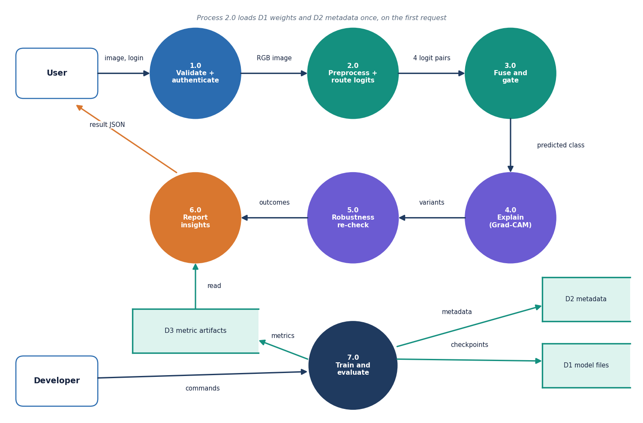
Figure 6: DFD level 1 of VeriVision AI: seven processes and three data stores.

5.3.3 Level 2: preprocessing, route logits and fusion
Level 2 expands processes 2.0 and 3.0 into the steps of app/inference.py and app/ensemble.py.
The sub-processes are: 2.1 decode and resize (preprocessing.decode_image, Resize in inference._transform_for); 2.2 normalise with the ImageNet mean and standard deviation; 2.3a to 2.3d the route logits of A1, A2, B (with the flipped copy) and C (inference.branch_logits, reading D1); 3.1 Gate 1 (ensemble.apply_gate1); 3.2 the weighted logit sum (ensemble.fuse_logits); 3.3 Gate 2 (ensemble.apply_gate2); and 3.4 the softmax and confidence wording (ensemble.softmax, inference.confidence_word).
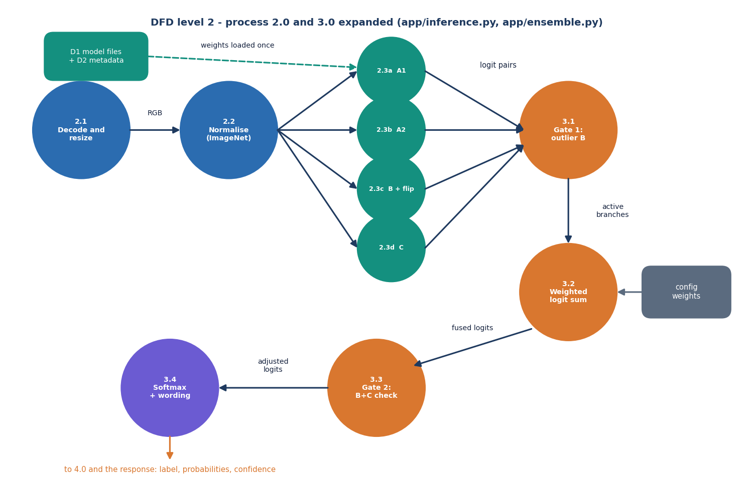
Figure 7: DFD level 2 of VeriVision AI: processes 2.0 and 3.0 expanded into eleven sub-processes.

5.4 UML Diagrams

5.4.1 Class diagram
FlaskApp, the application factory in app/__init__.py, registers two blueprints: Routes (app/routes.py) and Api (app/api.py). The Api blueprint reuses the analysis routine _run_analysis of Routes so that the classic page and the JSON endpoint return identical results. Both call Inference, which uses Preprocessing for validation and decoding, Models for the four architectures and their checkpoints, Ensemble for fusion and gating, Explainability for Grad-CAM and Robustness for the degraded variants. Config holds every tunable setting and can be overridden by environment variables. The training scripts reuse the model builders of Models. The modules are files of functions; they are drawn as classes to show responsibilities.
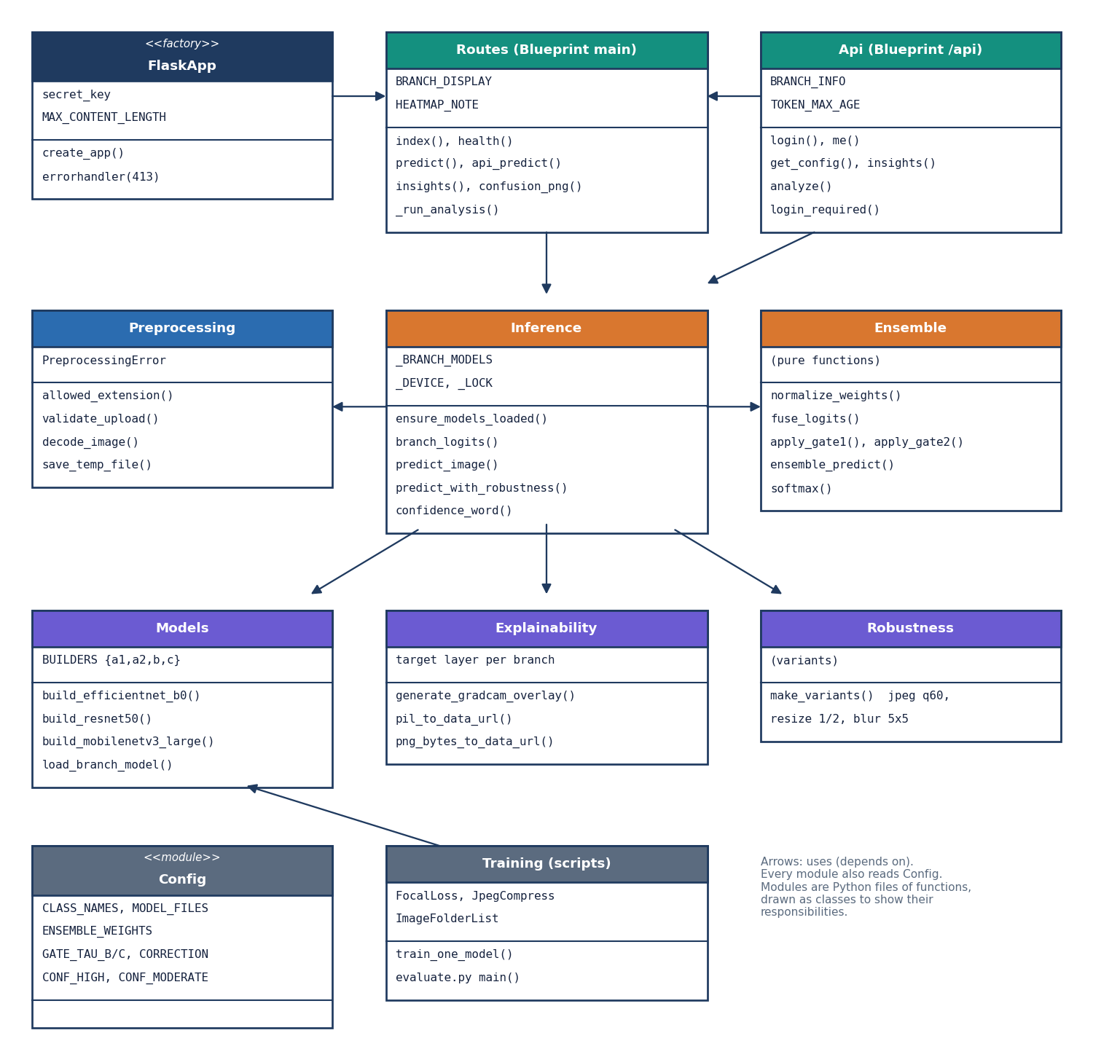
Figure 8: UML class diagram of VeriVision AI showing the application factory, the two blueprints and the service modules.

5.4.2 Sequence diagram
The sequence diagram follows one analysis. The browser posts the image with its bearer token; api.py verifies the token (401 if it is missing, forged or older than twelve hours), makes sure the models are loaded (503 if not), validates and decodes the upload (400 on failure) and calls predict_image. Inference runs the four forward passes and asks Ensemble for the fused result. api.py then asks Explainability for the three overlays and Inference for the robustness check, assembles one dictionary and returns it as JSON.
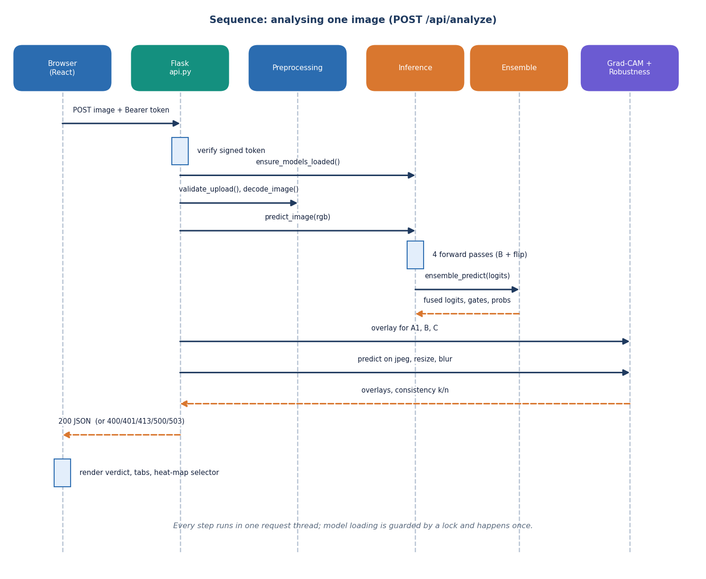
Figure 9: Sequence diagram of one image analysis, from the browser upload to the JSON response.

5.4.3 Use-case diagram
There are two actors. The user signs in with the demo account, uploads an image, reads the verdict and confidence, inspects the per-route votes, opens the Grad-CAM heat map and checks the robustness consistency; the user can also read the model insights and the system status. The developer reads the same insights and status pages and prepares data, trains and evaluates the models with the scripts. The verdict, votes, heat map and robustness all depend on an uploaded image.
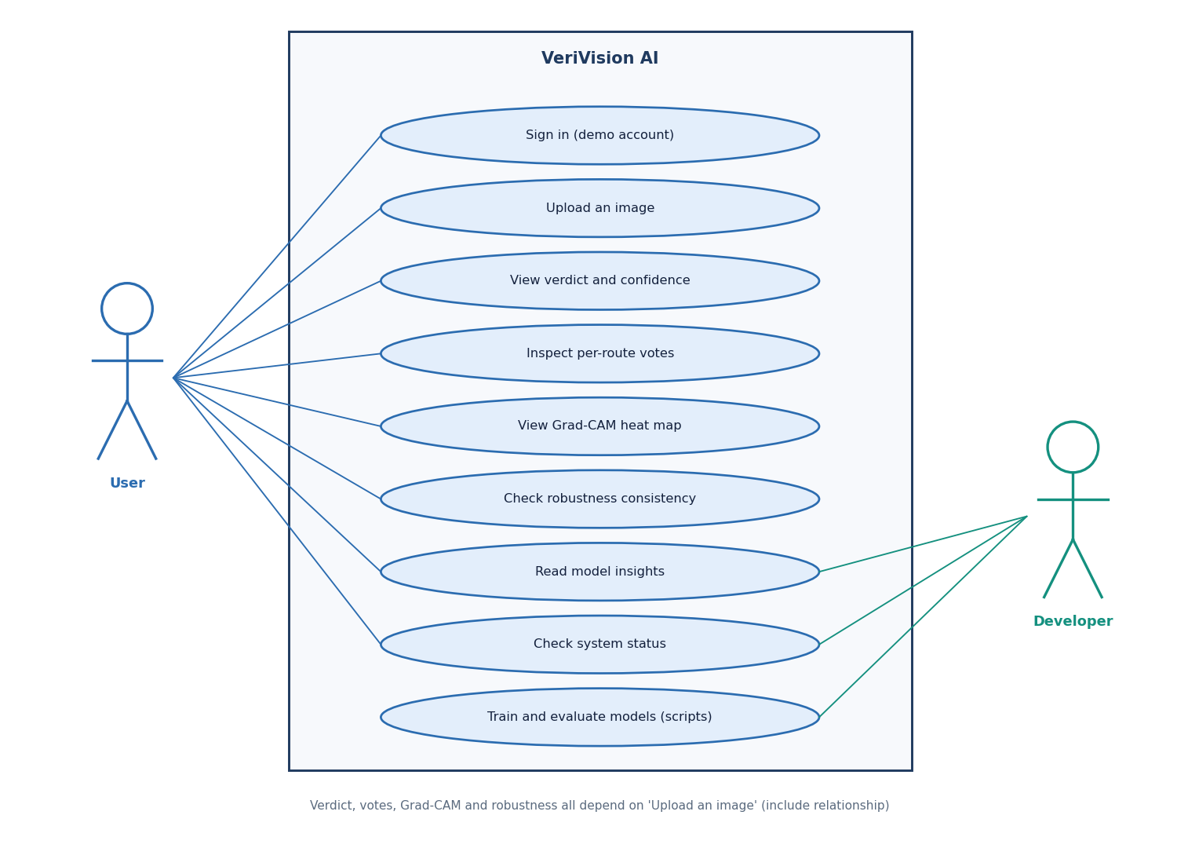
Figure 10: Use-case diagram of VeriVision AI with the user and the developer.

5.5 Data Model and Storage Design
VeriVision AI has no relational database. The system keeps no user accounts (one demo account is configured), no history of analyses and no uploaded images, so a database would add a dependency without adding a capability. Everything that persists is a file, and the entity-relationship diagram below shows those files and their relations. The two entities at the bottom, SessionToken and UploadBuffer, exist only inside a request and are never stored.
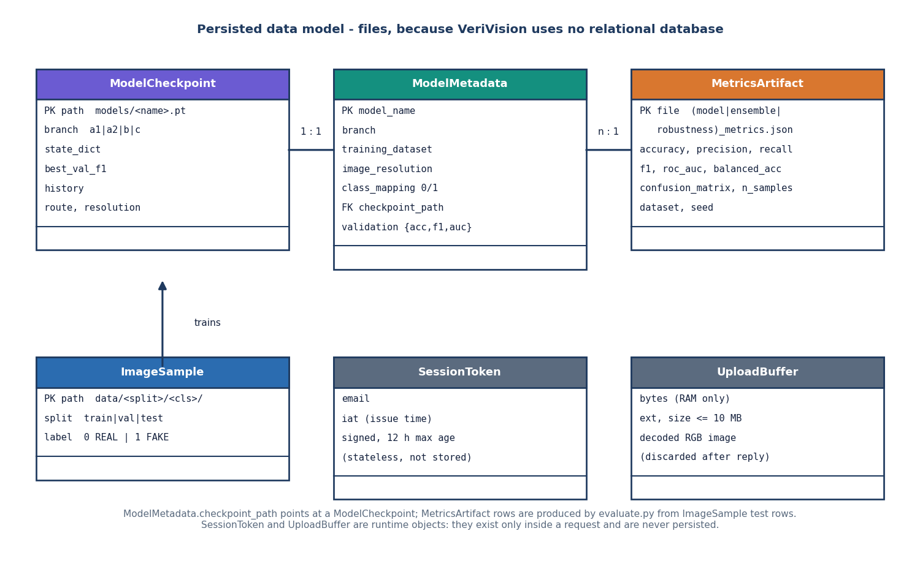
Figure 11: Persisted data model of VeriVision AI: model checkpoints, model metadata and metric artifacts, plus the runtime-only session token and upload buffer.
Table 14: Persisted and runtime data
Entity | Where | Content | Written by | Read by
ModelCheckpoint | models/*.pt | state_dict, best validation F1, training history, route, resolution | scripts/common.train_one_model | models.load_branch_model
ModelMetadata | models/model_metadata.json | model name, branch, training dataset, resolution, class mapping, checkpoint path, scores | scripts/evaluate.py or scripts/publish_cifake_models.py | GET /api/config
MetricsArtifact | artifacts/metrics/ | model, ensemble and robustness JSON; confusion_matrix.png | scripts/evaluate.py or scripts/publish_cifake_models.py | GET /api/insights, /artifacts/confusion_matrix.png
ImageSample | data/train|val|test/real|fake | PNG images; label 0 = REAL, 1 = AI_GENERATED from the folder name | scripts/prepare_*.py | scripts/common.collect_split
SessionToken | browser only | email and issue time, signed, 12 h maximum age | api.login | api.login_required
UploadBuffer | RAM | uploaded bytes and the decoded RGB image | preprocessing | inference, explainability

The class mapping 0 = REAL and 1 = AI_GENERATED is defined once, in app/config.py, and is used by training, inference, Grad-CAM and the interface. The scores stored in the metadata file and the metric files are written from the held-out test evaluation (by evaluate.py, or in this project by publish_cifake_models.py from experiments/cifake/metrics.json, in the same format), so the Insights and How-it-works pages read measured values and never typed ones.

5.6 Module Design
The back end has eleven modules, each with one responsibility. The table lists them with their main functions and line counts, which show that the whole serving code is small enough to be read in one sitting.
Table 15: Back-end modules (app/)
Module | Lines | Responsibility | Main functions
__init__.py | 29 | Application factory; JSON-aware 413 handler | create_app
config.py | 69 | All settings, environment overrides, class mapping, weights, gates | constants
preprocessing.py | 88 | Upload validation and decoding | validate_upload, decode_image, PreprocessingError
models.py | 83 | Architectures and checkpoint loading | build_efficientnet_b0, build_resnet50, build_mobilenetv3_large, load_branch_model
inference.py | 143 | Model cache, route logits, flip TTA, verdict, robustness check | ensure_models_loaded, branch_logits, predict_image, predict_with_robustness
ensemble.py | 129 | Logit fusion and the two gates | fuse_logits, apply_gate1, apply_gate2, ensemble_predict, softmax
explainability.py | 80 | Grad-CAM overlays and data-URL helpers | generate_gradcam_overlay, pil_to_data_url
robustness.py | 34 | JPEG, resize and blur variants | make_variants
routes.py | 197 | Classic pages, health, original JSON predict, shared analysis | health, predict, api_predict, insights, _run_analysis
api.py | 140 | Demo sign-in, config, insights, protected analyze | login, me, get_config, insights, analyze, login_required
run.py | - | Entry point, .env reader, model pre-load, server start | app.run on 127.0.0.1:8414

Around the serving code sit the scripts and the front end. The data scripts (prepare_dataset.py, prepare_cifake.py, prepare_xdomain.py) build the image folders; common.py and train_a1.py, train_a2.py, train_b.py and train_c.py hold the augmentation, the focal loss, the training loop with early stopping and the per-route freezing rules; evaluate.py, run_cifake_experiments.py and measure_latency.py produce the metrics, the ablations, the robustness and cross-domain results and the timings; smoke_test.py and two pytest files check the system. The front end has seven routes (landing, sign-in, four workspace pages and a fallback page) and a lib/ folder with the fetch client, the session, the analysis state and the theme.

5.7 Design of the Core Algorithm
The core algorithm is the fusion of the four route outputs. Each route returns a pair of raw logits. The weights are 0.35 for A1, 0.15 for A2, 0.25 for B and 0.25 for C; they are normalised at run time so that any positive set works. Two deterministic gates operate on the logits and never on probabilities. Gate 1 removes Route B when its margin |l_fake - l_real| is at least 2.5 and all three other routes point to the other class; the remaining weights are renormalised. Gate 2 acts after the weighted sum: when B and C agree on a class with margins of at least 2.5 and 2.5, and the fused direction is the opposite one, the fused logits are nudged toward the B and C class by 0.75, the winning logit rising by that amount and the other falling by half of it. A softmax then gives the probabilities; the larger is the confidence, shown as High at 0.85 or more, Moderate at 0.60 or more and Low below that.
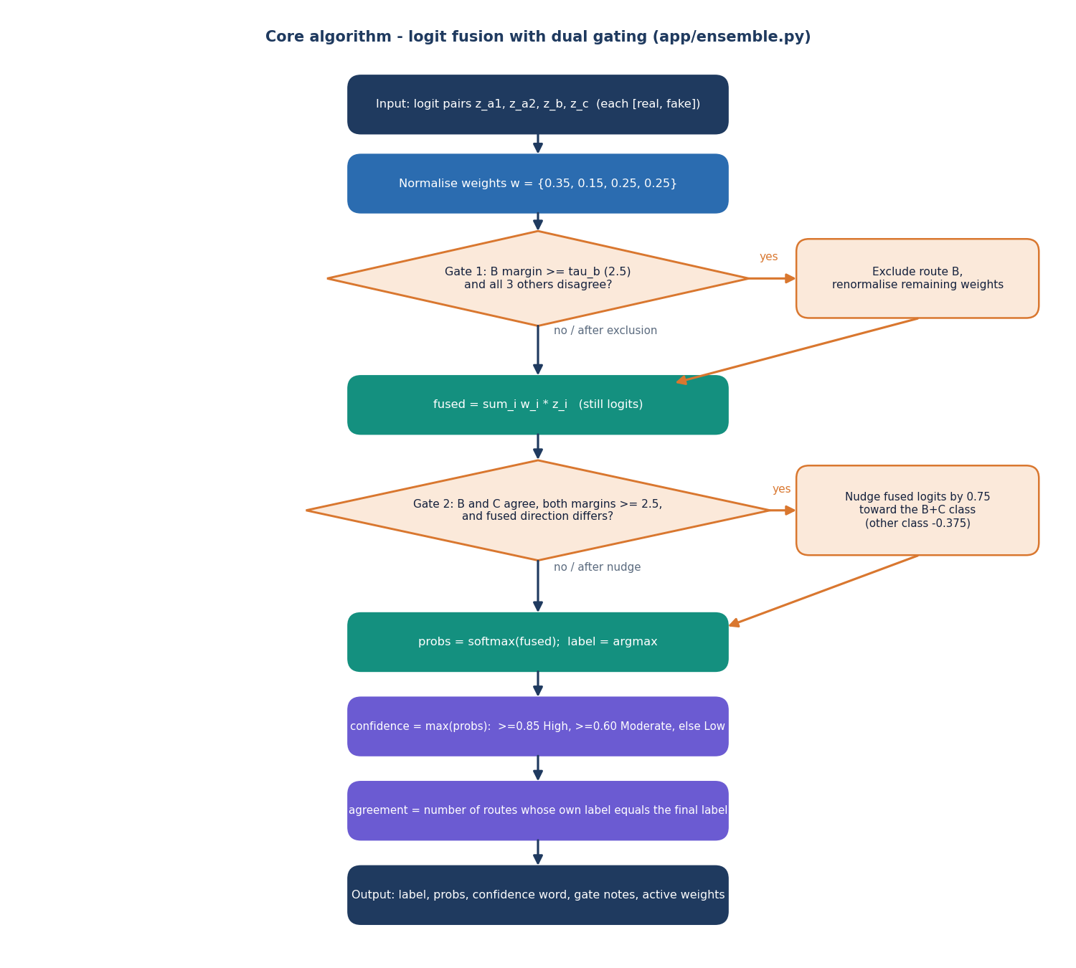
Figure 12: Flowchart of the logit fusion with the two gating rules implemented in app/ensemble.py.
The design deliberately keeps every step visible. The response carries the per-route labels and probabilities, the active weights after Gate 1, a sentence for each gate saying whether it fired and why, and the number of routes that agree with the final label, so that a reader can reconstruct the verdict by hand. The gate values are engineering defaults taken in the spirit of the dual gating in HEDGE [2], not values tuned for this project; Chapter 8 reports that on the held-out test set Gate 1 fired on 7 of 2,000 images and Gate 2 on none.
Explanation follows the same rule. Grad-CAM [26] is computed with the pytorch-grad-cam library [27] on the last convolutional block of the route (features[-1] for A1 and C, layer4[-1] for B), for the class the ensemble predicted, and is blended over the input image. It is offered for three of the four routes: A2 shares its architecture with A1 and was left out to keep the response small. The interface states that a heat map is an explanation aid and not proof of authenticity.

5.8 User Interface Design
The interface is a single-page React application with a fixed side navigation, a status chip showing whether the API is online and on which device it runs, a theme switch and a sign-out button. It was designed around the order of a user's questions: what is the answer, how sure is it, who voted, where did the models look, and how stable is the answer. The Analyze page therefore shows the verdict card first, then the branch votes next to the robustness check, then the Grad-CAM heat maps with one tab per route.
Table 16: Pages of the web application
Page | Route | Purpose | Data source
Landing | / | Introduction, headline measured numbers, how the system works | GET /api/insights, /api/config
Sign in | /login | Demo account sign-in with a button that fills the demo credentials | POST /api/auth/login, GET /api/config
Analyze image | /app | Upload, verdict, votes, Grad-CAM, robustness | POST /api/analyze
Model insights | /app/insights | Held-out metrics, confusion matrix, clean-versus-degraded chart | GET /api/insights
How it works | /app/models | The four routes: backbone, input size, loss, fusion weight, trained-on, validation F1 | GET /api/config
System status | /app/status | Live /health answer: API, models loaded, device; upload rules | GET /health, /api/config

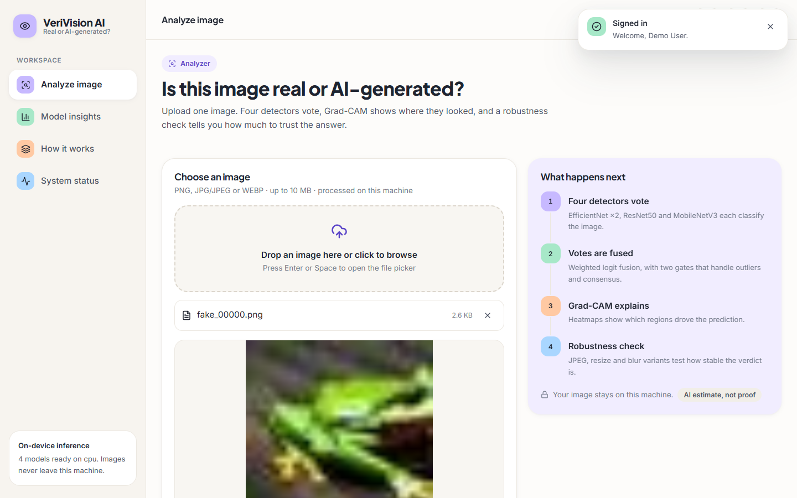  Figure 13: Analyze page with an image chosen and the four steps explained on the right. | 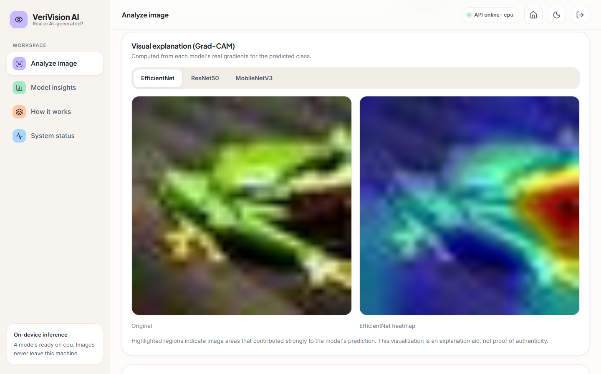  Figure 14: Grad-CAM tab: original image beside the EfficientNet heat map.

Several choices keep the interface honest. Every number on the Insights and How-it-works pages is read from the API and so from the evaluation files. The verdict is worded as 'Likely AI-generated' or 'Likely real', never as a certainty, and the confidence word is shown with the percentage. Errors from the API are shown as readable messages. Light and dark themes are both supported, and the upload area opens the file picker from the keyboard (Enter or Space).

5.9 Design Decisions and Their Reasons
Table 17: Principal design decisions
Decision | Alternative | Reason
Four small CNN routes, ImageNet-pretrained, upper blocks fine-tuned | One large foundation-model detector | Trainable on a CPU in minutes to under an hour per route; large backbones need GPUs (HEDGE used eight H800 cards)
Heterogeneous routes (backbone, size, loss, augmentation) | Four copies of one model | Different inductive biases make errors less correlated; Chapter 8 measures how much this helps
Fusion in logit space | Averaging probabilities, majority vote | Keeps the strength of each route's evidence; Chapter 8 compares all three on the same logits
Two deterministic gates | Learned meta-classifier | No extra training data needed and the rule can be read in the response; the gates did not improve results here
Robustness re-check in the response | Report only the verdict | Social-media compression removes cues; the user sees whether the verdict survives it
File-based storage, no database | A relational database | Nothing needs to be stored between requests; images are never kept
Flask API plus React front end, classic pages kept | Single server-rendered app | The React app gives the richer result view; the classic pages stay as a fallback and keep the original JSON contract

The design has known weaknesses that Chapters 7 and 8 make visible. The gates add complexity for no measured gain, the fusion weights were set by hand rather than fitted, the models see only a resized copy of the image and so cannot use full-resolution detail, and nothing in the design protects against an adversary who knows the models.

CHAPTER 6: METHODOLOGY AND SOFTWARE IMPLEMENTATION

6.1 Overall Methodology
The methodology has two halves: an offline half that builds the four detectors and measures them, and an online half that serves one image at a time. The offline half takes a class-balanced subset of a public benchmark, fine-tunes four ImageNet-pretrained CNNs with different augmentation, loss and resolution, and evaluates each route and the fused ensemble on a held-out test set, on degraded copies of it and on a probe set from other sources. The online half validates an upload, runs the four routes, fuses their logits, explains the verdict with Grad-CAM and re-tests the image under three degradations. The stages are:
1. Data preparation. A class-balanced CIFAKE subset is written to train, validation and test folders; a cross-domain probe set is prepared separately.
2. Preprocessing and augmentation. Each route has its own training augmentation and a common evaluation transform (resize and ImageNet normalisation).
3. Route training. Four routes are fine-tuned from ImageNet weights with AdamW, cosine decay and early stopping on the validation F1.
4. Evaluation. Per-route and ensemble metrics, fusion ablations, a threshold sweep, bootstrap intervals, calibration, robustness and cross-domain tests are computed from cached logits.
5. Deployment. The checkpoints, a metadata file and the metric artifacts are written where the Flask service reads them.
6. Inference and explanation. For each upload: four route logits, fusion with two gates, a verdict with a confidence word, three Grad-CAM overlays and a robustness consistency score.

6.2 Dataset
The data are drawn from CIFAKE [8], a benchmark of 60,000 real images taken from CIFAR-10 [9] and 60,000 synthetic images generated with Stable Diffusion v1.4 [10], all 32 x 32 pixels, with an official split of 100,000 training and 20,000 test images. The copy used here is the Hugging Face mirror dragonintelligence/CIFAKE-image-dataset (parquet, JPEG, mirror labels 0 = FAKE and 1 = REAL; the dataset card has no licence field, while the Kaggle original and other copies are tagged MIT). The labels are remapped to the product's convention, 0 = REAL and 1 = AI_GENERATED.
The full dataset was not used, because the models are trained on a CPU. A class-balanced subset was drawn with seed 42: 3,000 real and 3,000 generated images for training and 600 of each for validation, both from the official training split and without overlap, and 1,000 of each for testing, from the official test split only. The test set therefore never overlaps with training, but the training subset is only 6 % of the official training split and the test set is 10 % of the official test split, and every conclusion about accuracy carries that limit.
Table 18: Data splits used in this project
Set | Source | Real | AI-generated | Total | Used for
Train | CIFAKE official train split | 3,000 | 3,000 | 6,000 | Fine-tuning the four routes
Validation | CIFAKE official train split (no overlap) | 600 | 600 | 1,200 | Early stopping, best checkpoint
Test | CIFAKE official test split | 1,000 | 1,000 | 2,000 | All reported metrics, ablations, threshold sweep
Robustness subset | First 500 per class of the test set | 500 | 500 | 1,000 | JPEG, resize, blur and noise tests
Cross-domain probe | Hugging Face Parveshiiii/AI-vs-Real (MIT) | 300 | 300 | 600 | Transfer to other photographs and generators

The cross-domain probe uses 300 real photographs of about 640 pixels and 300 generated images of 1,024 x 1,024 pixels, re-saved as JPEG at quality 95. The dataset card does not name the generators, so the probe measures transfer to some unseen generator and content domain, not to a specific model. Before this run the shipped models had been trained on deterministic synthetic demo images (500 / 100 / 100 per class); that data was replaced and is kept only as a backup.
Figure 15: Class counts of the train, validation, test, robustness and cross-domain sets.

6.3 Preprocessing and Augmentation
At inference time every route uses the same transform: the image is converted to RGB, resized with bilinear interpolation to the route's square input size (224 x 224 for A1, A2 and C, 320 x 320 for B) without keeping the aspect ratio, converted to a tensor and normalised with the ImageNet mean (0.485, 0.456, 0.406) and standard deviation (0.229, 0.224, 0.225) [24]. CIFAKE images are 32 x 32, so they are enlarged by a factor of 7 or 10; the networks therefore see smooth, up-sampled pictures, which matters for the results in Chapter 8.
Training uses a different augmentation for each route, so that the routes learn different invariances. Route A1 uses the mildest, A2 the strongest, which imitates the degradations of social-media sharing, and B and C a moderate mixture.
Table 19: Training augmentation per route (scripts/common.py)
Route | Augmentation
A1 | Random resized crop (scale 0.8-1.0), horizontal flip, colour jitter (brightness 0.15, contrast 0.15, saturation 0.1)
A2 | Random resized crop (0.6-1.0), flip, rotation up to 12 degrees, colour jitter (0.3, 0.3, 0.2, hue 0.05), Gaussian blur (3 x 3, sigma 0.1-1.5), Gaussian noise (std 3-12, p 0.4), JPEG (quality 40-90, p 0.5), down-up resize (scale 0.4-0.8, p 0.4)
B and C | Random resized crop (0.75-1.0), flip, rotation up to 8 degrees, colour jitter (0.2, 0.2, 0.15), Gaussian blur (3 x 3, sigma 0.1-1.2), JPEG (quality 50-95, p 0.35)

6.4 Algorithm Choice and Justification
Convolutional networks with transfer learning. Generated images leave local statistical traces, and convolutional networks learn such traces directly from pixels. Fine-tuning ImageNet-pretrained backbones is the practical choice on a CPU: only the upper blocks are trained, which keeps training to minutes per route. The backbones are EfficientNet-B0 [19], ResNet50 [20] and MobileNetV3-Large [21]; they differ in design (compound-scaled mobile blocks, residual blocks, neural-architecture-searched blocks), which gives the ensemble different error patterns.
Heterogeneous ensemble with logit fusion and gates. The design follows HEDGE [2], which fuses three routes in logit space and adds two gating rules, but replaces its large foundation-model backbones (DINOv3 and MetaCLIP2, trained on eight H800 GPUs) with small CNNs. Fusing logits keeps the strength of each route's evidence, which a majority vote throws away and a probability average compresses. The gates are cheap deterministic rules that need no training data. Chapter 8 tests each of these choices on the same logits instead of assuming them.
Grad-CAM for explanation. Grad-CAM [26] produces a class-specific heat map for any CNN from the gradients of the output with respect to the last convolutional feature map, without retraining or changing the architecture. It was chosen because the project goal is an interpretable verdict and because the batch's own abstract names it. It is an explanation aid: a heat map shows where the gradient signal is strong, not a proof that those pixels are manufactured.
Relation to the base paper. The batch's base paper, CTrue [1], is a one-class face-deepfake detector that trains only on authentic faces plus synthesised pseudo-fakes, on an EfficientNet-B4 backbone with a hybrid-curvature representation. This project does not implement it. It addresses general images, trains a supervised binary classifier and adds an explanation and a deployed interface; the comparison in Chapter 8 states where the two differ.

6.5 Mathematical Formulation
Let z_k = (z_k,real, z_k,fake) be the raw logit pair of route k (A1, A2, B or C), w_k its weight (normalised to sum to 1), and d_k = argmax z_k its predicted direction (0 = REAL, 1 = AI_GENERATED). The margin of a route is the absolute difference of its two logits.
m_k = | z_k,fake - z_k,real | (1)
Gate 1 removes Route B when it is a confident outlier: B's margin reaches tau_B = 2.5 and every one of the other three routes points to the other class. The remaining weights are renormalised.
exclude B if m_B >= tau_B and d_k != d_B for each of A1, A2, C (2)
The fused logits are the weighted sum over the active routes, and Gate 2 then checks the consensus of B and C.
z_fused = sum_k w_k * z_k (over active routes) (3)
Gate 2 applies when B and C agree on a class c, both margins reach tau_B and tau_C = 2.5, and the fused direction is the other class. With delta = 0.75, the logit of class c is raised by delta and the other logit is lowered by delta / 2.
z_fused,c += delta ; z_fused,other -= delta / 2 if d_B = d_C != d_fused, m_B >= tau_B, m_C >= tau_C (4)
The probabilities and the verdict follow from a softmax. The confidence is the larger probability, reported as High when it is at least 0.85, Moderate when it is at least 0.6 and Low below that.
p_c = exp(z_c) / (exp(z_real) + exp(z_fake)) ; verdict = argmax p ; confidence = max p (5)
Route C is trained with the focal loss [22], which down-weights examples that are already classified well. With p_t the probability of the true class and gamma = 2:
FL(p_t) = (1 - p_t)^gamma * ( - log p_t ) (6)
Grad-CAM weights each feature map A^k of the target layer by the average gradient of the class score y^c and keeps only the positive evidence:
alpha_k^c = (1 / Z) * sum_i sum_j dy^c / dA^k_ij ; L^c = ReLU( sum_k alpha_k^c * A^k ) (7)
The evaluation uses accuracy, precision, recall, F1, balanced accuracy and the area under the ROC curve (AUC), computed with scikit-learn [29]. The expected calibration error (ECE) [25] bins the winning-class probability into 15 equal bins between 0.5 and 1 and averages the gap between accuracy and confidence, weighted by bin size. Accuracy intervals are 95 % percentile bootstrap intervals from 2,000 resamples of the test set [31].
ECE = sum_b ( n_b / n ) * | acc_b - conf_b | (8)

6.6 Model Architecture and Training
All four routes replace the ImageNet classifier by a two-class head. A1 and A2 use EfficientNet-B0 with dropout 0.3 and a linear layer; B uses ResNet50 with a linear layer; C uses MobileNetV3-Large with a 1,280-unit hidden layer, Hard-Swish and dropout 0.2. Only the upper blocks are fine-tuned and the rest stay frozen at their ImageNet values, which is why the trainable parameter counts are much smaller than the totals.
Table 20: Routes and training configuration
 | A1 | A2 | B | C
Backbone | EfficientNet-B0 | EfficientNet-B0 | ResNet50 | MobileNetV3-Large
Input size | 224 | 224 | 320 (+ flip TTA) | 224
Loss | Cross-entropy | Cross-entropy | Cross-entropy | Focal, gamma 2
Fine-tuned blocks | features 7-8, head | features 6-8, head | layer4, fc | features 15-16, head
Trainable / total parameters | 1,131,954 / 4,010,110 | 3,158,302 / 4,010,110 | 14,968,834 / 23,512,130 | 2,185,522 / 4,204,594
Learning rate / batch | 3e-4 / 32 | 3e-4 / 32 | 2e-4 / 16 | 3e-4 / 32
Planned epochs / seed | 5 / 42 | 5 / 43 | 3 / 44 | 5 / 45
Epochs run / best epoch | 5 / 5 | 5 / 5 | 3 / 2 | 5 / 5
Best validation accuracy / F1 | 0.9258 / 0.9270 | 0.8983 / 0.9047 | 0.8775 / 0.8902 | 0.9058 / 0.9110
Training time (CPU, upper bound) | about 24 min | about 22 min | about 53 min | about 13 min

All routes use AdamW [23] with weight decay 1e-4, a cosine-annealing learning-rate schedule over the planned epochs, and early stopping on the validation F1 with a patience of three epochs; the checkpoint with the best validation F1 is kept. Seeds are fixed for Python, NumPy and PyTorch. Training ran on the CPU of the development machine (Intel Core i5-12500, 6 cores / 12 threads, 15.7 GB of memory, no GPU) with PyTorch [28] 2.14.1. The times are wall-clock times from file timestamps on a PC that was shared with other jobs, so they are upper bounds. Route B, the most expensive, was planned for only 3 epochs; its best validation F1 came at epoch 2 and that checkpoint was kept.
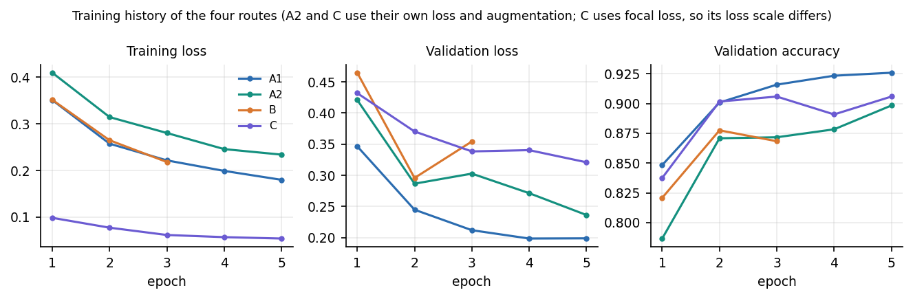
Figure 16: Training and validation curves of the four routes.

6.7 Evaluation Protocol
The evaluation was designed so that every reported number can be recomputed. The four routes are run once over each evaluation set and the raw logits are cached; every later analysis (the fusion variants, the threshold sweep, the intervals and the calibration) is computed from those cached logits, so that the variants differ only in the fusion rule and not in the model outputs. Route B is evaluated with the same horizontal-flip averaging that the application uses.
Table 21: Experiments run on the cached logits
Experiment | Data | What it answers
Clean evaluation | 2,000 test images | Accuracy, precision, recall, F1, balanced accuracy, AUC and confusion matrix of each route and of the deployed ensemble
Fusion ablation | Same logits | Do the weights and the two gates help? Variants: no gates, Gate 1 only, Gate 2 only, equal weights, probability averaging, majority vote
Threshold sweep | Same logits | How do precision, recall and F1 move as the decision threshold on the fused fake probability changes from 0.1 to 0.9?
Bootstrap intervals | Same logits | Is a difference in accuracy larger than sampling noise? 2,000 resamples, 95 % percentile interval
Calibration | Same logits | Do the confidence values match accuracy? Expected calibration error with 15 bins
Robustness | 1,000-image subset | Accuracy after JPEG quality 60, half-size resample, 5 x 5 Gaussian blur (sigma 1) and Gaussian noise (sigma 6)
Cross-domain probe | 600 images from another source | Do the models transfer to full-resolution photographs and other generators?
Failure analysis | Same logits | Which images are wrong, how large is their margin, which routes disagree?

The protocol has known weaknesses. The ensemble weights and gate values were fixed before the test set was scored, but the threshold sweep and the ablations are evaluated on the same test set, so any operating point chosen from them is optimistic. A single training run per route was made, so no run-to-run variance is available beyond the bootstrap interval. The robustness conditions are applied to 32-pixel images, where a half-size resample leaves a 16-pixel picture.

6.8 Application Architecture
The application is a Flask service [30] with two blueprints and a React front end. app/__init__.py builds the Flask object, registers the blueprints and installs a JSON-aware handler for requests that exceed the upload limit. run.py reads an optional .env file (real environment variables win), tries to load the four models at start so the first request is fast, and starts the server on 127.0.0.1:8414; if the checkpoints are missing it still starts and reports the problem on /health.
Models are loaded lazily and once. inference.ensure_models_loaded checks that all four checkpoint files exist, builds each architecture, loads its weights, puts it in evaluation mode and stores it in a module-level dictionary under a lock, so concurrent first requests load only once. The device is CUDA when available and the CPU otherwise. Settings (ports, upload limit, file locations, weights, gate values, confidence thresholds, seed and demo credentials) live in app/config.py and can be overridden by VERIVISION_* environment variables.
The React application is built with Vite and served on port 5414. Its dev server proxies /api, /health and /artifacts to the Flask service, so the browser talks to a single origin and no cross-origin configuration is needed. The bearer token returned by the sign-in is kept in the browser's local storage and attached by a small fetch client; a 401 answer clears it and returns the user to the sign-in page. A Dockerfile and a compose file run the same two services with both ports published on 127.0.0.1 only.

6.9 Explanation and Robustness Modules
app/explainability.py wraps the pytorch-grad-cam library [27]. For a route and a predicted class it builds a GradCAM object on the route's target layer, computes the map for the one input image, blends it over the resized original with the library's overlay function and returns the overlay as a PNG data URL. The target layer is the last block of the feature extractor: features[-1] for the two EfficientNet routes and MobileNetV3, and layer4[-1] for ResNet50. The class used is the ensemble's predicted class, so the map explains the answer that was given; the hooks are released after each call. The overlays are produced for routes A1, B and C.
app/robustness.py produces three variants of the uploaded image in addition to the original: JPEG compression at quality 60, a bilinear half-size down-sampling followed by up-sampling to the original size, and a Gaussian blur with a 5 x 5 kernel and sigma 1.0. inference.predict_with_robustness runs the complete prediction on each variant, including the fusion, and reports the verdict of each plus a consistency string, the number of variants that agree with the original verdict over the number of valid variants (for example 3/4). The check is a stability indicator for the user; a low consistency means the verdict depends on fine detail that ordinary re-saving removes.
Table 22: Configuration variables (app/config.py)
Variable | Default | Meaning
VERIVISION_HOST, VERIVISION_PORT | 127.0.0.1, 8414 | Address and port of the Flask service
VERIVISION_MAX_UPLOAD_MB | 10 | Upload size limit
VERIVISION_MODEL_A1, _A2, _B, _C | models/*.pt | Checkpoint file of each route
VERIVISION_W_A1, _A2, _B, _C | 0.35, 0.15, 0.25, 0.25 | Fusion weights (normalised at run time)
VERIVISION_GATE_TAU_B, _TAU_C, _CORRECTION | 2.5, 2.5, 0.75 | Gate thresholds and correction size
VERIVISION_SEED | 42 | Random seed for data preparation and training
VERIVISION_SECRET_KEY | development string | Signing key of the session token
VERIVISION_DEMO_EMAIL, _PASSWORD, _NAME | demo account | Credentials of the demo sign-in

6.10 API Design
The API has nine endpoints, listed below. The three analysis endpoints take the image as a multipart form field named image. All errors on /api paths are JSON objects with an error message.
Table 23: Endpoints of the VeriVision AI API
Method and path | Token | Request | Success response | Errors
GET /health | no | - | status, models_loaded, device, error | 503 when models are missing
GET /api/config | no | - | max_mb, extensions, weights, routes, gates, confidence thresholds, model metadata, demo account | -
GET /api/insights | no | - | available, ensemble, models, robustness, confusion_exists | -
GET /artifacts/confusion_matrix.png | no | - | PNG image | 404 JSON if absent
POST /api/auth/login | no | JSON email, password | token, user | 401
GET /api/auth/me | yes | Authorization: Bearer | user | 401
POST /api/analyze | yes | multipart image | verdict, votes, Grad-CAM, robustness (below) | 400, 401, 413, 500, 503
POST /api/predict | no | multipart image | label, probabilities, confidence, confidence word, route labels, agreement | 400, 500, 503
GET /, POST /predict, GET /insights | no | form upload | Classic server-rendered pages | error page: 400, 413, 500, 503

The /api/analyze response is a single JSON object: filename; the original image as a data URL; predicted_label, confidence, confidence_pct, confidence_word, prob_real and prob_fake; a branches list with key, name, label and the two probabilities of each route; cams with the Grad-CAM overlay of routes a1, b and c as data URLs (null for a route whose overlay failed); agreement_count; excluded_branch, gate1_reason, gate2_applied, gate2_reason and active_weights; robustness with the outcome of each variant and a consistency string such as 3/4; the device; and a note stating that the heat map is an explanation aid and not proof. /api/predict returns only the verdict fields and needs no token, which keeps the original JSON contract of the first version.

6.11 Security and Error Handling
The system is designed for local use and its security is proportionate to that. Access to /api/analyze needs a bearer token. The token is created with itsdangerous' URLSafeTimedSerializer, which signs the e-mail and issue time with the application secret and a fixed salt; it is valid for 12 hours and is rejected if it is missing, altered or expired. Sign-in compares the e-mail and the password with hmac.compare_digest, which takes the same time whatever the input, and gives the same message for a wrong e-mail and a wrong password. The credentials come from configuration (a demo account) and are not stored in a database.
Uploads are validated before any decoding. The file must be present and have an allowed extension (png, jpg, jpeg or webp), must not be empty and must not exceed 10 MB (enforced twice: by Flask's MAX_CONTENT_LENGTH, which answers 413, and by a size check). The bytes are then opened with Pillow and verified; a file that does not decode is refused, and so is an image smaller than 8 x 8 pixels. The image is held in memory only and is never written to disk by the API path, and the analysis is returned to the caller and not stored.
Table 24: Error handling
Situation | HTTP status | Message shown to the user
Missing, forged or expired token | 401 | Please sign in to analyze images.
Wrong e-mail or password | 401 | Email or password is not correct.
No file, wrong extension, empty file, undecodable or tiny image | 400 | A specific sentence for each case (for example 'Unsupported file type')
Upload larger than the limit | 413 | Image exceeds the 10 MB size limit.
Checkpoint file missing | 503 | Lists the missing files and points to the training workflow
Unexpected inference or loading error | 500 | Generic message; the traceback goes to the server log only

Known limits of the security design are stated plainly. The demo account and its password are returned by /api/config so that the sign-in page can fill them; the default signing secret is a fixed development string unless VERIVISION_SECRET_KEY is set; /api/predict is open; there is no rate limiting, no HTTPS and no account management. The service binds to 127.0.0.1 by default, and the Docker files publish the ports on 127.0.0.1 only, so these limits are acceptable for a local demonstration but not for a public deployment.

6.12 Installation and Execution
The system runs on Windows 10 or 11 with Python 3.10 or newer (3.11 was used) and, for the web application, Node.js 20 or newer. No GPU is needed. The dependencies are pinned in requirements.txt (Flask 3.1.3, torch 2.14.1, torchvision 0.29.1, Pillow 13.0.0, numpy 2.4.6, scikit-learn 1.9.1, opencv-python-headless 5.0.0.93, grad-cam 1.5.7, pytest 9.1.1 and others); about 3 GB of disk space is needed for the packages and model files. There are three ways to run it.
1. Automatic. Double-click run.bat. It checks Python, creates .venv, installs the requirements, trains the models if no checkpoint exists, copies .env.example to .env, installs the web packages once, starts the API on port 8414 and the web application on port 5414 in two windows and opens the browser. The demo login is demo@verivision.ai / Demo@1234.
2. Manual. Create a virtual environment, install requirements.txt, prepare the data, run scripts/train_a1.py, train_a2.py, train_b.py and train_c.py, run scripts/evaluate.py, then python run.py; in a second terminal run npm install and npm run dev inside frontend/.
3. Docker. docker compose up --build starts the API and the web application with ports 8414 and 5414 published on 127.0.0.1; the models and artifacts folders are mounted into the container.
For this project's measured results the four routes were trained with scripts/prepare_cifake.py followed by the four training scripts with --epochs 5, 5, 5 and 3 and --data-root data/cifake, evaluated with scripts/run_cifake_experiments.py and installed with scripts/publish_cifake_models.py, which writes the checkpoints, the metadata and the metric files in the format the Insights page reads. Appendix B gives the full user guide.

CHAPTER 7: SYSTEM TESTING
This chapter describes how VeriVision AI was tested, what each test really asserts, and what the testing does not cover. Model quality (accuracy, robustness, transfer) is measured on held-out data and is reported in Chapter 8; this chapter is about whether the software around the models behaves correctly.

7.1 Testing Strategy
Three layers of automated testing were used. The first is a pytest suite of 19 tests (19 passed in 35 s on the development PC) that checks the pure logic (upload validation, weight normalisation, logit fusion and the two gates) and the Flask routes through the test client. The second is an end-to-end smoke script, scripts/smoke_test.py, that runs against the live API and the Vite proxy with the real trained models and passed 29 of 29 checks. The third is a browser walk-through, scripts/capture_screens.py, which drives every screen in Chrome with real data and records the console and network errors; it finished with none. A small script, scripts/edge_cases.py, was added for this report to exercise unusual uploads and the security checks against the real models.
A test passes when the observed status code, response fields or numerical result equal the expected ones; there are no tolerance bands except for floating-point comparisons. The pytest suite does not need trained models: the one test that runs the full prediction path builds the four architectures with random weights, so it checks the structure of the response and not the quality of the verdict.
Table 25: Testing environment
Item | Value
Machine | Intel Core i5-12500 (6 cores / 12 threads), 15.7 GB memory, no GPU, Windows 11
Software | Python 3.11.9, PyTorch 2.14.1 (CPU), torchvision 0.29.1, Flask 3.1.3, pytest 9.1.1, Node 24 for the front end
Models under test | The four CIFAKE-trained checkpoints installed in models/
Servers (smoke test) | API on 127.0.0.1:8414, Vite proxy on 5414

7.2 Unit Testing
tests/test_verivision.py holds nine unit tests of the logic and two route tests. Each test builds its own inputs, so the gates and the fusion are tested with hand-chosen logits whose correct outcome can be worked out on paper.
Table 26: Unit tests of the application logic
ID | Test | What it asserts | Result
U1 | preprocessing: valid image | A 64 x 64 PNG decodes to an RGB image of the same size; 'photo.JPG' has an allowed extension | Pass
U2 | preprocessing: unsupported and corrupt | 'notes.txt' and a name without extension are not allowed; validate_upload and decode_image raise PreprocessingError for a .txt upload and for bytes that are not an image | Pass
U3 | weight normalisation | The default weights sum to 1; the weights 7 and 3 become 0.7 and 0.3 | Pass
U4 | logit fusion uses the weights | Equal logits stay unchanged under equal weights; with weights 0.75 / 0.25 the fused value is 3.0 | Pass
U5 | Gate 1 excludes an outlier | B at (0, 5) against three routes pointing REAL: B is excluded and removed from the active weights | Pass
U6 | Gate 1 keeps an agreeing B | When all four routes agree, nothing is excluded and all four weights stay | Pass
U7 | Gate 2 corrects | Fused logits (4, 0) pointing REAL while B and C strongly say fake: the correction is applied and the fake logit rises | Pass
U8 | Gate 2 without consensus | When C disagrees with B, the logits are returned unchanged and applied is false | Pass
U9 | response structure | With random-weight fixture checkpoints the full prediction returns a valid label, probabilities in [0, 1] that sum to 1, and a label for each of the four routes | Pass
U10 | health route | GET /health returns 200 or 503 and a status field | Pass
U11 | classic predict route, bad file | POST /predict with a .txt upload returns 400 (or 503 if models are missing) | Pass

7.3 Integration Testing
tests/test_api.py tests the JSON API that the React application uses, through the Flask test client, so the blueprints, the token handling, the upload guards and the error handler are exercised together.
Table 27: Integration tests of the JSON API
ID | Test | What it asserts | Result
I1 | wrong password | POST /api/auth/login with a wrong password returns 401 and an error message | Pass
I2 | missing body | Login with no JSON body returns 401 | Pass
I3 | login and /auth/me | The demo login returns a token; /auth/me with it returns the demo e-mail; without a token or with 'Bearer garbage' it returns 401 | Pass
I4 | config describes the ensemble | /api/config lists the routes a1, a2, b, c in order, the upload limit and the three gate settings | Pass
I5 | insights shape | /api/insights has available and confusion_exists; when available, accuracy lies in [0, 1] | Pass
I6 | analyze requires login | POST /api/analyze without a token returns 401 | Pass
I7 | bad upload | A .txt upload with a valid token returns 400 (or 503) with a JSON error | Pass
I8 | oversize upload | A body of 10 MB + 1 KB returns 413 with a JSON message that mentions MB | Pass

The integration of the front end with the API was tested by the smoke script, which also requests /health and /api/config through the Vite proxy on port 5414 and checks that the application shell is served.

7.4 Functional Testing
The smoke test covers the main user flow with the real models and the real front-end proxy. Its 29 checks fall into six groups, and all 29 passed.
Table 28: Groups of the smoke test (scripts/smoke_test.py)
Group | Checks | Examples of what is verified
Health and public JSON | 5 | Models loaded; four routes and upload limits in /api/config; demo account exposed; insights contain ensemble, model and robustness metrics; confusion matrix served
Authentication | 4 | Wrong password gives 401; demo login returns a token; the token resolves to the demo user; analyze without a token gives 401
Main flow, run for one AI-generated and one real test image | 12 | Status 200; verdict and probabilities consistent (sum to 1); four votes with active weights summing to 1; Grad-CAM overlays for a1, b and c; robustness outcomes for original, jpeg, resize and blur with a consistency string; original image echoed back
Validation errors | 3 | Unsupported type gives 400 'Unsupported'; corrupt PNG gives 400 'decoded'; no file gives 400
Original surface | 3 | /api/predict keeps its JSON contract; classic pages / and /insights render; classic /predict still shows its error page
Front end and proxy | 2 | The shell with the root element is served; /health and /api/config work through the proxy

These are functional tests of behaviour, not of accuracy: the smoke test confirms that a verdict is produced and is well-formed, not that it is correct. The two test images are the first fake and the first real file of the test folder.

7.5 Security Testing
The security checks that exist are the ones in the pytest and smoke suites plus those added in scripts/edge_cases.py. They confirm that analysis cannot be reached without a valid token, that a token with an altered signature is refused, that a wrong password is refused (the code gives the same message for a wrong e-mail, which no test separately checks), that unsupported extensions, empty and undecodable files and over-size bodies are refused before inference, and that errors are returned as JSON without a stack trace. No penetration test, fuzzing, dependency audit or test of the default secret key was done, and the demo account and its password are deliberately exposed by /api/config (Section 6.11).

7.6 Validation and Edge Cases
Unusual uploads were sent to POST /api/analyze with the demo token and the real models through the Flask test client. The table gives the HTTP status and what the application answered.
Table 29: Edge-case uploads to /api/analyze
Case | Status | Result
32 px CIFAKE test image (PNG) | 200 | Analysed: REAL (97.2 %), robustness 4/4, Grad-CAM ok
Grayscale PNG 64 x 64 | 200 | Analysed: REAL (100.0 %), robustness 1/4, Grad-CAM ok
RGBA PNG 64 x 64 with alpha channel | 200 | Analysed: AI_GENERATED (100.0 %), robustness 4/4, Grad-CAM ok
WebP 64 x 64 | 200 | Analysed: AI_GENERATED (100.0 %), robustness 3/4, Grad-CAM ok
Smallest accepted size, 8 x 8 PNG | 200 | Analysed: REAL (91.1 %), robustness 3/4, Grad-CAM ok
7 x 7 PNG (below the minimum) | 400 | The image is too small to analyze. Please upload a larger image.
Large JPEG 2,000 x 1,500 | 200 | Analysed: REAL (100.0 %), robustness 4/4, Grad-CAM ok
Upper-case extension .PNG | 200 | Analysed: REAL (97.2 %), robustness 4/4, Grad-CAM ok
PNG bytes with a .jpg extension | 200 | Analysed: REAL (97.2 %), robustness 4/4, Grad-CAM ok
Truncated JPEG (first half of the bytes) | 400 | This file could not be decoded as an image. It may be corrupted or unsupported.
Text file named .png | 400 | This file could not be decoded as an image. It may be corrupted or unsupported.
Empty file | 400 | The uploaded file is empty. Please try a different image.
GIF image (extension not allowed) | 400 | Unsupported file type. Please upload a PNG, JPG/JPEG or WEBP image.
Path-like file name ../../x.png | 200 | Analysed: REAL (97.2 %), robustness 4/4, Grad-CAM ok
Upload of 10 MB + 1 KB | 413 | Image exceeds the 10 MB size limit. Please upload a smaller file.
No token | 401 | refused
Token with altered signature | 401 | refused

The same image sent twice returned an identical fused probability (0.028294 and 0.028294), so the analysis is deterministic. Grayscale, transparent and WebP images are converted to RGB before inference, and the file type is decided by the content of the file and by the extension together: the extension must be on the allowed list, but the bytes are decoded by their real format. The images in the table that are random noise (grayscale, RGBA, WebP and 8 x 8) have no real-world origin, so their verdicts mean nothing; they are included because they show the robustness check at work. The grayscale noise image was called REAL with 100.0 % confidence but kept that verdict in only one of the four variants (consistency 1/4), which is the situation the check is meant to expose: a high confidence does not mean a stable answer.

7.7 Performance Testing
Response times were measured against the running API on 127.0.0.1 with scripts/measure_latency.py, eight runs per endpoint, on an otherwise idle machine after the models had loaded. (The address 127.0.0.1 is used because on this PC the name localhost adds about two seconds through an IPv6 fall-back.)
Table 30: Response times of the API (median of 8 runs; minimum to maximum)
Endpoint and input | Median | Minimum | Maximum
GET /health | 16 ms | 2 ms | 27 ms
GET /api/insights | 5 ms | 3 ms | 17 ms
POST /api/predict, 32 x 32 image (four routes and fusion) | 0.25 s | 0.23 s | 0.29 s
POST /api/predict, 1,024 x 1,024 image | 0.28 s | 0.26 s | 0.32 s
POST /api/analyze, 32 x 32 image (adds Grad-CAM and robustness) | 1.70 s | 1.66 s | 1.82 s
POST /api/analyze, 1,024 x 1,024 image | 1.98 s | 1.93 s | 2.02 s

The full analysis takes about two seconds on this CPU, of which the four-route prediction is about a quarter of a second; the rest is the three Grad-CAM overlays and the three re-runs of the prediction for the robustness check. Image size matters little because every image is resized to 224 or 320 pixels first. In the offline evaluation, batched inference of all four routes took 283 ms per image. Model loading happens once at start and was not timed. The earlier README estimate of 10 to 60 s per image was pessimistic for this machine.

7.8 User Acceptance Testing
No user study was carried out: no participant outside the project team used the application, and no usability score, task-completion time or satisfaction rating was collected. What was done is a walk-through by the team of every screen with real data (the 19 screenshots in Chapter 8 and Appendix C were captured this way), checking that the pages load, the demo login works, an upload produces a result, the heat-map tabs switch, and the page works in the light and the dark theme. This shows that the flow is complete, not that users understand or trust the verdict.

7.9 Summary of Results and Findings
Table 31: Summary of the test runs
Suite | Run | Passed | Notes
pytest (tests/test_verivision.py, tests/test_api.py) | 19 | 19 | 35 s; 11 + 8 tests; random-weight fixtures for the prediction path
Smoke test (scripts/smoke_test.py) | 29 | 29 | Live API, real models, Vite proxy
Edge-case script (scripts/edge_cases.py) | 18 | 18 | 14 upload cases, the oversize body, 2 token cases and the determinism check; every case behaved as the code specifies
Browser walk-through (scripts/capture_screens.py) | all screens | all screens | No console errors and no failed requests

Four findings come from the testing rather than from the pass counts. First, the pytest suite passes with untrained weights, so it protects the plumbing and would not notice a model that is wrong; the earlier shipped models, trained on synthetic data, also passed every test while scoring a meaningless 100 %, which is why Chapter 8 relies on a held-out evaluation. Second, the gate unit tests use hand-made logits that make a gate fire, and they prove that the rules are coded as specified; on the 2,000 real test images Gate 1 fired seven times and Gate 2 never, so the rules that the tests exercise are almost never exercised in use. Third, confidence is not stability (Section 7.6). Fourth, the full analysis is cheap enough on a CPU (about two seconds) that no queue or background job was needed.
Table 32: Objectives and the tests that cover them
Objective (batch document 6) | Covered by | Status
2. Preprocess and augment images | U1, U2 (validation and decoding); augmentation is exercised by training, not by unit tests | Partly tested
3. Train a CNN classifier | Held-out evaluation (Chapter 8); pytest only checks the response structure | Measured, not unit-tested
4. Evaluate cross-generator performance | Cross-domain probe (Chapter 8); no software test | Measured; not achieved
5. Apply Grad-CAM | Smoke test: overlays for a1, b and c present; edge cases: overlays for every analysed image | Output tested, faithfulness not
6. Deploy an interface returning verdict, confidence and explanation | I1-I8, smoke test main flow, browser walk-through | Tested

7.10 Limits of the Testing Done
• The model tests in pytest use random weights; verdict correctness is tested only by the held-out evaluation of Chapter 8, not by unit tests.
• There are no unit tests of app/explainability.py and app/robustness.py; they are covered only by the smoke test and the edge cases, which check that overlays and variants are produced, not that a heat map is faithful.
• No load or concurrency test was run; the service was exercised by one client at a time, and model loading uses a lock but this was not stress-tested.
• No test on a GPU, on Linux or macOS, or inside the Docker containers was recorded.
• No adversarial test was made: nothing shows how the models behave against images edited to fool them.
• The smoke test uses two images, and the edge-case set is small; they show that the paths work, not that every file in the wild is handled.
• No user study was carried out (Section 7.8).

CHAPTER 8: RESULTS AND OUTPUT SCREENS
This chapter reports what the system actually does. It starts with the experimental set-up and the output screens of the running application, then gives the model results on the held-out test set, the fusion and threshold analysis, robustness to degradation, the cross-domain probe, the Grad-CAM explanations, the comparison with the base paper, sample inputs and outputs, success and failure cases, limitations, and the objectives measured against outcomes. Several results are negative, and they are reported as findings.

8.1 Experimental Set-up
Every measurement in this chapter was made on one machine: an Intel Core i5-12500 (6 cores, 12 threads) with 15.7 GB of memory, no GPU, Windows 11, Python 3.11.9, PyTorch 2.14.1 (CPU build), torchvision 0.29.1, Flask 3.1.3 and scikit-learn 1.9.1. The screens of Section 8.2 were captured from the running application at 1440 x 900 pixels after the four routes had been retrained on real data. The models that the repository originally shipped had been trained on synthetic demo images and scored 100% on every metric, which says nothing about real images; they are kept only in models/demo_backup/ and none of their numbers is used below.
Table 33: Evaluation set-up used for every result in this chapter
Item | Setting
Training data | CIFAKE subset [8]: 3,000 real (CIFAR-10 [9]) + 3,000 Stable Diffusion v1.4 [10] images, 32 x 32 px; 6% of the 100,000 official training images
Validation data | 600 + 600 images from the official training split, disjoint from the training subset; used for early stopping
Held-out test | 1,000 real + 1,000 AI-generated images from the official test split (n = 2,000); never used for training
Robustness subset | First 500 real + 500 AI-generated test images (1,000), the same images in every condition
Cross-domain probe | 300 real photographs + 300 AI-generated images from another public source (full resolution, about 640 px and 1024 px); generators not named by the source
Training | AdamW, cosine decay, early stopping on validation F1; epochs A1 5, A2 5, C 5, B 3; seeds 42 to 45; single run per route
Metrics | Accuracy, precision, recall, F1, ROC-AUC, balanced accuracy, confusion matrix, 95% bootstrap interval (2,000 resamples), expected calibration error (15 bins)

The test subset is balanced, so accuracy and balanced accuracy coincide. All images are 32-pixel JPEG thumbnails: a well-known public benchmark, but nothing in this chapter says how the models behave on modern high-resolution generators.

8.2 Output Screens
The screens below were captured from the running application with real data in it: the test images fake_00000.png and real_00000.png from the CIFAKE test subset, and two full-resolution images from the cross-domain probe. The web app is served on port 5414 and talks to the Flask API on port 8414; the demo account is demo@verivision.ai.
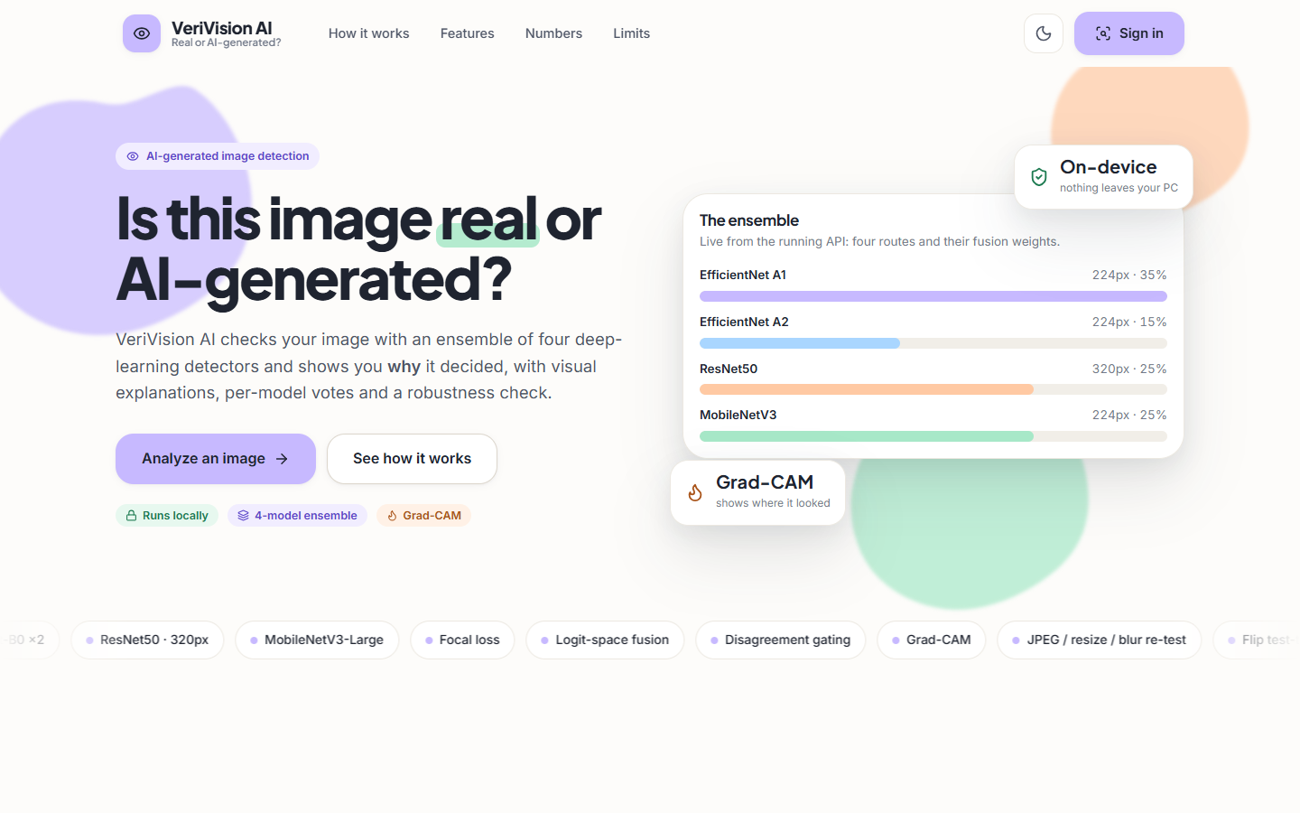  Figure 17: Landing page (light theme): the four routes with their input sizes and fusion weights, read live from the API. | 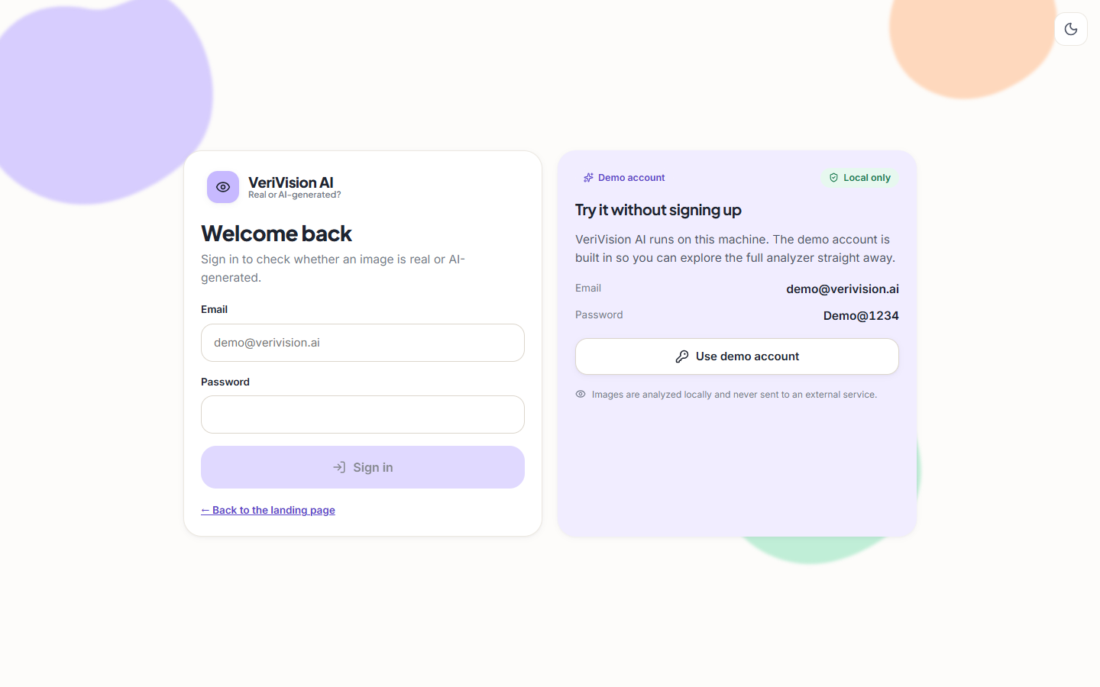  Figure 18: Sign-in page: the demo account is shown beside the form; images are analysed locally.

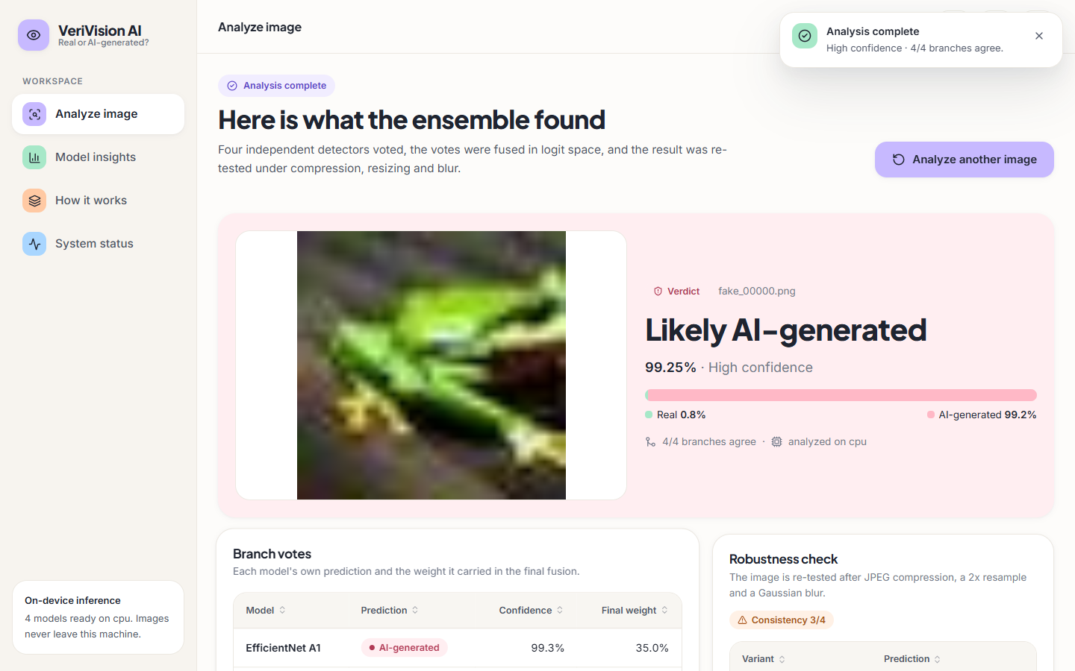  Figure 19: Result for fake_00000.png: "Likely AI-generated", 99.25% (High confidence), 4/4 branches agree; the bar splits the fused probability into Real 0.8% and AI-generated 99.2%. | 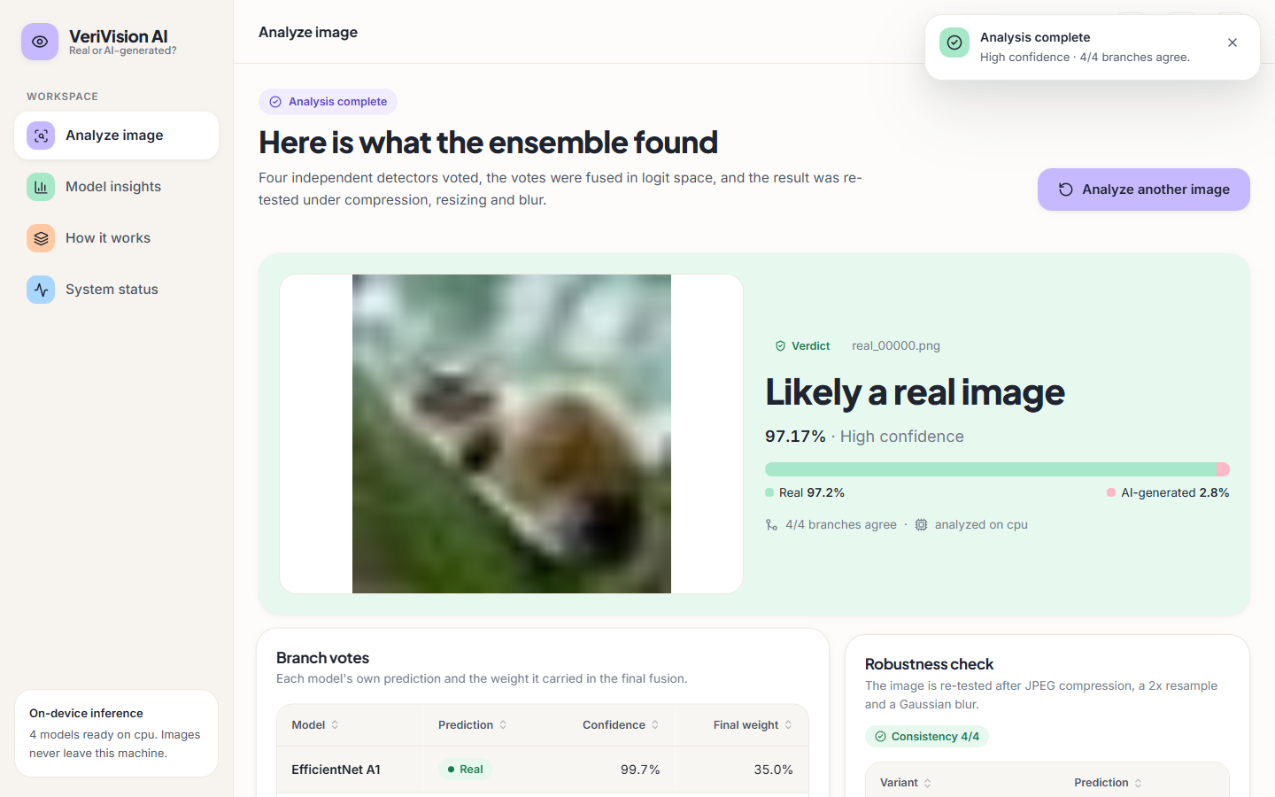  Figure 20: Result for real_00000.png: "Likely a real image", 97.17% (High confidence), Real 97.2% / AI-generated 2.8%, 4/4 branches agree, robustness consistency 4/4 (green).

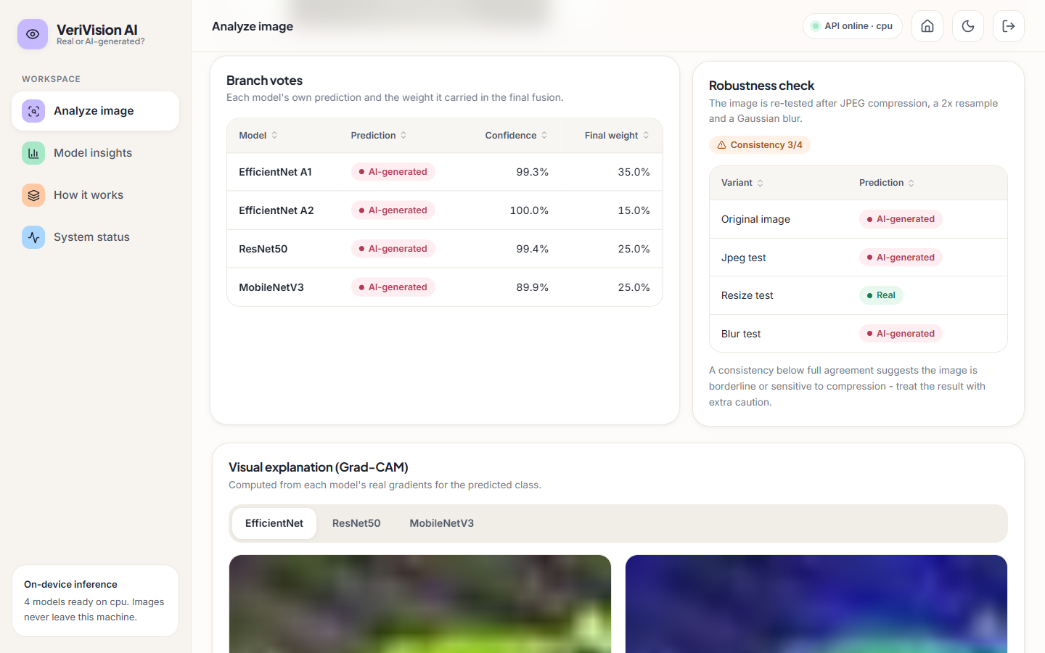
Figure 21: Branch votes and robustness check for the same image. All four routes vote AI-generated (99.3%, 100.0%, 99.4%, 89.9%) with fusion weights 35, 15, 25 and 25%. The re-test agrees on the original, JPEG and blur variants but reads the 2x resized copy as Real, giving consistency 3/4 and an amber warning.
Figure 22: Grad-CAM tab for route A1 (EfficientNet): the activation concentrates on the right edge of the subject. | 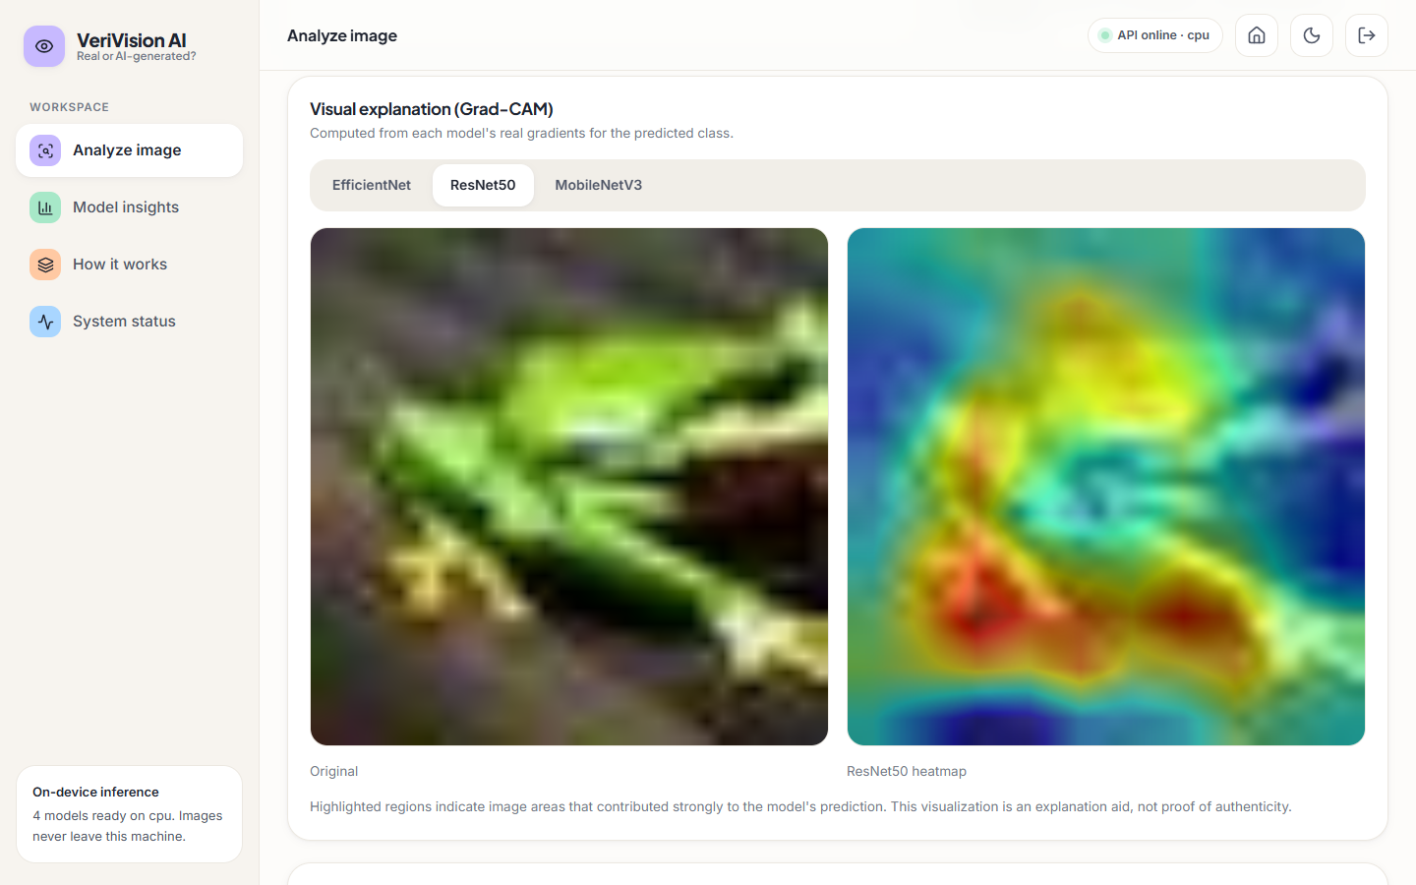  Figure 23: Grad-CAM tab for route B (ResNet50) on the same image: activation spreads over most of the subject.

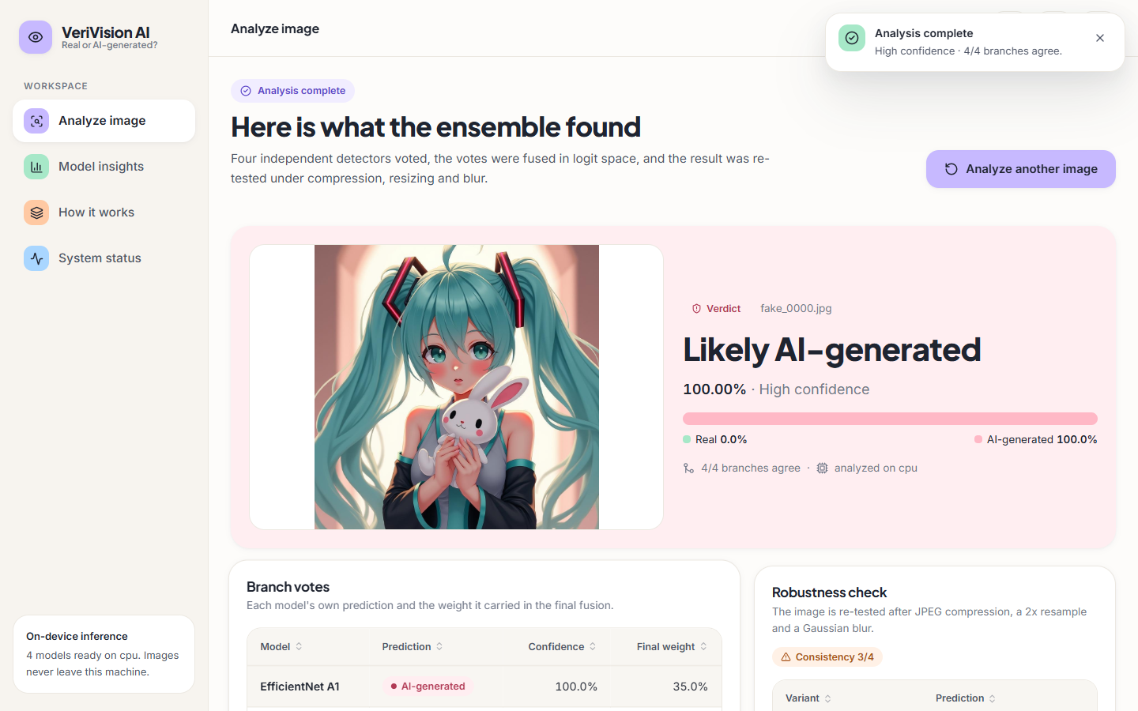  Figure 24: Cross-domain AI-generated image (fake_0000.jpg, 1024 px): correctly called AI-generated with 100.00% confidence, but the robustness check agrees on only 3/4 variants. | 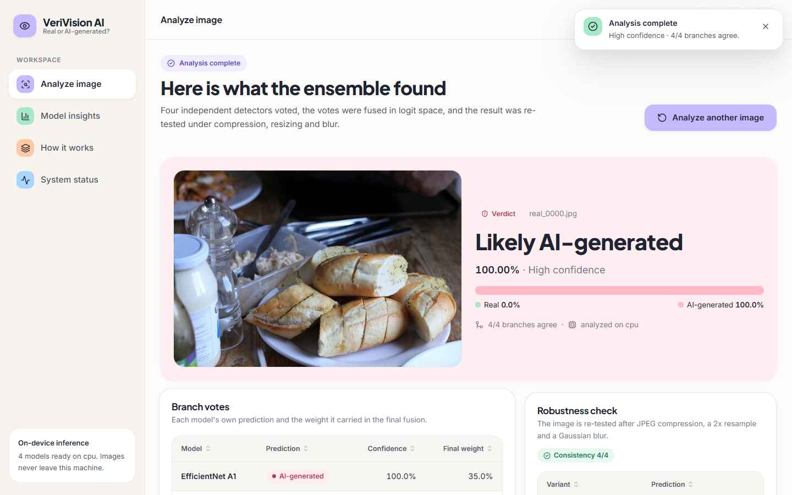  Figure 25: Cross-domain real photograph (real_0000.jpg): called AI-generated with 100.00% confidence and 4/4 consistency. This is a confident wrong answer.

The model is sure of both verdicts, yet the second is wrong, and the consistency check cannot flag it because every variant gives the same wrong answer. Section 8.6 measures how often this happens.
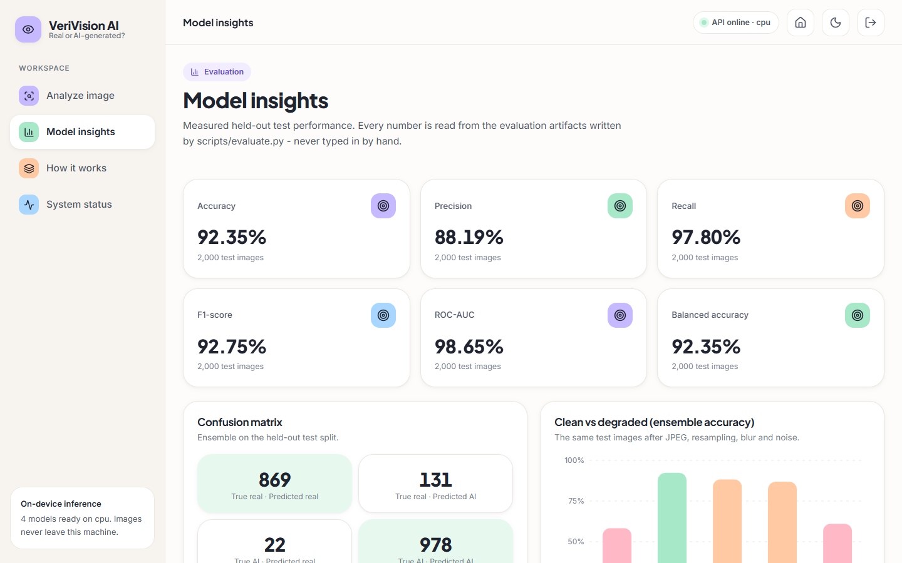
Figure 26: Model insights page: held-out ensemble metrics (accuracy 92.35%, precision 88.19%, recall 97.80%, F1 92.75%, ROC-AUC 98.65%, balanced accuracy 92.35%), the confusion matrix (869 / 131 / 22 / 978) and the clean-versus-degraded chart, all read from the evaluation files.
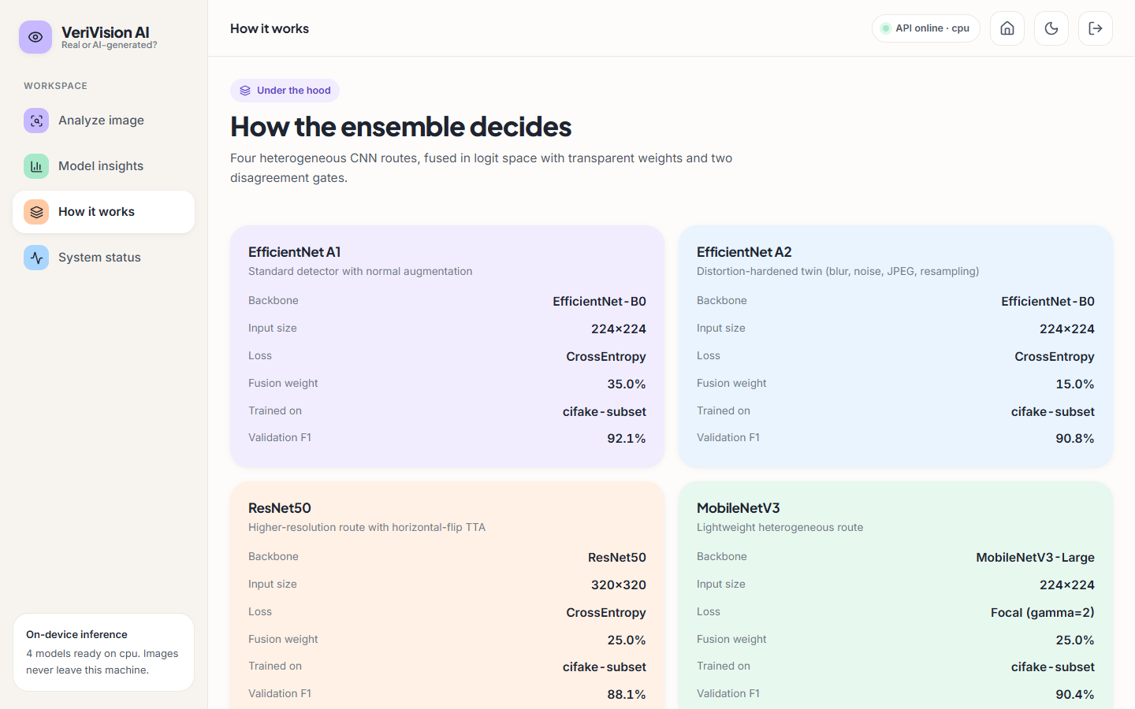  Figure 27: How-it-works page with one card per route: backbone, input size, loss, fusion weight and F1. | 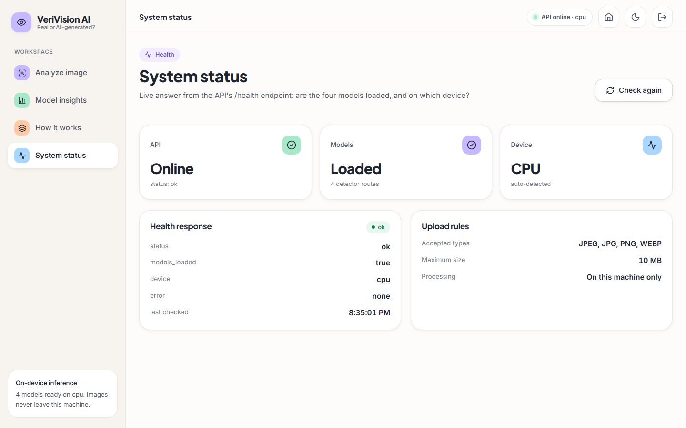  Figure 28: System status page: the /health answer (models loaded, device cpu) and the upload rules.

Section 8.12 notes that the "Validation F1" rows of the how-it-works page show test-set F1 values. Further screens (dark theme, the page mid-animation, the landing page sections) are in Appendix C.

8.3 Model Performance on the Held-out Test Set
The first table below gives the held-out results of the four routes and the deployed ensemble on the 2,000 test images (single run, seed 42). The ensemble reaches an accuracy of 92.35%, an F1 of 92.75% and a ROC-AUC of 98.65%. The best single route, EfficientNet-B0 A1, reaches 91.80% accuracy and 97.49% ROC-AUC, and its bootstrap interval (0.905-0.930) overlaps that of the ensemble (0.911-0.934). The 0.55-point accuracy advantage of the ensemble over A1 is therefore not statistically distinguishable on this sample; its higher ROC-AUC (0.9865 against 0.9749) and a lower false-negative rate (2.2% against 4.7%) are the clearer gains. ResNet50 B has the highest single-route ROC-AUC (0.9828) but the lowest accuracy (0.8660), because its threshold sits too far toward AI-generated: it finds 99.1% of the fakes and wrongly flags 25.9% of the real images.
Table 34: Held-out performance of the four routes and the ensemble (n = 2,000)
Model | Accuracy | Precision | Recall | F1 | ROC-AUC | 95% CI (accuracy)
EfficientNet-B0 A1 | 0.9180 | 0.8907 | 0.9530 | 0.9208 | 0.9749 | 0.905-0.930
EfficientNet-B0 A2 | 0.9020 | 0.8533 | 0.9710 | 0.9083 | 0.9769 | 0.888-0.915
ResNet50 B | 0.8660 | 0.7928 | 0.9910 | 0.8809 | 0.9828 | 0.851-0.881
MobileNetV3-Large C | 0.8995 | 0.8648 | 0.9470 | 0.9041 | 0.9670 | 0.885-0.912
Ensemble (deployed) | 0.9235 | 0.8819 | 0.9780 | 0.9275 | 0.9865 | 0.911-0.934

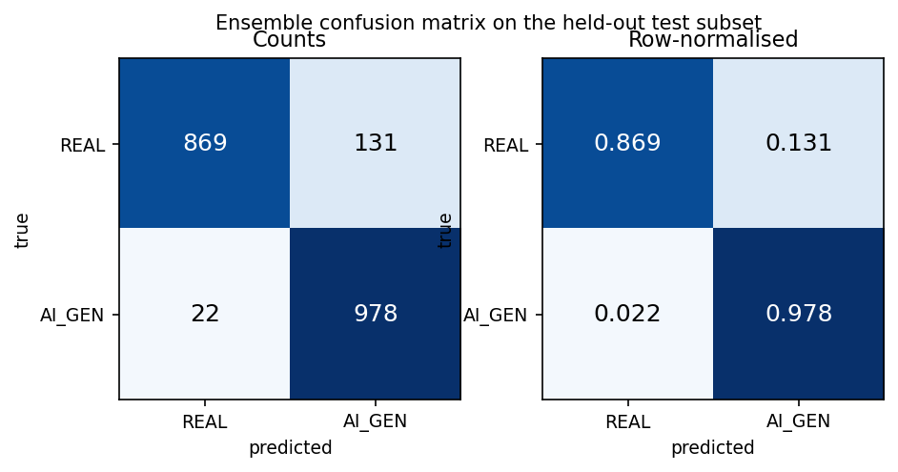  Figure 29: Confusion matrix of the deployed ensemble: counts (left) and row-normalised (right). | 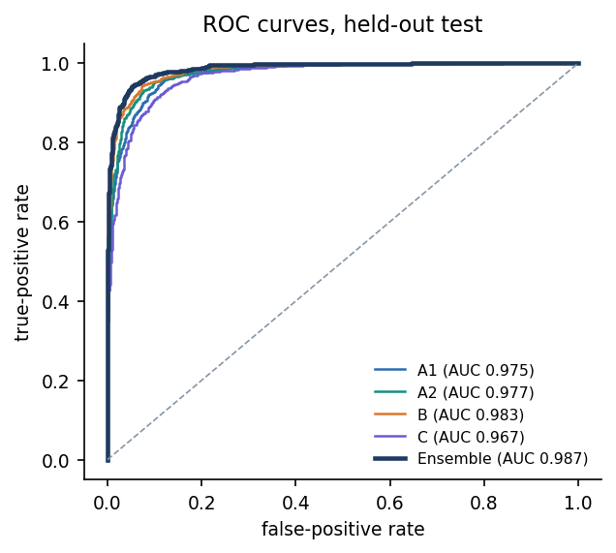  Figure 30: ROC curves of the four routes and the ensemble on the held-out test set.

Table 35: Confusion-matrix counts and error rates (positive class: AI_GENERATED)
Model | TN | FP | FN | TP | FPR | FNR | Predicted fake
EfficientNet-B0 A1 | 883 | 117 | 47 | 953 | 11.7% | 4.7% | 53.5%
EfficientNet-B0 A2 | 833 | 167 | 29 | 971 | 16.7% | 2.9% | 56.9%
ResNet50 B | 741 | 259 | 9 | 991 | 25.9% | 0.9% | 62.5%
MobileNetV3-Large C | 852 | 148 | 53 | 947 | 14.8% | 5.3% | 54.8%
Ensemble | 869 | 131 | 22 | 978 | 13.1% | 2.2% | 55.5%

Every route and the ensemble predict AI-generated more often than the true 50% share (the ensemble 55.5%). The ensemble makes 153 errors in 2,000: 131 real images flagged as AI-generated (false-positive rate 13.1%) and 22 fakes missed (2.2%). In a forensic setting the first kind of error, calling a genuine photograph fake, is the costly one, and it is the more frequent one here.
Figure 31: Training and validation curves of the four routes (route B stopped after three epochs; C uses focal loss, so its loss scale differs).
Validation accuracy of A1 was still rising at epoch 5 (92.58%); A2 and C ended at 89.83% and 90.58%, and B reached its best validation F1 (0.8902) at epoch 2 of 3. With only 3 to 5 epochs on 6,000 images (CPU-only hardware) these are not converged models; a longer run on the full 100,000 images would probably score higher.
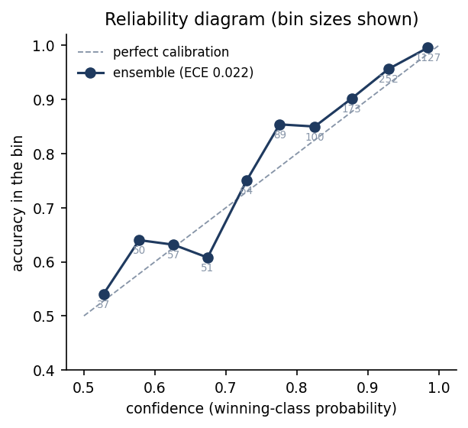  Figure 32: Reliability diagram of the ensemble (expected calibration error 0.022); bin sizes are printed under the points. | 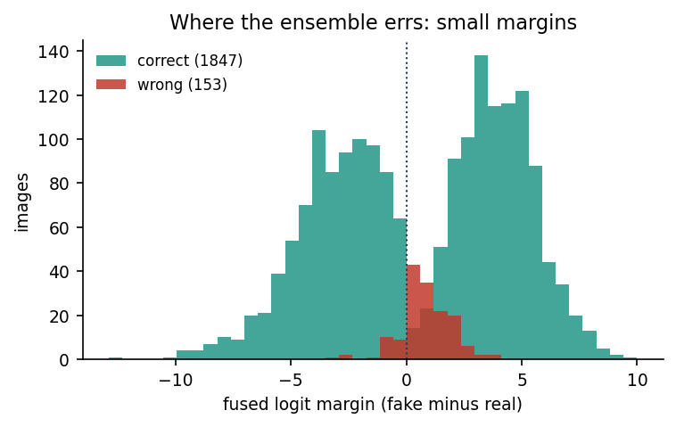  Figure 33: Fused logit margin of correct (green) and wrong (red) predictions on the test set.

The ensemble is well calibrated on this test set: its expected calibration error is 0.022, close to the best single routes (A1 0.018, A2 0.018) and far below route C (0.122) and route B (0.058). The reliability curve lies slightly above the diagonal in the middle bins (a little under-confident), and 1,127 of the 2,000 images fall in the top bin. Calibration holds only on the training distribution; Section 8.6 shows that confidence does not survive a change of domain.

8.4 Fusion Rules and Decision Threshold
The fusion rule of Chapter 6 was tested by replacing it, on the same cached logits, with simpler variants. The ablation table below shows that the two gates did not improve the result: Gate 1 fired on 7 of 2,000 images and Gate 2 on none, and removing both gates scores 0.9245 against 0.9235 for the deployed rule, a difference of two images. Probability averaging scores slightly higher in accuracy (0.9260) but lower in ROC-AUC (0.9846), and majority voting loses ranking quality (ROC-AUC 0.9383) presumably because its score takes only a few distinct values. The gate design follows HEDGE [2], whose own ablation gained 0.37 robust-F1 points from its gates on a different, much harder benchmark; here the thresholds (2.5, 2.5, 0.75) are engineering defaults that were never tuned, and the finding is that the gates are inactive on this data.
Table 36: Fusion-rule ablation on the held-out test set (same logits)
Variant | Accuracy | F1 | ROC-AUC
Deployed: weights + Gate 1 + Gate 2 | 0.9235 | 0.9275 | 0.9865
Weights only (no gates) | 0.9245 | 0.9285 | 0.9868
Gate 1 only | 0.9235 | 0.9275 | 0.9865
Gate 2 only | 0.9245 | 0.9285 | 0.9868
Equal weights + gates | 0.9215 | 0.9257 | 0.9867
Probability averaging (weights) | 0.9260 | 0.9299 | 0.9846
Majority vote (ties to weighted) | 0.9230 | 0.9269 | 0.9383

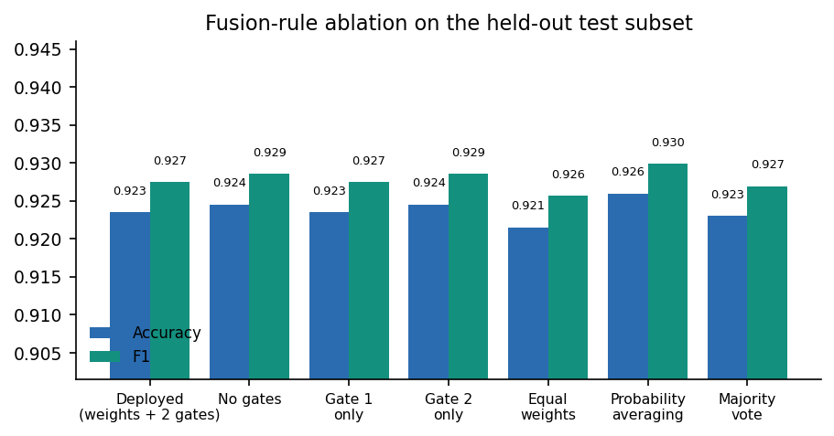  Figure 34: Accuracy and F1 of the fusion variants; the vertical axis starts at 0.905, which magnifies differences of a few images. | 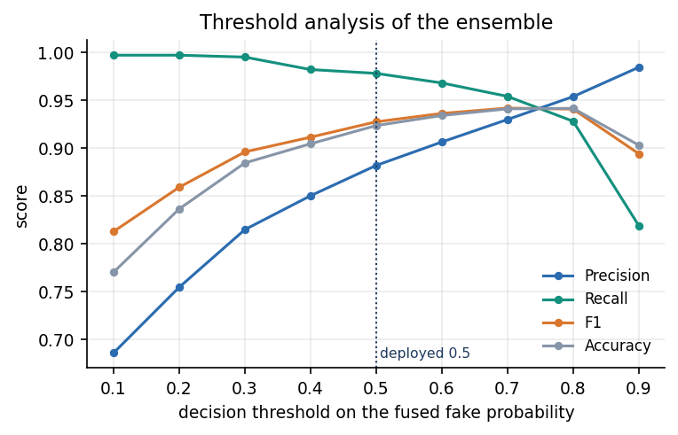  Figure 35: Precision, recall, F1 and accuracy of the ensemble as the decision threshold on the fused fake probability moves from 0.1 to 0.9.

The deployed threshold is 0.5. Raising it to 0.7 or 0.8 lowers the false-positive rate to 7.2% and 4.5% at a cost in recall (95.4% and 92.8%), and accuracy peaks at 94.1% to 94.2%. That gain is optimistic: the threshold was read off the test subset, and a fair choice would need a separate validation set. The sweep does show the trade-off an operator would face, since the model's error is asymmetric and a higher threshold protects real images at the price of missing more fakes.

8.5 Robustness to Compression, Resizing, Blur and Noise
The same 1,000 test images were degraded and re-scored by every route (table and chart below). JPEG compression and noise cost the ensemble about 4 to 5 accuracy points. Resizing and blur are far more damaging: ensemble accuracy falls to 61.0% and 58.3%, close to chance, and the models stop calling images AI-generated (only 12.2% and 8.9% of images are predicted fake against 55% on clean images). The ranking information is only partly lost, since ROC-AUC stays at 0.801 and 0.865: the decision threshold moves rather than the scores becoming random. Route B, trained at 320 pixels with flip augmentation, holds up best against resizing and blur (68.6% and 69.1%), but it is the least robust to JPEG (80.3%) and noise (74.6%).
Table 37: Accuracy under degradation (1,000 images, same images in every condition)
Condition | A1 | A2 | B | C | Ensemble | Ens. AUC | Ens. pred. fake
Clean (1,000-image subset) | 92.2% | 90.0% | 86.5% | 89.9% | 92.4% | 0.986 | 55.0%
JPEG quality 60 | 88.9% | 88.5% | 80.3% | 86.2% | 88.3% | 0.978 | 59.7%
Resize to 1/2 and back | 59.1% | 53.3% | 68.6% | 52.3% | 61.0% | 0.801 | 12.2%
Gaussian blur 5x5, sigma 1 | 59.8% | 54.6% | 69.1% | 52.5% | 58.3% | 0.865 | 8.9%
Gaussian noise, sigma 6 | 84.1% | 87.4% | 74.6% | 86.8% | 86.9% | 0.975 | 61.9%

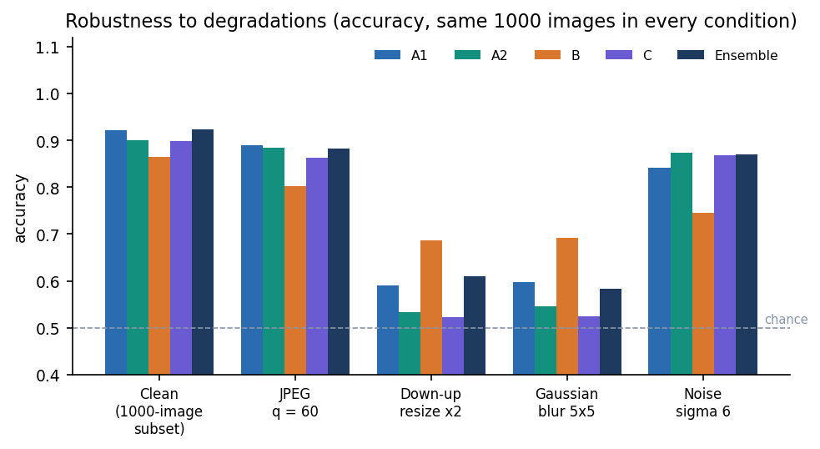
Figure 36: Accuracy of each route and the ensemble on the clean subset and four degradations (dashed line: chance).
Route A2 was trained with blur, noise, JPEG and resampling augmentation precisely to resist these conditions, yet it is not more robust than A1 to resizing (53.3% against 59.1%) or blur (54.6% against 59.8%); its only visible benefit is on noise (87.4% against 84.1%). The same fragility appears in the application: the robustness check of the sample result in Section 8.2 flipped the verdict of the sample image under the resize variant, and a consistency below full agreement is the application's own warning to treat the result with caution.

8.6 Cross-domain Probe
Objective 4 asked for cross-generator evaluation. The probe set contains 300 real photographs and 300 AI-generated images from another public source, at full resolution and with different content (food, animals, illustrations, fantasy scenes) from the CIFAKE objects. The generators are not named by the source, so the probe tests transfer to some unseen generator and domain, not to a specific model. Because resolution, content and generator all change together, the probe cannot say which of them causes the failure.
Table 38: Cross-domain probe, 600 images (models trained on CIFAKE only)
Model | Accuracy | ROC-AUC | Real kept REAL | AI found
EfficientNet-B0 A1 | 50.7% | 0.501 | 170/300 | 134/300
EfficientNet-B0 A2 | 47.8% | 0.385 | 4/300 | 283/300
ResNet50 B | 48.7% | 0.215 | 1/300 | 291/300
MobileNetV3-Large C | 52.2% | 0.564 | 20/300 | 293/300
Ensemble | 51.0% | 0.499 | 163/300 | 143/300

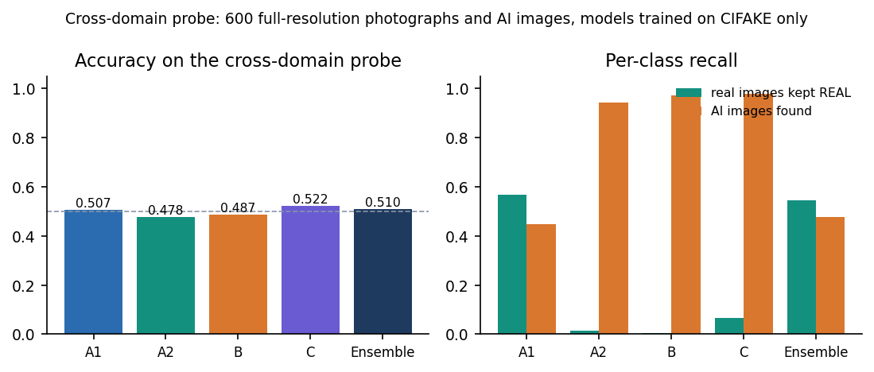
Figure 37: Cross-domain accuracy (left) and per-class recall (right) of each route and the ensemble; the dashed line is chance.
The result is a clear failure to generalise. The ensemble scores 51.0% with a ROC-AUC of 0.499, which is chance; A2, B and C call almost every image AI-generated (B keeps only 1 of 300 real photographs as real), and A1 is close to a coin flip. ROC-AUC below 0.5 for route B (0.215) means its scores are inverted on this data. The deployed confidence is meaningless here: the last pair of screens in Section 8.2 shows a real photograph called AI-generated with 100.00% confidence. Objective 4 was therefore measured and not achieved. This agrees with the literature on cross-generator transfer [3], [12], [13], but this project did not train on several generators or at several resolutions, so it cannot offer a remedy.

8.7 Grad-CAM Explanations
Grad-CAM was run on the predicted class for routes A1, B and C with the same code that the application uses. The figure below shows the first three correctly classified real images and the first three correctly classified AI-generated images of the test set, so the examples are typical and not chosen for neat heat maps.
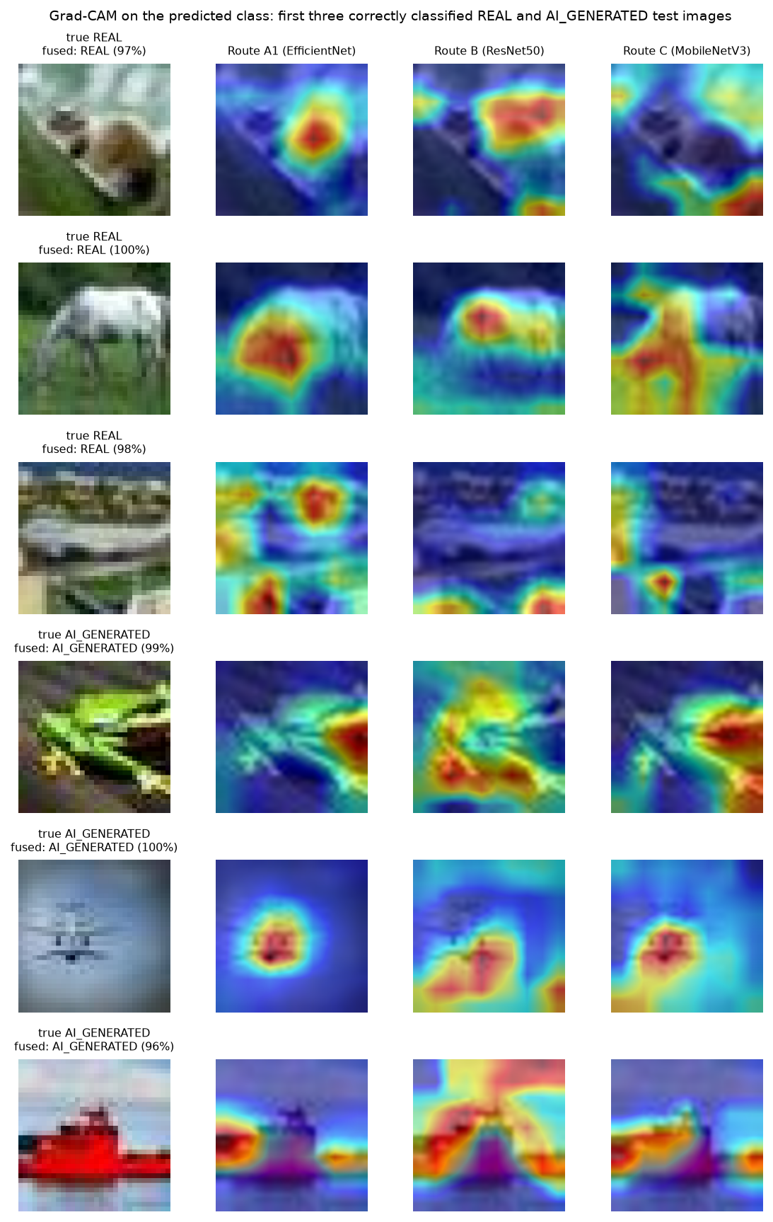
Figure 38: Grad-CAM overlays of routes A1, B and C on the first three real (top) and first three AI-generated (bottom) correctly classified test images.
The maps are coarse blobs, because the target layers have a 7 x 7 to 10 x 10 spatial grid that is upsampled to the image. They usually sit on the main object, but different routes pick different parts of it (for the green frog, A1 and C focus on the head, B on the body), and on the real images the maps are as strong as on the fakes. No map points to a recognisable artefact; the maps show where the evidence is, not what it is. Grad-CAM was judged by eye only (no deletion or insertion test), so the maps are not proof that the model uses a particular region.
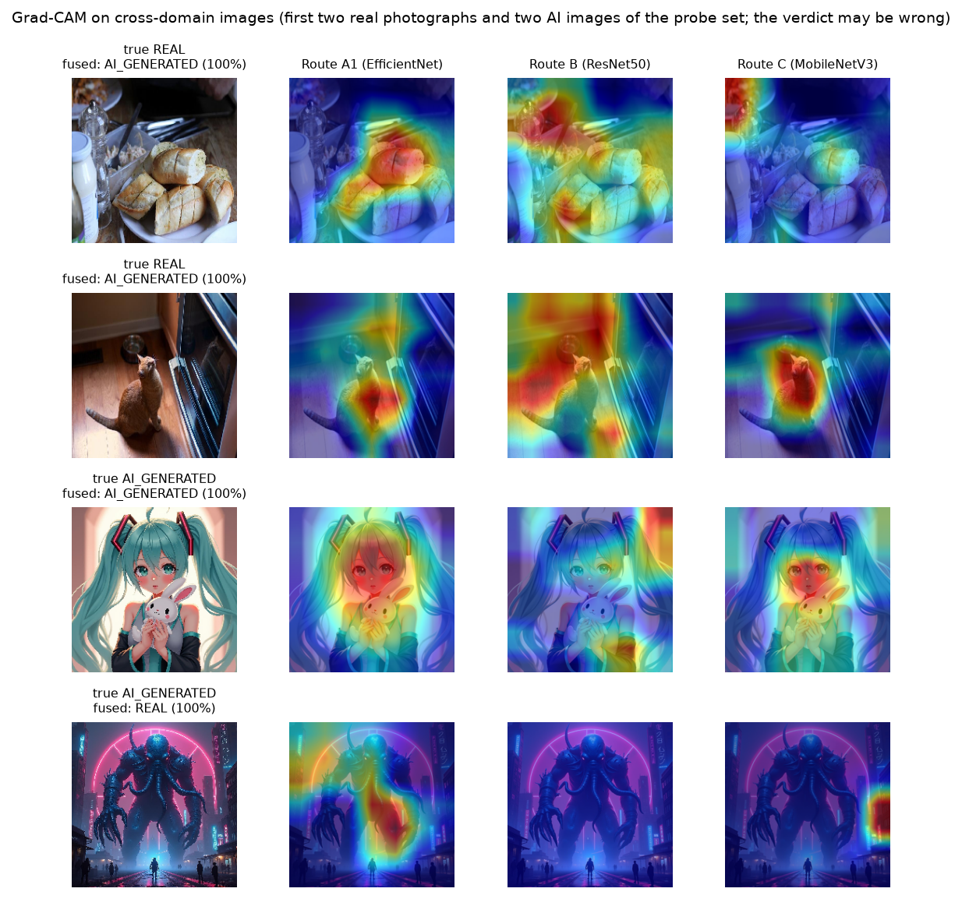
Figure 39: Grad-CAM overlays on the cross-domain probe: two real photographs (both called AI-generated, 100%) and two AI images (the second called REAL, 100%).
On the cross-domain images the maps look as confident as on CIFAKE even where the verdict is wrong (the real bread and cat photographs are called AI-generated, with maps on the food and the cat), so a heat map says nothing about whether the verdict can be trusted.

8.8 Comparison with the Base Paper and the Design Reference
The batch's base paper is the CTrue detector of Larue et al. [1], a one-class face-deepfake detector; this project does not implement it. The design of the heterogeneous routes and gates follows HEDGE [2]. The three works differ in task, data and compute, so the table below lists them side by side and the only like-for-like number is the ROC-AUC on data of the work's own domain.
Table 39: Comparison with the base paper and the design reference
Aspect | CTrue (base paper) | HEDGE (design reference) | This project
Task | Face deepfake detection, one-class | AI-generated image detection in the wild | Real vs AI-generated, general 32-px images
Training data | 720 pristine FaceForensics++ videos plus pseudo-fakes | Not itemised in this report | 6,000 CIFAKE images (6% of the set)
Backbone | EfficientNet-B4 (19.3 M parameters) | DINOv3 and MetaCLIP2 based routes | Four small CNNs, 4.0 M to 23.5 M parameters
Compute | Two V100 GPUs, 200 epochs, about 16 h | 8 H800 GPUs | One CPU, 3 to 5 epochs, 13 to 53 min per route
Headline | AUC 98.9% on FF++ (in-domain) | Balanced accuracy 98.3% on five benchmarks | AUC 98.65%, accuracy 92.35% on CIFAKE (in-domain)
Cross-dataset | AUC 77.0% on DFDC (lambda = 1 ablation) | Robust F1 80.52, 80.89 with gates (competition set) | AUC 49.9%, accuracy 51.0% (cross-domain probe)
Gates / fusion | Not used (single model) | Logit fusion plus dual gating | Logit fusion plus two gates (no gain here)

In-domain, the project's ROC-AUC (98.65%) is close to the base paper's FaceForensics++ figure (98.9%), but the two numbers measure different tasks on different data, with a very different training budget, and they are not evidence that one method is better. Cross-dataset, the base paper's DFDC AUC of 77.0% is well below its in-domain value yet well above this project's 49.9%; the base paper was designed for generalisation and this project was not. The CTrue cross-dataset table is an image in the PDF and is not quoted. The comparison with HEDGE is about design only: the idea of logit fusion with gates is reused, and the ablation of Section 8.4 finds that the gates add nothing on CIFAKE.

8.9 Sample Inputs and Outputs, Speed and Testing
Table 40: Sample analyses captured from the application
Input | True class | Verdict | Confidence | Branches agree | Consistency | Correct
fake_00000.png (32 px) | AI-generated | Likely AI-generated | 99.25% | 4/4 | 3/4 | Yes
real_00000.png (32 px) | Real | Likely a real image | 97.17% | 4/4 | 4/4 | Yes
fake_0000.jpg (1024 px) | AI-generated | Likely AI-generated | 100.00% | 4/4 | 3/4 | Yes
real_0000.jpg (about 640 px) | Real | Likely AI-generated | 100.00% | 4/4 | 4/4 | No

Each POST /api/analyze response carries the verdict and confidence word, the fused probabilities, a record per route, the Grad-CAM overlays as data URLs, the agreement count, the gate decisions and the robustness outcomes with the consistency string. Invalid input returns a JSON error (400 unsupported, empty, corrupt or tiny file; 401 no token; 413 above 10 MB; 503 model files missing).
Table 41: Response time of the running API (median of 8 runs, 127.0.0.1, idle machine)
Endpoint | 32 px image | 1024 px image
GET /health | 16 ms | -
GET /api/insights | 5 ms | -
POST /api/predict (four routes + fusion) | 0.25 s | 0.28 s
POST /api/analyze (adds Grad-CAM x3 and robustness x4) | 1.70 s | 1.98 s

The full analysis takes under two seconds on the CPU, so the 10 to 60 seconds assumed in the first README was too pessimistic for this machine. Model loading happens once at start and is not timed; batched offline inference in the evaluation script costs 283 ms per image for all four routes. The pytest suite (19 tests) passed 19 of 19 in 35 s, the end-to-end smoke test passed 29 of 29 checks, and the capture script walked every screen with a clean browser console. Unit tests for the Grad-CAM and robustness modules, load tests and a GPU run were not done.

8.10 Success and Failure Analysis
Where the ensemble succeeds. All four routes agree on 81.2% of the test images; on those 1,624 images the fused label is right 96.2% of the time, against 76.3% on the other 376 (computed from the cached route logits with the weighted sum, which differs from the deployed rule on two images). Correct predictions have a mean fused margin of 3.56 logit units against 1.09 for wrong ones (figure in Section 8.3): the errors are concentrated near the decision boundary, so the confidence value carries real information on CIFAKE-like images.
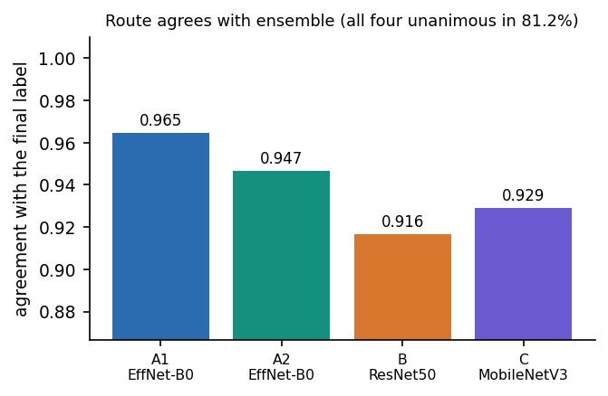
Figure 40: Agreement of each route with the final label (the vertical axis starts at 0.87).
Where it fails. The figure below shows the first six false positives and six false negatives. The false positives are real thumbnails (a truck, a bird, an aeroplane, a car, a sailing boat, a dog) with fake probabilities from 0.51 to 0.89; the false negatives are AI-generated images with natural-looking subjects (a cat, a dog, a sailing boat, a horse) and fake probabilities from 0.07 to 0.40. Nothing in these thumbnails lets a person tell which is which either, so the errors are plausibly cases where the generator's output matches natural statistics at 32 pixels; the project did not test that explanation. Agreement with the final label is highest for A1 (96.5%) and lowest for B (91.6%), consistent with B's bias toward AI-generated.
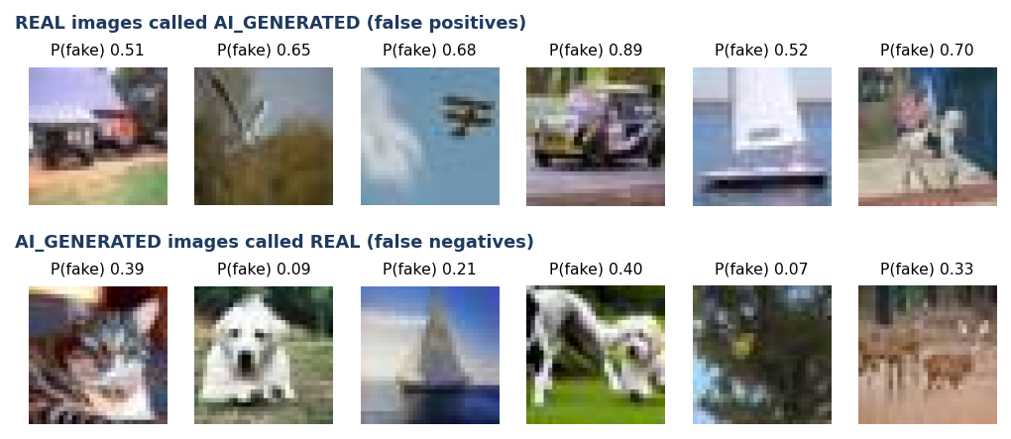
Figure 41: First six false positives (real images called AI-generated, top) and first six false negatives (AI images called real, bottom) with the ensemble's fake probability.
Two failure modes matter for use. A resized or blurred image is read as real, so a fake re-saved at a smaller size is likely to pass; and on images from outside CIFAKE the model is confidently wrong, as the real photograph of Section 8.2 shows. Neither is caught by the visible safeguards (consistency check, Grad-CAM), so the application's own wording, "AI estimate, not proof", is the right framing.

8.11 Limitations of the Results
• Single run per route. Seeds 42 to 45 and one training run each: the ranking of the routes carries run-to-run uncertainty that the bootstrap interval, which resamples only the test set, does not capture.
• Small training subset. 6,000 of 100,000 CIFAKE images and 3 to 5 epochs, chosen for CPU time; a full-data run would probably score higher.
• Tiny images, one generator. CIFAKE images are 32 x 32 JPEG from one generator (Stable Diffusion 1.4). The results do not transfer to modern high-resolution generators, and there is no per-generator breakdown.
• Optimistic operating point. The threshold sweep and the fusion ablation were evaluated on the test subset itself; the deployed gate thresholds and weights are engineering defaults that were not tuned.
• Qualitative explanations. Grad-CAM maps were inspected by eye; there is no faithfulness test.
• Not measured. A user study, GPU timing, load testing, adversarial attacks, and unit tests of the explanation and robustness modules.

8.12 Objectives versus Outcomes
Table 42: Objectives of the project against what was measured
No. | Objective | Outcome | Status
1 | Assemble a dataset of real and AI-generated images | CIFAKE subset (real CIFAR-10 + one generator) with a 6,000 / 1,200 / 2,000 split and a 600-image probe from another source; several generators were not assembled | Partly met
2 | Preprocess and augment for robustness | Per-route augmentation implemented; the distortion-hardened route A2 was not more robust to resize or blur than A1 | Met, with limited effect
3 | Train a CNN classifier | Four routes and a fused ensemble: 92.35% accuracy, F1 92.75%, ROC-AUC 98.65% on the held-out CIFAKE test set | Met
4 | Evaluate cross-generator performance | Measured on 600 full-resolution images: ensemble 51.0% accuracy, ROC-AUC 0.499 (chance) | Measured, not achieved
5 | Apply Grad-CAM to explain classifications | Grad-CAM on three routes in the application and in the figures of Section 8.7; judged qualitatively only | Met (qualitative)
6 | Deploy behind an interface with verdict, confidence and explanation | Flask API (8414) and React app (5414); full analysis in 1.7 to 2.0 s on CPU; 19/19 tests and 29/29 smoke checks passed | Met

Note on the interface. The how-it-works page labels the held-out test F1 of each route as "Validation F1", and the validation block of models/model_metadata.json holds the same test-set values, not the validation F1 recorded during training (A1 0.927, A2 0.905, B 0.890, C 0.911). The numbers on screen are correct as test-set results; only the label is wrong, and the README may still describe the earlier demo-data scores.

CHAPTER 9: CONCLUSION

9.1 Summary of the work
The project set out to detect AI-generated images with convolutional neural networks and to explain each decision with Grad-CAM. The result is VeriVision AI: four ImageNet-pretrained CNN routes (EfficientNet-B0 with two augmentation regimes, ResNet50 at 320 px and MobileNetV3-Large), fused in logit space with two deterministic gates, together with Grad-CAM heat maps, a per-image robustness check and a Flask and React application that runs entirely on the user's machine. The shipped models were first trained on synthetic demonstration images, whose perfect scores carry no meaning; they were replaced for this report by models trained on a real data subset, and every number in the report comes from those models.
On a class-balanced subset of the CIFAKE benchmark [8] (6,000 training, 1,200 validation and 2,000 held-out test images) the ensemble reached an accuracy of 92.35% (95% interval 91.1% to 93.5%), F1 0.9275 and ROC-AUC 0.9865. A single analysis through the API takes a median of 0.25 s for the verdict alone and 1.70 s with the heat maps and the robustness check, on a desktop CPU.

9.2 Objectives achieved
Table 43: Objectives of the project against the measured outcome
No. | Objective | Status | Evidence
1 | Assemble a dataset of real photographs and AI-generated images | Partly met | CIFAKE subset (one generator, 32 px) plus a 600-image full-resolution probe from another source; not several generators
2 | Preprocess and augment the images | Met | Per-route resizing, ImageNet normalisation and augmentation; the distortion-hardened route did not improve resize/blur robustness
3 | Train CNN classifiers | Met | Four routes; ensemble accuracy 92.35%, F1 0.9275, ROC-AUC 0.9865 on 2,000 held-out images
4 | Evaluate cross-generator performance | Measured, not achieved | Cross-domain probe: accuracy 51.0%, ROC-AUC 0.499 (chance level); generator and domain shift not separable
5 | Apply Grad-CAM | Met (qualitative) | Heat maps for three routes in every analysis; faithfulness not measured
6 | Deploy an interface with verdict, confidence and explanation | Met | Flask API + React app; /api/analyze median 1.70 s on CPU; 19/19 tests, 29/29 smoke checks

9.3 Key findings
1. The ensemble is the best model by ROC-AUC (0.9865), but its accuracy advantage over the best single route (A1, 91.80%) is not statistically distinguishable: the two bootstrap intervals overlap.
1. The fusion gates did not help. Gate 1 fired on 7 of 2,000 images and Gate 2 on 0; the ensemble without gates scored 92.45%. Logit-space fusion matched probability averaging on accuracy and beat it, and majority voting, on ROC-AUC.
1. Errors lean toward the AI-generated class (false-positive rate 13.1%, false-negative rate 2.2%). Wrong answers lie close to the decision boundary (mean fused margin 1.09 against 3.56 for correct answers), and all four routes agree on 81.2% of images.
1. Resizing and blurring remove the detectable cue on 32 px images: the ensemble falls to 61.0% and 58.3%, while JPEG q=60 and noise cost about four to five points. Distortion-hardened training did not change this.
1. The models do not transfer: on 600 full-resolution images from another source the ensemble scored 51.0% (ROC-AUC 0.499). Strong in-domain scores on CIFAKE therefore say little about modern generators.
1. Compared with the base paper [1] the only like-for-like figure is ROC-AUC: 98.65% here in-domain on CIFAKE against 98.9% on FaceForensics++ in the paper. The paper's DFDC figure (77.0%) and this project's cross-domain figure (49.9%) both fall when the data change, but the tasks, data and training regimes differ, so neither is evidence that one method is better.

9.4 Practical applications
As built, the tool suits teaching and demonstration: it shows how an ensemble, an explanation and a robustness check can be combined into one interface that runs offline. For an analyst it is a second opinion on small, compressed images similar to its training data, to be read together with the per-route votes, the heat map and the consistency score. It should not be used to decide a dispute on its own.

9.5 Known limitations
The limits that matter most are the small low-resolution single-generator training data, the chance-level cross-domain result, the fragility to resizing and blur, the bias toward the AI-generated class, the untuned gates and thresholds, the single training run per route, the qualitative explanations and the demonstration-grade sign-in. They are discussed in Chapters 1 and 8 and in the scope and limitations document, and the items that were not measured are listed there.

CHAPTER 10: FUTURE SCOPE

10.1 Improvements to the existing system
1. Train on the full data and on more generators. Use all 100,000 CIFAKE training images and add GAN and newer diffusion generators at several resolutions, then report accuracy per generator. This is the direct remedy for the chance-level cross-domain result (51.0%).
1. Tune the operating point on a validation set. Choose the decision threshold, the fusion weights and the gate thresholds on held-out validation data, not on the test set. The sweep suggests that a threshold of 0.7 would lower the false-positive rate from 13.1% to 7.2%; this must be confirmed on separate data.
1. Add features that survive resizing. Frequency-domain inputs [14] or frozen foundation-model features with a linear probe [13] transfer better across generators in the literature and could be added as a fifth route; whether they survive the half-size resample that defeated the CNNs here is an experiment to run.
1. Calibrate the probabilities. Apply temperature scaling per route and to the fused logits so that the confidence words (High, Moderate, Low) correspond to measured accuracy [25].
1. Run a seed study. Repeat training with five or more seeds, report mean and spread, and re-test whether the ensemble gain and the A2 result survive.

10.2 Additional features
• A per-generator or per-source breakdown on the Insights page once data from several generators exist.
• Batch upload and a downloadable report (verdict, votes, heat maps, robustness) for an analyst's case file.
• A saved-analysis history with per-user accounts and a database, with an explicit retention policy.
• Heat maps for route A2 and a switch between Grad-CAM variants, together with a short plain-language reading of each map.
• A "cannot decide" outcome when the routes disagree or when the image is far from the training resolution, instead of always returning a label.

10.3 Scalability and deployment
The analysis is CPU-bound and takes a median of 1.70 s with explanations. A deployment for several users would run the API behind a production WSGI server with a request queue, move the heat-map and robustness work to a background job, load models once per worker and cache results by image hash. A GPU would shorten training from hours to minutes and allow larger backbones and the full dataset. Before any shared deployment the demo account must be replaced with real authentication, the secret key must be set through the environment, and the demo credentials must no longer be returned by /api/config.

10.4 Further research
1. Quantitative faithfulness of the explanations. Test the Grad-CAM maps with deletion and insertion curves and with a small user study, and compare them with other attribution methods.
1. Separating generator shift from domain shift. Build a probe in which the real and fake images share content and resolution but differ in generator, so that the cause of the cross-domain failure can be identified.
1. Adversarial and post-processing robustness. Measure the detector under compression chains, screenshots, resizing pipelines and deliberate attacks designed to remove generation traces.
1. One-class and pseudo-fake training for general images. The base paper's one-class idea [1] was developed for faces; testing whether pseudo-fake training helps a general-image detector to generalise is an open question that this project did not address.

REFERENCES
[1] N. Larue, V. Struc, P. Peer and N.-S. Vu, "Learning the manifold of authenticity: hybrid-curvature representation learning for generalizable deepfake detection," IEEE Access, vol. 14, pp. 101988-102001, 2026, doi: 10.1109/ACCESS.2026.3702429.
[2] F. Wu, D. Lu, M. Yao, X. Xu and F. Guo, "HEDGE: Heterogeneous ensemble for detection of AI-generated images in the wild," arXiv:2604.03555, Apr. 2026.
[3] N. Tasnim, K. Uddin and K. M. Malik, "AI-generated image detection: an empirical study and future research directions," arXiv:2511.02791, Nov. 2025.
[4] "Deepfake and AI-generated image detection system," Int. J. Multidisciplinary Research (IJFMR), 2025. [unverified: listed as recorded in the batch survey; authors, volume and pages not confirmed]
[5] "Deepfake tweet detection using CNN and FastText embeddings: leveraging deep learning to identify AI-generated tweets," 2025. [unverified: listed as recorded in the batch survey; text-based study, authors and venue not confirmed]
[6] "Multimodal deepfake detection across cultures and languages," in Proc. 1st Deepfake Forensics Workshop: Detection, Attribution, Recognition, and Adversarial Challenges in the Era of AI-Generated Media, 2025. [unverified: listed as recorded in the batch survey; authors and pages not confirmed]
[7] "Deepfake detection using deep learning: a neural network-based approach to identifying AI-generated media," 2025. [unverified: listed as recorded in the batch survey; authors and venue not confirmed]
[8] J. J. Bird and A. Lotfi, "CIFAKE: image classification and explainable identification of AI-generated synthetic images," IEEE Access, vol. 12, pp. 15642-15650, 2024 (arXiv:2303.14126).
[9] A. Krizhevsky, "Learning multiple layers of features from tiny images," Univ. Toronto, Toronto, ON, Canada, Tech. Rep., 2009.
[10] R. Rombach, A. Blattmann, D. Lorenz, P. Esser and B. Ommer, "High-resolution image synthesis with latent diffusion models," in Proc. IEEE/CVF Conf. Comput. Vis. Pattern Recognit. (CVPR), 2022, pp. 10684-10695.
[11] I. Goodfellow et al., "Generative adversarial nets," in Proc. Adv. Neural Inf. Process. Syst. (NeurIPS), vol. 27, 2014, pp. 2672-2680.
[12] S.-Y. Wang, O. Wang, R. Zhang, A. Owens and A. A. Efros, "CNN-generated images are surprisingly easy to spot... for now," in Proc. IEEE/CVF CVPR, 2020, pp. 8695-8704.
[13] U. Ojha, Y. Li and Y. J. Lee, "Towards universal fake image detectors that generalize across generative models," in Proc. IEEE/CVF CVPR, 2023, pp. 24480-24489.
[14] J. Frank, T. Eisenhofer, L. Schonherr, A. Fischer, D. Kolossa and T. Holz, "Leveraging frequency analysis for deep fake image recognition," in Proc. 37th Int. Conf. Mach. Learn. (ICML), PMLR vol. 119, 2020, pp. 3247-3258.
[15] R. Corvi, D. Cozzolino, G. Zingarini, G. Poggi, K. Nagano and L. Verdoliva, "On the detection of synthetic images generated by diffusion models," in Proc. IEEE Int. Conf. Acoust., Speech Signal Process. (ICASSP), 2023, pp. 1-5.
[16] D. Gragnaniello, D. Cozzolino, F. Marra, G. Poggi and L. Verdoliva, "Are GAN generated images easy to detect? A critical analysis of the state-of-the-art," in Proc. IEEE Int. Conf. Multimedia Expo (ICME), 2021, pp. 1-6.
[17] A. Rossler, D. Cozzolino, L. Verdoliva, C. Riess, J. Thies and M. Niessner, "FaceForensics++: learning to detect manipulated facial images," in Proc. IEEE/CVF Int. Conf. Comput. Vis. (ICCV), 2019, pp. 1-11.
[18] Y. Li, X. Yang, P. Sun, H. Qi and S. Lyu, "Celeb-DF: a large-scale challenging dataset for DeepFake forensics," in Proc. IEEE/CVF CVPR, 2020, pp. 3207-3216.
[19] M. Tan and Q. Le, "EfficientNet: rethinking model scaling for convolutional neural networks," in Proc. 36th Int. Conf. Mach. Learn. (ICML), PMLR vol. 97, 2019, pp. 6105-6114.
[20] K. He, X. Zhang, S. Ren and J. Sun, "Deep residual learning for image recognition," in Proc. IEEE Conf. Comput. Vis. Pattern Recognit. (CVPR), 2016, pp. 770-778.
[21] A. Howard et al., "Searching for MobileNetV3," in Proc. IEEE/CVF ICCV, 2019, pp. 1314-1324.
[22] T.-Y. Lin, P. Goyal, R. Girshick, K. He and P. Dollar, "Focal loss for dense object detection," in Proc. IEEE ICCV, 2017, pp. 2980-2988.
[23] I. Loshchilov and F. Hutter, "Decoupled weight decay regularization," in Proc. Int. Conf. Learn. Represent. (ICLR), 2019.
[24] J. Deng, W. Dong, R. Socher, L.-J. Li, K. Li and L. Fei-Fei, "ImageNet: a large-scale hierarchical image database," in Proc. IEEE CVPR, 2009, pp. 248-255.
[25] C. Guo, G. Pleiss, Y. Sun and K. Q. Weinberger, "On calibration of modern neural networks," in Proc. 34th Int. Conf. Mach. Learn. (ICML), PMLR vol. 70, 2017, pp. 1321-1330.
[26] R. R. Selvaraju, M. Cogswell, A. Das, R. Vedantam, D. Parikh and D. Batra, "Grad-CAM: visual explanations from deep networks via gradient-based localization," in Proc. IEEE ICCV, 2017, pp. 618-626.
[27] J. Gildenblat and contributors, "PyTorch library for CAM methods (pytorch-grad-cam)," GitHub repository, 2021. [Online]. Available: https://github.com/jacobgil/pytorch-grad-cam
[28] A. Paszke et al., "PyTorch: an imperative style, high-performance deep learning library," in Proc. Adv. Neural Inf. Process. Syst. (NeurIPS), vol. 32, 2019, pp. 8024-8035.
[29] F. Pedregosa et al., "Scikit-learn: machine learning in Python," J. Mach. Learn. Res., vol. 12, pp. 2825-2830, 2011.
[30] Pallets Projects, "Flask documentation," 2024. [Online]. Available: https://flask.palletsprojects.com/
[31] B. Efron and R. J. Tibshirani, An Introduction to the Bootstrap. New York, NY, USA: Chapman & Hall, 1993.

APPENDIX A: IMPORTANT CODE
The listings are copied from 8.ProjectCode in the state in which the results of this report were measured; docstrings and comments are unchanged and the line ranges are whole statements.

A.1 Upload validation and decoding (`app/preprocessing.py`)
An upload is rejected before any model runs if it has no name, an unsupported extension, no bytes or too many bytes; decode_image (same file) then verifies the file, converts it to RGB and refuses images under 8 pixels.
def validate_upload(file_storage):
"""Validate a Flask FileStorage upload. Returns (bytes, ext)."""
if file_storage is None or not getattr(file_storage, "filename", ""):
raise PreprocessingError("No image file was provided. Please choose an image to analyze.")
filename = file_storage.filename
if not allowed_extension(filename):
raise PreprocessingError(
"Unsupported file type. Please upload a PNG, JPG/JPEG or WEBP image."
)
data = file_storage.read()
if not data:
raise PreprocessingError("The uploaded file is empty. Please try a different image.")
if len(data) > config.MAX_CONTENT_LENGTH:
raise PreprocessingError(
f"Image exceeds the {config.MAX_UPLOAD_MB} MB size limit. Please upload a smaller file."
)
ext = filename.rsplit(".", 1)[-1].lower()
return data, ext

A.2 Running the four routes (`app/inference.py`)
Route B averages the logits of the image and its horizontal flip; each route receives the image at its own resolution and returns raw logits, never probabilities.
def branch_logits(pil_image):
"""Run all branches and return raw logits dict."""
ensure_models_loaded()
t_a = _transform_for(config.RESOLUTION_A)(pil_image).unsqueeze(0)
t_b = _transform_for(config.RESOLUTION_B)(pil_image).unsqueeze(0)
t_c = _transform_for(config.RESOLUTION_C)(pil_image).unsqueeze(0)
# Horizontal-flip TTA for Route B
t_b_flip = torch.flip(t_b, dims=[3])
with torch.no_grad():
out_b = _BRANCH_MODELS["b"](t_b.to(_DEVICE))
out_b_flip = _BRANCH_MODELS["b"](t_b_flip.to(_DEVICE))
avg_b = ((out_b + out_b_flip) / 2.0)[0].detach().cpu().tolist()
logits = {
"a1": _logits_for_tensor(_BRANCH_MODELS["a1"], t_a),
"a2": _logits_for_tensor(_BRANCH_MODELS["a2"], t_a),
"b": [float(avg_b[0]), float(avg_b[1])],
"c": _logits_for_tensor(_BRANCH_MODELS["c"], t_c),
}
return logits

A.3 Weighted logit fusion and the two gates (`app/ensemble.py`)
The core of the system. Gate 1 drops route B when it is confident and all other routes disagree; Gate 2 nudges the fused logits toward a confident B and C consensus. On the CIFAKE test set Gate 1 fired on 7 images and Gate 2 on none.
def apply_gate1(logits, weights, tau_b=None):
"""Possibly exclude Route B as an outlier.

Returns (active_branches, excluded_branch_or_None, reason).
"""
tau = config.GATE_TAU_B if tau_b is None else tau_b
if "b" not in logits:
return dict(weights), None, "route B unavailable"
b_dir = branch_direction(logits["b"])
b_margin = abs(logits["b"][1] - logits["b"][0])
others = [k for k in logits.keys() if k != "b"]
disagreeing = sum(1 for k in others if branch_direction(logits[k]) != b_dir)
if b_margin >= tau and disagreeing >= 3 and len(others) >= 3:
# Note: with 4 branches, disagreeing>=3 means every other branch
# points the other way while B is very confident.
remaining = {k: v for k, v in weights.items() if k != "b" and k in logits}
return remaining, "b", (
f"Route B excluded: strong disagreement (margin {b_margin:.2f} >= {tau}) "
f"with {disagreeing} other branches."
)
return {k: v for k, v in weights.items() if k in logits}, None, "all branches active"

def apply_gate2(fused, logits, tau_b=None, tau_c=None, correction=None):
"""Possibly nudge fused logits toward a B+C consensus.

Returns (adjusted_fused, applied_bool, reason).
"""
tb = config.GATE_TAU_B if tau_b is None else tau_b
tc = config.GATE_TAU_C if tau_c is None else tau_c
corr = config.GATE_CORRECTION if correction is None else correction
if "b" not in logits or "c" not in logits:
return list(fused), False, "B+C consensus unavailable"
b_dir = branch_direction(logits["b"])
c_dir = branch_direction(logits["c"])
b_margin = abs(logits["b"][1] - logits["b"][0])
c_margin = abs(logits["c"][1] - logits["c"][0])
fused_dir = branch_direction(fused)
fused_margin = abs(fused[1] - fused[0])
if b_dir == c_dir and b_dir != fused_dir and b_margin >= tb and c_margin >= tc:
adjusted = list(fused)
# Nudge both logits: strengthen consensus class, weaken the other.
if b_dir == 1:
adjusted[1] += corr
adjusted[0] -= corr * 0.5
else:
adjusted[0] += corr
adjusted[1] -= corr * 0.5
return adjusted, True, (
f"B+C consensus correction applied toward {config.CLASS_NAMES[b_dir]} "
f"(B margin {b_margin:.2f}, C margin {c_margin:.2f}, fused margin {fused_margin:.2f})."
)
return list(fused), False, "no consensus correction"

def ensemble_predict(logits, weights=None, tau_b=None, tau_c=None, correction=None):
"""Full fusion pipeline. Returns a dict with fused logits, probs, gates."""
w = dict(config.ENSEMBLE_WEIGHTS) if weights is None else dict(weights)
active_w, excluded, gate1_reason = apply_gate1(logits, w, tau_b=tau_b)
fused = fuse_logits(logits, active_w)
fused_adj, gate2_applied, gate2_reason = apply_gate2(
fused, logits, tau_b=tau_b, tau_c=tau_c, correction=correction
)
probs = softmax(fused_adj)
pred = 0 if fused_adj[0] >= fused_adj[1] else 1
branch_dirs = {k: branch_direction(v) for k, v in logits.items()}
agreement = sum(1 for d in branch_dirs.values() if d == pred)
return {
"fused_logits": fused_adj,
"probabilities": probs,
"predicted_class": pred,
"predicted_label": config.CLASS_NAMES[pred],
"excluded_branch": excluded,
"gate1_reason": gate1_reason,
"gate2_applied": gate2_applied,
"gate2_reason": gate2_reason,
"branch_directions": branch_dirs,
"agreement_count": agreement,
"active_weights": normalize_weights(active_w),
}

A.4 Grad-CAM (`app/explainability.py`)
def generate_gradcam_overlay(pil_image, branch="a1", predicted_class=1):
"""Run Grad-CAM on one branch and return (overlay_pil, heatmap_pil, png_bytes)."""
inference.ensure_models_loaded()
model = inference._BRANCH_MODELS[branch]
device = next(model.parameters()).device
target_layer = _target_layer(model, branch)
input_tensor = _input_tensor(pil_image, branch).to(device)
# NB: grad-cam pairs each target with one batch element, so targets must
# accept 1-D per-image outputs — use the standard ClassifierOutputTarget.
cam = GradCAM(model=model, target_layers=[target_layer])
try:
grayscale = cam(input_tensor=input_tensor,
targets=[ClassifierOutputTarget(predicted_class)])[0]
finally:
try:
cam.activations_and_grads.release()
except Exception:
pass
if grayscale is None or getattr(grayscale, "size", 0) == 0:
raise RuntimeError(f"Grad-CAM produced an empty heatmap for branch '{branch}'.")

A.5 Robustness variants (`app/robustness.py`)
def make_variants(pil_image):
"""Return dict name -> PIL image for original, jpeg, resize, blur."""
variants = {"original": pil_image}
arr = np.array(pil_image)
# JPEG compression simulation (quality 60)
try:
buf = io.BytesIO()
pil_image.save(buf, format="JPEG", quality=60)
buf.seek(0)
variants["jpeg"] = Image.open(buf).convert("RGB")
except Exception:
pass
# Downsample / upsample
try:
w, h = pil_image.size
small = pil_image.resize((max(8, w // 2), max(8, h // 2)), Image.BILINEAR)
variants["resize"] = small.resize((w, h), Image.BILINEAR)
except Exception:
pass
# Gaussian blur
try:
blurred = cv2.GaussianBlur(arr, (5, 5), 1.0)
variants["blur"] = Image.fromarray(blurred)
except Exception:
pass
return variants

A.6 The analyze endpoint (`app/api.py`)
@api_bp.route("/analyze", methods=["POST"])
@login_required
def analyze():
"""Full analysis (verdict, branches, Grad-CAM, robustness) as JSON - the data /predict renders into HTML."""
try:
inference.ensure_models_loaded()
except FileNotFoundError as exc:
return jsonify({"error": str(exc)}), 503
except Exception:
log.exception("Model loading failed")
return jsonify({"error": "Image analysis is temporarily unavailable. Please try again later."}), 500
try:
upload = request.files.get("image")
raw, _ext = preprocessing.validate_upload(upload)
pil_image = preprocessing.decode_image(raw)
data_url = explainability.pil_to_data_url(pil_image)
ctx = _run_analysis(pil_image, data_url, upload.filename)
ctx["max_mb"] = config.MAX_UPLOAD_MB
return jsonify(ctx)
except preprocessing.PreprocessingError as exc:
return jsonify({"error": str(exc)}), 400
except HTTPException:
raise # e.g. 413 - handled by the app's JSON-aware error handler
except Exception:
log.exception("Inference failed")
return jsonify({"error": "Could not analyze this image. Please try a different file."}), 500

A.7 The training loop (`scripts/common.py`)
Every route is trained by this loop: AdamW with cosine decay, early stopping on the validation F1, and the best state restored at the end. Route C swaps the cross-entropy criterion for the focal loss of the same file.
best_f1 = -1.0
best_state = None
bad_epochs = 0
history = {"train_loss": [], "val_loss": [], "val_f1": [], "val_acc": []}

for epoch in range(epochs):
model.train()
running = 0.0
for xb, yb in train_loader:
xb, yb = xb.to(device), yb.to(device)
optimizer.zero_grad()
loss = criterion(model(xb), yb)
loss.backward()
optimizer.step()
running += loss.item() * xb.size(0)
train_loss = running / max(len(train_loader.dataset), 1)

model.eval()
val_loss_sum = 0.0
all_pred, all_true = [], []
with torch.no_grad():
for xb, yb in val_loader:
xb, yb = xb.to(device), yb.to(device)
out = model(xb)
val_loss_sum += nn.CrossEntropyLoss()(out, yb).item() * xb.size(0)
all_pred.extend(out.argmax(1).cpu().tolist())
all_true.extend(yb.cpu().tolist())
val_loss = val_loss_sum / max(len(val_loader.dataset), 1)
val_f1 = float(f1_score(all_true, all_pred, zero_division=0)) if all_true else 0.0
val_acc = float(np.mean(np.array(all_pred) == np.array(all_true))) if all_true else 0.0
scheduler.step()

history["train_loss"].append(train_loss)
history["val_loss"].append(val_loss)
history["val_f1"].append(val_f1)
history["val_acc"].append(val_acc)
print(f"epoch {epoch+1}/{epochs} train_loss={train_loss:.4f} val_loss={val_loss:.4f} "
f"val_acc={val_acc:.4f} val_f1={val_f1:.4f}", flush=True)

if val_f1 > best_f1 + 1e-4:
best_f1 = val_f1
best_state = copy.deepcopy(model.state_dict())
bad_epochs = 0
else:
bad_epochs += 1
if bad_epochs >= patience:
print(f"Early stopping at epoch {epoch+1} (best val F1 {best_f1:.4f})", flush=True)
break

APPENDIX B: INSTALLATION AND USER GUIDE

B.1 Requirements
• Windows 10 or 11 (64-bit) with Python 3.10 or newer (3.11.9 was used for every measurement) and, for the web app, Node.js 20 or newer. About 3 GB of free disk space. No GPU is required: the application uses CUDA when it is available and the CPU otherwise.
• Python packages are pinned in requirements.txt: Flask 3.1.3, torch 2.14.1, torchvision 0.29.1, Pillow 13.0.0, numpy 2.4.6, pandas 3.0.6, scikit-learn 1.9.1, matplotlib 3.11.2, opencv-python-headless 5.0.0.93, grad-cam 1.5.7, pytest 9.1.1, requests 2.34.2.
• Docker Desktop is optional (docker compose up --build, or run-docker.bat); the trained files in models/ and artifacts/ must already exist because they are mounted into the container.

B.2 One-click start
1. Open the project folder and double-click run.bat.
2. The script checks Python, creates .venv, installs requirements.txt, copies .env.example to .env if needed, installs the web packages (frontend/node_modules, one-time) and starts two windows: the API on http://localhost:8414 and the web app on http://localhost:5414.
3. If models/efficientnet_a1.pt is missing, run.bat prepares the data and trains the models first (one-time; slow on a CPU).
4. The browser opens the web app. Choose Sign in, then Use demo account (demo@verivision.ai / Demo@1234).
5. To stop, close the two server windows.

B.3 Manual commands
To start the application by hand (Windows command prompt, from the project folder):
python -m venv .venv
.venv\Scripts\activate.bat
python -m pip install -r requirements.txt
.venv\Scripts\python.exe run.py (API, port 8414)
cd frontend && npm install && npm run dev (web app, port 5414)

To reproduce the results of Chapter 8 on the CIFAKE subset (the data are downloaded from the Hugging Face mirror named in scripts/prepare_cifake.py; the cross-domain shards go into data/xdomain_raw/ first):
python scripts/prepare_cifake.py --train-per-class 3000 --val-per-class 600 --test-per-class 1000
python scripts/prepare_xdomain.py
scripts\train_chain_cifake.bat (trains A1, C, A2 for 5 epochs and B for 3 epochs into models\cifake)
python scripts/publish_cifake_models.py
python scripts/run_cifake_experiments.py (writes experiments/cifake/metrics.json)
python scripts/docs_build/make_figures.py (charts in docs/figures)
python scripts/measure_latency.py (API running; writes docs/metrics/latency.json)
python -m pytest tests
python scripts/smoke_test.py
python scripts/capture_screens.py (both servers running; screenshots in docs/screenshots)

B.4 Using the application
1. Open the landing page and select Sign in. Sign in with the demo account; the token is a signed value that expires after 12 hours.
2. On Analyze image, drop a PNG, JPG/JPEG or WEBP file (at most 10 MB) or click the upload area, check the preview and press Analyze image.
3. Read the verdict card: the verdict wording, the confidence word (High at 85% or more, Moderate at 60% or more, otherwise Low), the Real / AI-generated split and the number of agreeing routes.
4. Open Branch votes to see each route's label, confidence and fusion weight, and Robustness check to see whether the verdict survives JPEG, resizing and blur. A consistency below full agreement means the result needs extra caution.
5. Open the Grad-CAM tabs (EfficientNet, ResNet50, MobileNetV3) to see where each route looked. The heat map is an explanation aid, not proof of authenticity.
6. Model insights shows the measured held-out performance; How it works shows the four routes; System status shows the answer of /health and the upload rules.

B.5 Interface summary
Table 44: HTTP interface of the application (API on port 8414)
Method and path | Purpose | Notes
GET /health | Liveness and model status | models_loaded, device, error
GET /api/config | Routes, weights, gate and confidence settings, metadata | Public
GET /api/insights | Evaluation metrics shown on the insights page | Public
POST /api/auth/login | Demo sign-in, returns a signed bearer token | 401 for a wrong login
GET /api/auth/me | Current user from the token | 401 without a token
POST /api/analyze | Full analysis: verdict, votes, Grad-CAM, robustness | Token required; field image; 400, 401, 413, 500, 503
POST /api/predict | JSON verdict without the token | Same contract as the original server
GET /, POST /predict, GET /insights | Original server-rendered pages | Kept unchanged on port 8414

Table 45: Settings in .env (defaults shown)
Variable | Default | Meaning
VERIVISION_PORT | 8414 | API port
FRONTEND_PORT | 5414 | Web app port
VERIVISION_MAX_UPLOAD_MB | 10 | Upload limit
VERIVISION_DEMO_EMAIL / _PASSWORD | demo@verivision.ai / Demo@1234 | Demo sign-in
VERIVISION_W_A1, _A2, _B, _C | 0.35, 0.15, 0.25, 0.25 | Fusion weights (normalised at load)
VERIVISION_GATE_TAU_B, _TAU_C, _CORRECTION | 2.5, 2.5, 0.75 | Gate thresholds and nudge
VERIVISION_EPOCHS, VERIVISION_BATCH | 8, 32 | Training knobs for the default scripts

B.6 Troubleshooting
• The web app cannot reach the API. Start the API window (.venv\Scripts\python.exe run.py) and press Try again.
• Port already in use. Change VERIVISION_PORT or FRONTEND_PORT in .env and restart.
• Model files missing (503). Run the training steps of B.3 or re-run run.bat; the System status page names the missing files.
• Fake-data warning. If prepare_dataset.py cannot download the public data it falls back to clearly labelled synthetic demo images; metrics from such models are not meaningful.

APPENDIX C: ADDITIONAL SCREENS
Chapter 8 shows the main flow. The screens below complete the set: the dark theme, the upload states, the page captured while its numbers were still counting up, and the two landing-page sections that quote the measured results.
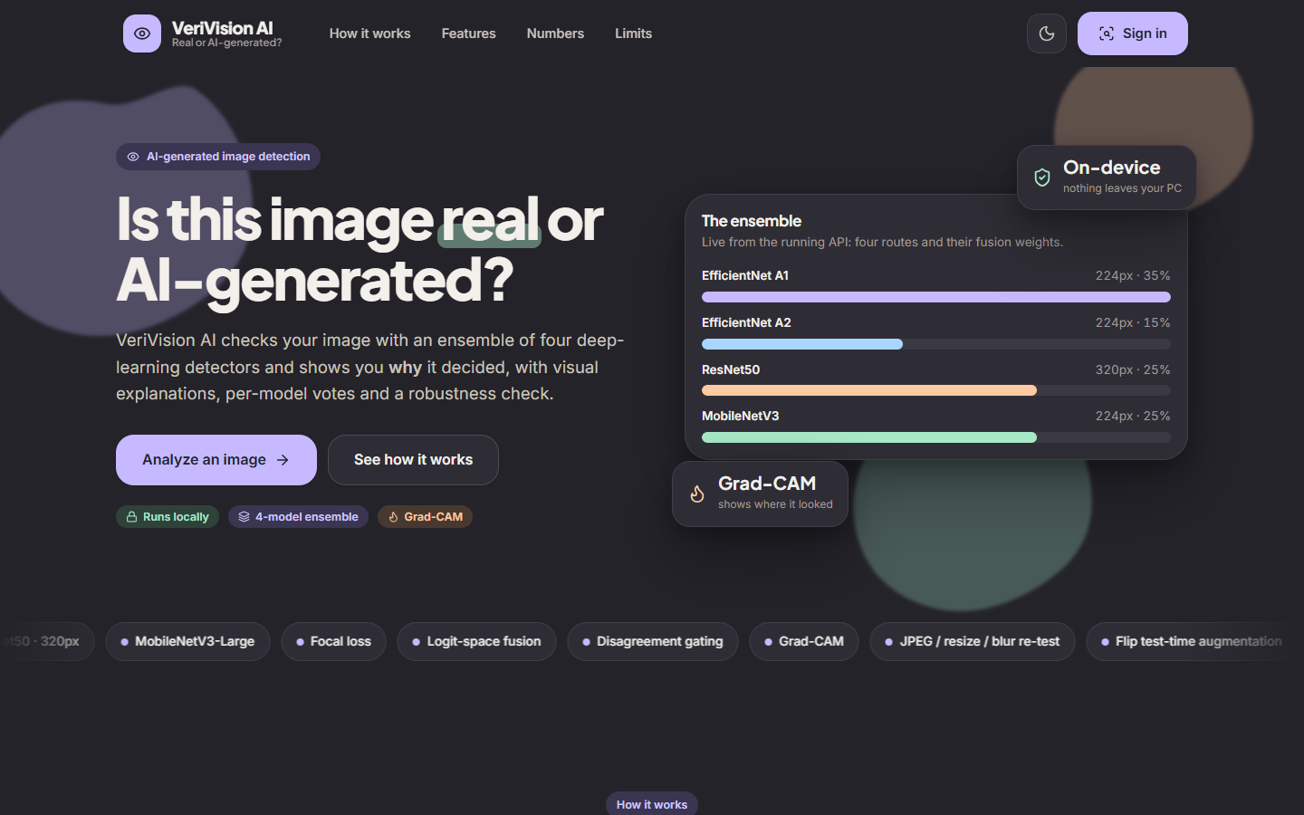  Figure 42: Landing page in the dark theme: the same ensemble card and feature strip; the theme is switched with the button at the top right. | 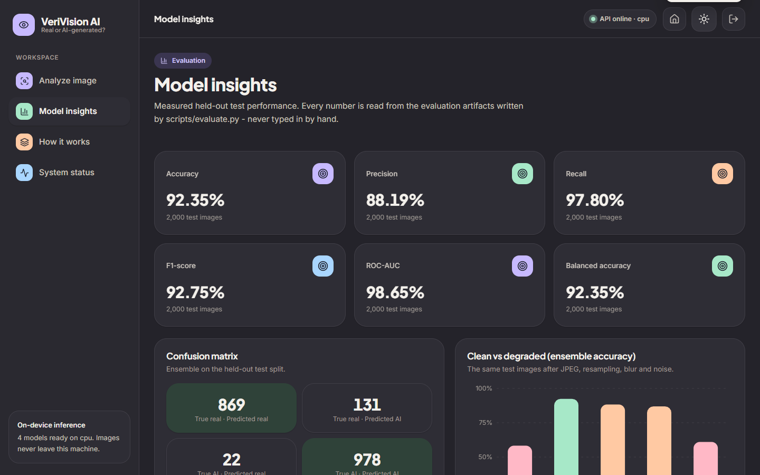  Figure 43: Model insights page in the dark theme: the same measured values as the light page of Chapter 8.

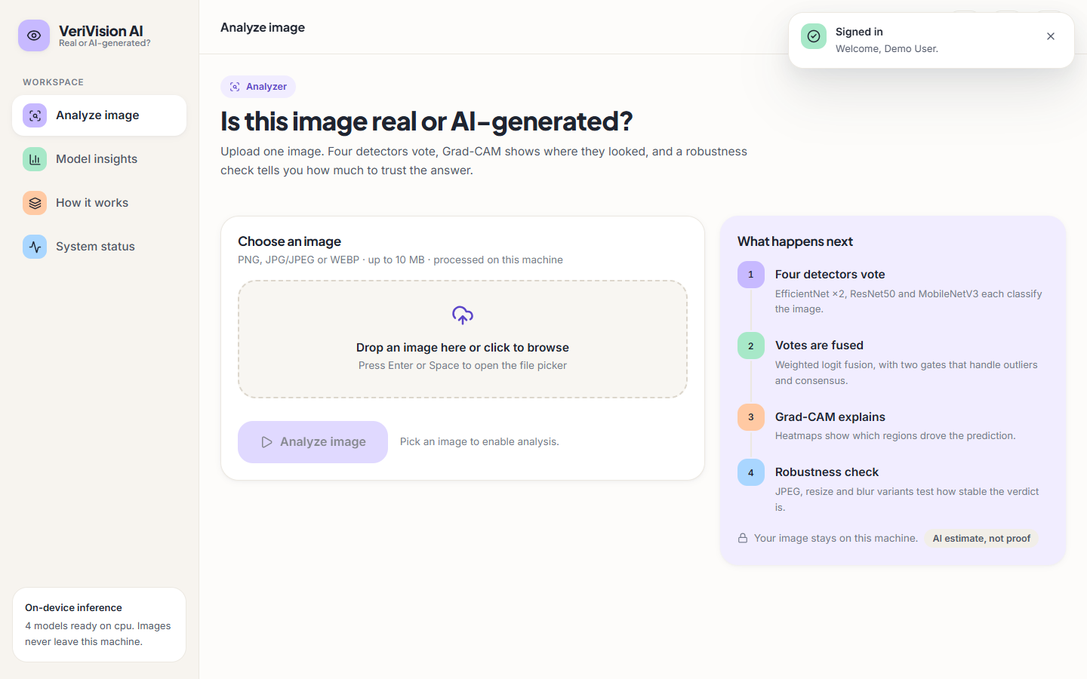  Figure 44: Analyze page after sign-in, before an image is chosen; the toast confirms "Signed in, Welcome, Demo User". | Figure 45: fake_00000.png (2.6 KB) selected: file name, size, remove button and a preview appear, and the Analyze button is enabled.

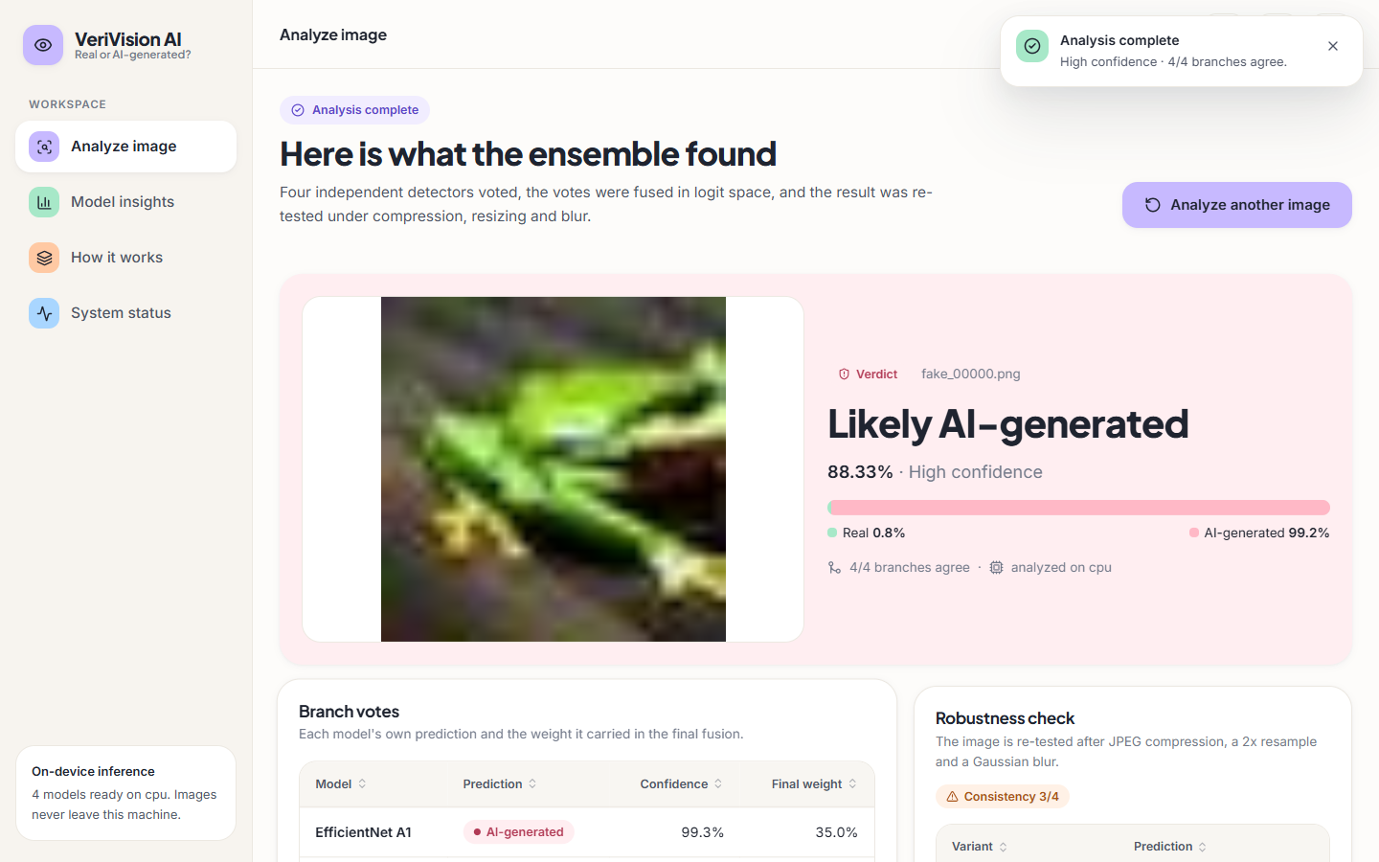
Figure 46: Result page captured while the headline confidence was still counting up: it reads 88.33% beside a bar already at Real 0.8% / AI-generated 99.2%; the settled value is 99.25% (Chapter 8). The file keeps the name 06_analyze_running.png from the capture script.
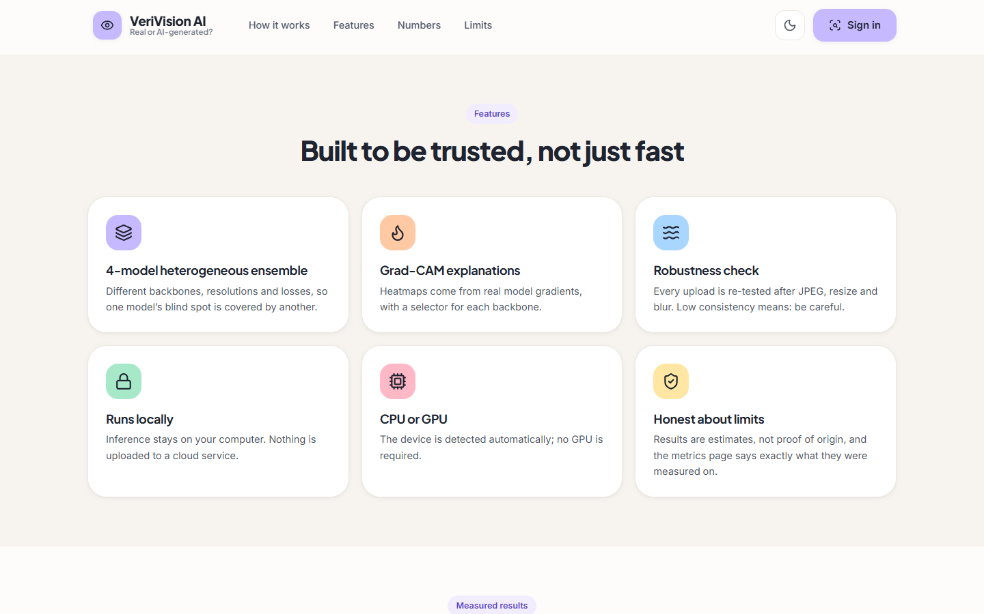  Figure 47: Landing page, features: four-model ensemble, Grad-CAM, robustness check, runs locally, CPU or GPU, and honest about limits. | 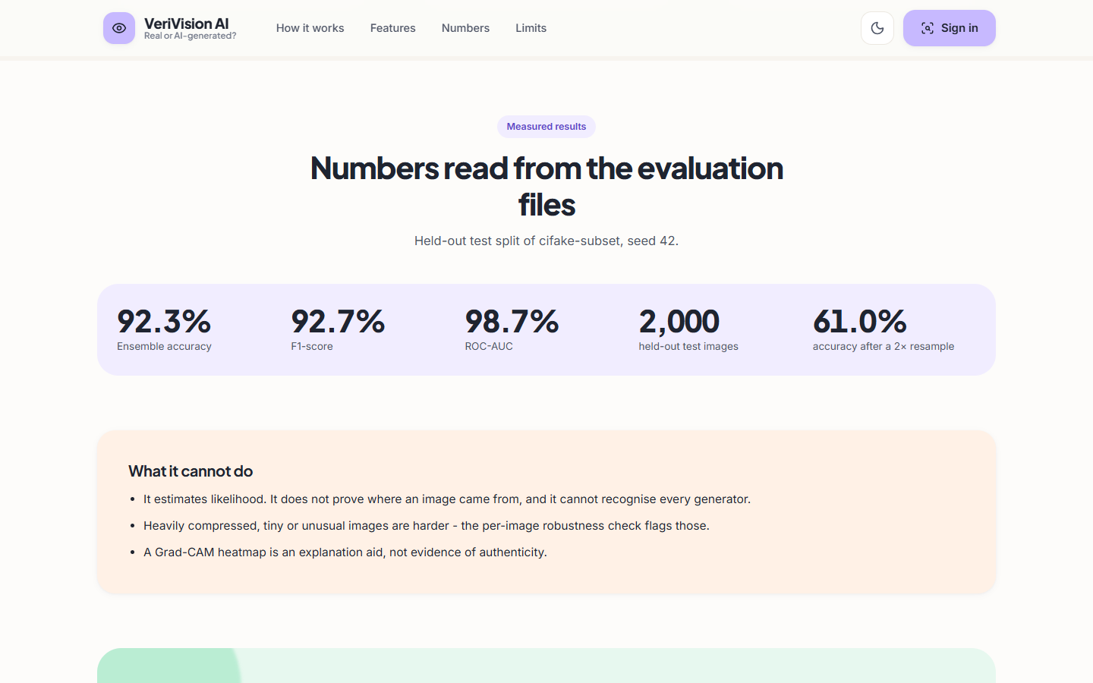  Figure 48: Landing page, numbers: accuracy 92.3%, F1 92.7%, ROC-AUC 98.7%, 2,000 test images and 61.0% after a 2x resample, with the "what it cannot do" box.

The landing page rounds the measured values to one decimal (92.35% is shown as 92.3% and 92.75% as 92.7%) and quotes the accuracy after a 2x resample (61.0%) next to the headline figures, so the weakest result is visible before sign-in.

